Published: JANUARY 04, 2017

Advance Message Box

Advance Message Box

Extension User Guide

Module version: 1.9.1.1

Contents
Advance Message Box 3
1. Configuration 4
1.1 To Enable/Disable the advanced message box extension 5
1.2 Send message to customer from admin panel 6
1.3 Create Message Template 7
1.4 My Message Box Section 8
1.5 Advance Message configuration 9
2. To access the Magento Frontend for Advance Message Box 10
2.1 My Message box section (Frontend) 11
2.2 Send New Messages section 12

Advance Message Box

Overview
Advance message box extension provides a unique feature of communication between the customers and the administrator. This extension adds a message box to customer’s dashboard, using which customers can send and receive messages from admin. The extension also allows an administrator to receive and send messages to a selected group of registered users. Admin can provide links and attachments with the messages. Advance Message Box extension therein provides a medium of interaction between the customer and the administrator and hence facilitates customers to easily contact the site owner if they have any concern in regards to the site.
Features
- Send messages to selected registered customers or group of customers
- Preview the messages before sending
- Provide links and attachments with the messages
- Create message templates which will be used while sending messages to customers
- Preview the message templates
- View sent messages in Message log
- Messages send to admin by customer(s)
- Export the customer’s messages to CSV or XML file
- At frontend the registered customers can view the messages sent to them by admin in “My Message Box” tab in the “My Account” section
- At frontend the registered customers can view the message sent by them to admin in “Send Messages” tab in the “My Account” section
- Customers can also send messages to admin from “Send Messages” tab in “My Account” section

1. Configuration
To access the Magento backend administration environment
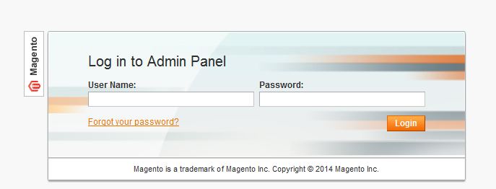

- Log in using user name and password
- Click Login button to display administration panel

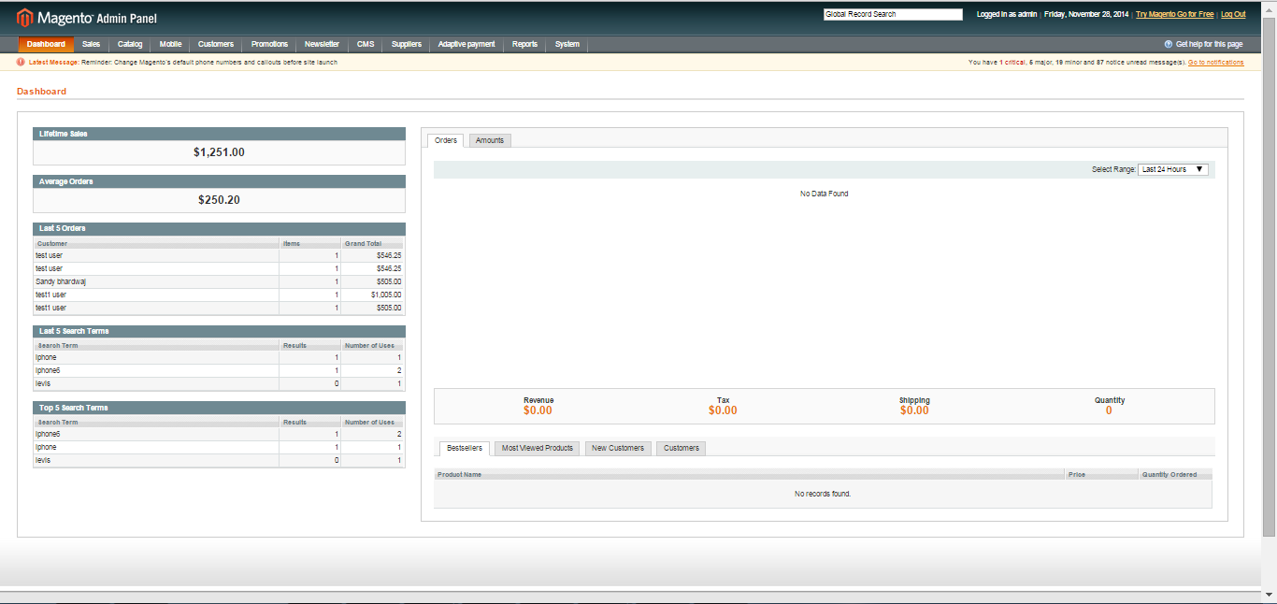

1.1 To Enable/Disable the advanced message box extension
Select Setting > Configuration from admin panel

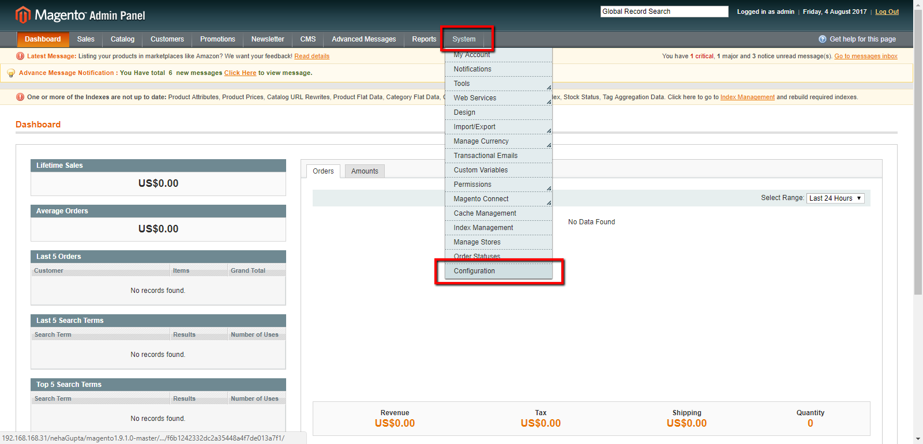

Go to ALW - Advance Messages to enable the message options for users
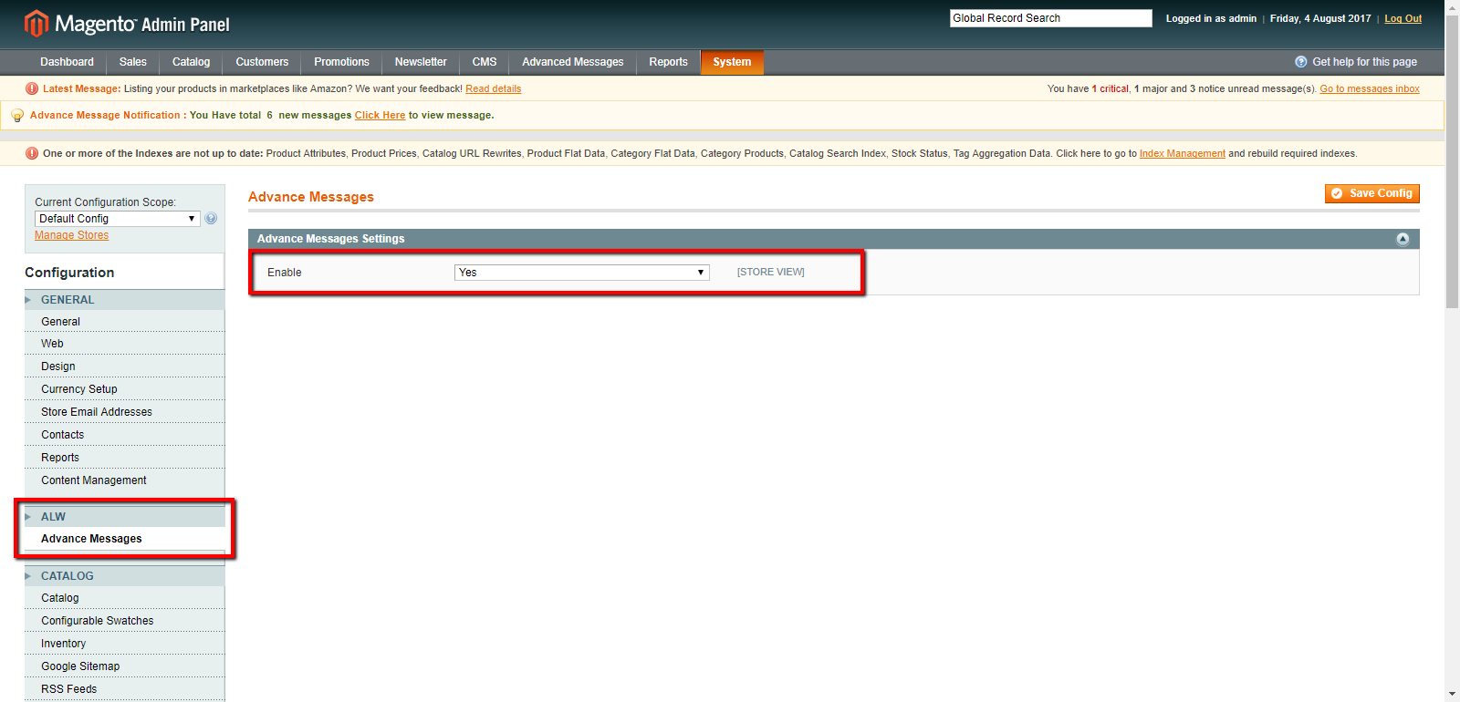

1.2 Send message to customer from admin panel
Select Advanced messages > send new messages from admin panel
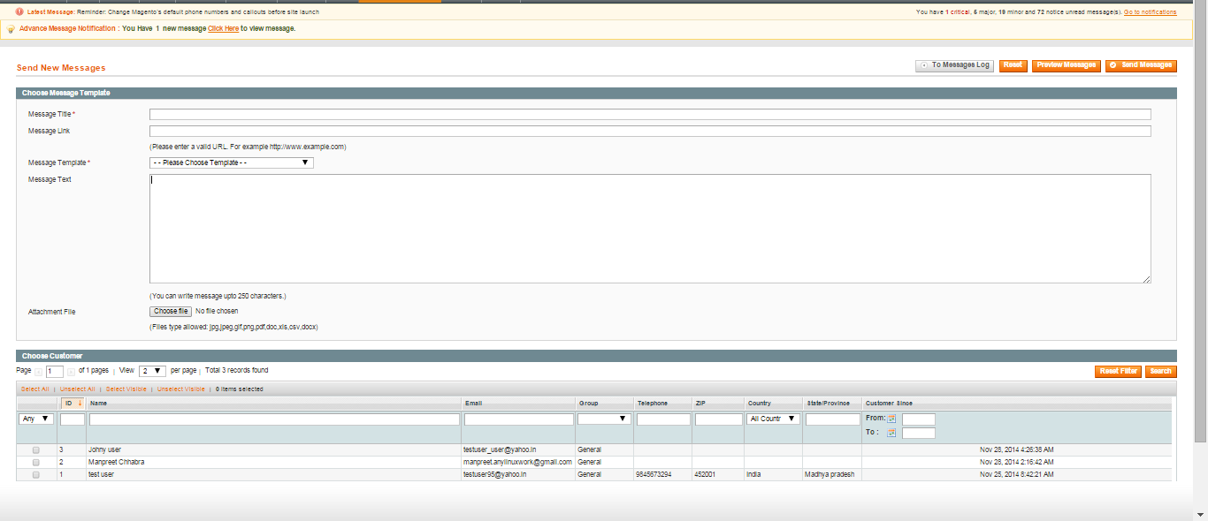

General tabs
- Message title : Define message title to be send
- Message link : Add a link along with message which is accessible
- Message template : Select available template from dropdown
- Message Text : Defines content of message to be send
- Attachment file : To attach file with message
- Choose customer : Select customers from list, to send messages
- Preview message : Admin can preview typed message through this tab
- Reset : It will reset filled entries

1.3 Create Message Template
Select Advanced messages>Message template from admin panel
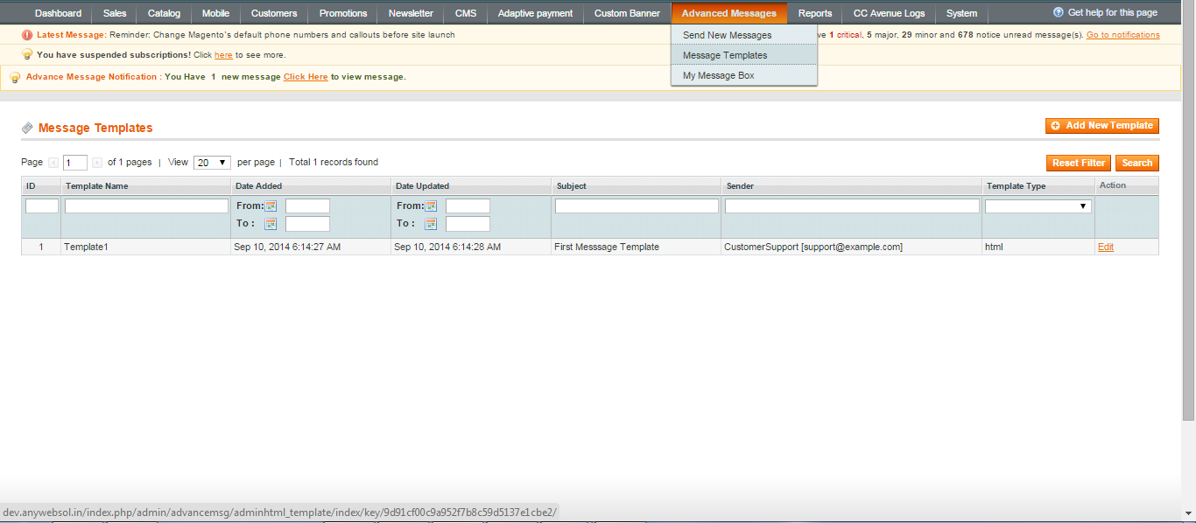

- A list of created template will be displayed here
- Click add new template tab, to add a new template to list
- Add new template page will be displayed as shown below

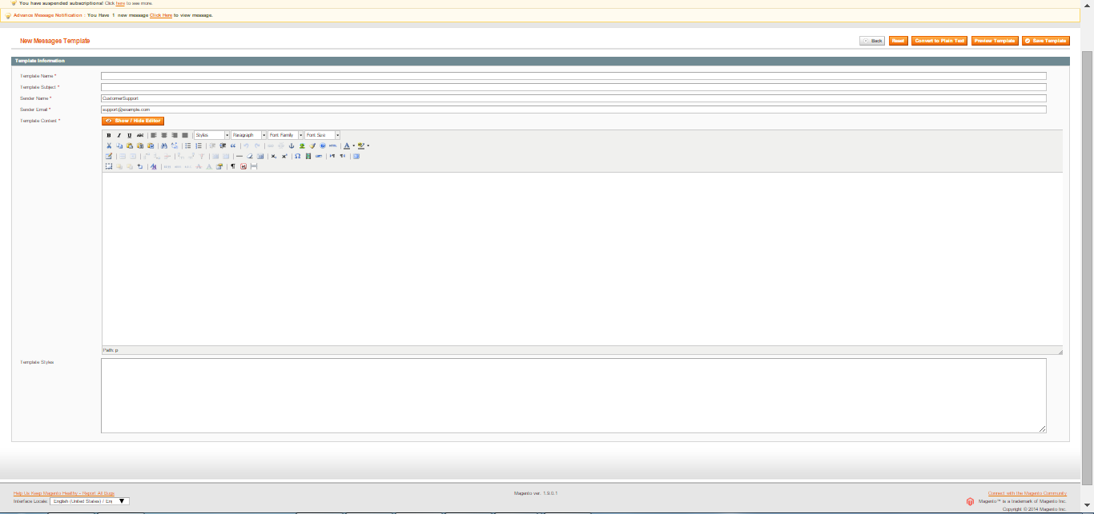

General Tabs
- Template Name : Template name will displayed
- Template subject : Defines Subject of template
- Sender name : Display’s name of sender along with message
- Sender Email: Sender’s email address will be display with message
- Template content : Display’s body of template
- Convert to plain text : It will hide html editor
- Preview template : Admin can preview created template through this
- Save template : It will save created template

1.4 My Message Box Section
Select Advanced messages>My message box section from admin panel

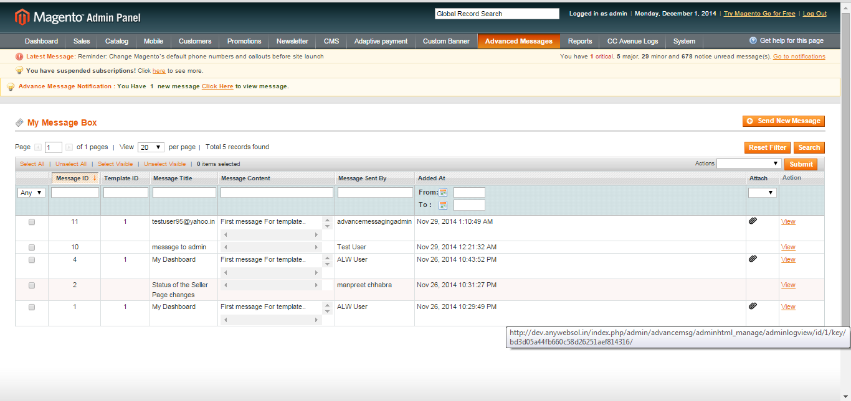

General Tabs
- View : Admin can view both messages send and received
- Send new messages : This tab will take to send new messages window
- Actions : Admin can perform actions on send and receive messages
- Submit : It will submit actions performed

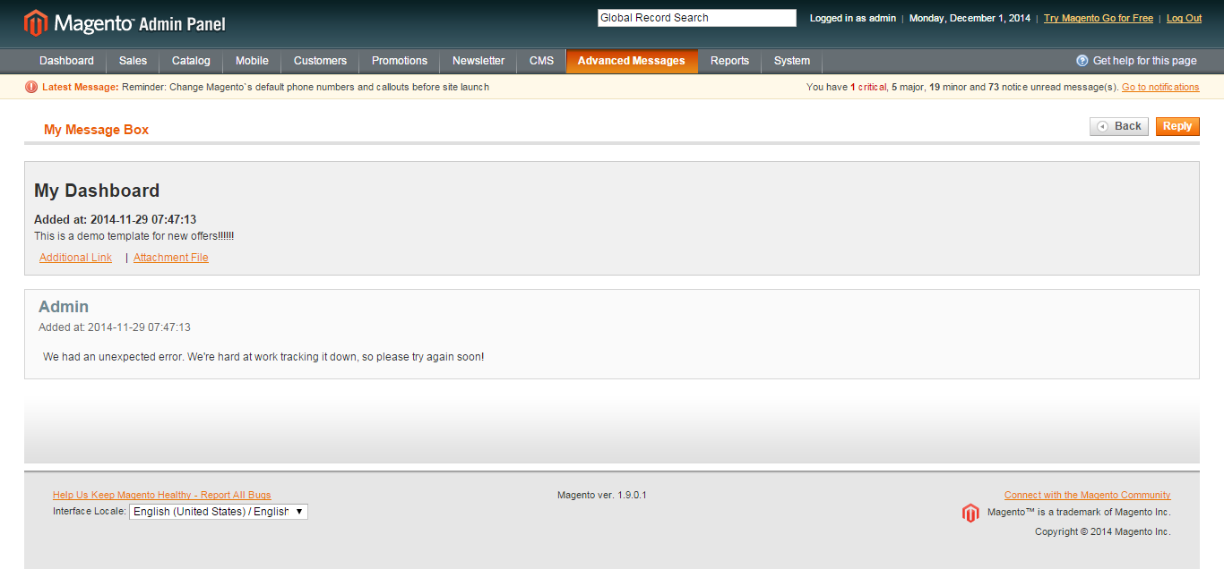
General Tabs
- Threads contain both send and receive messages with their respective names
- Reply : Admin can reply to same thread
- Back: It will take back to “my message” box section

1.5 Advance Message configuration
Select System > Configuration > Advance messaging from admin panel
Enable or disable Configuration catalog extension

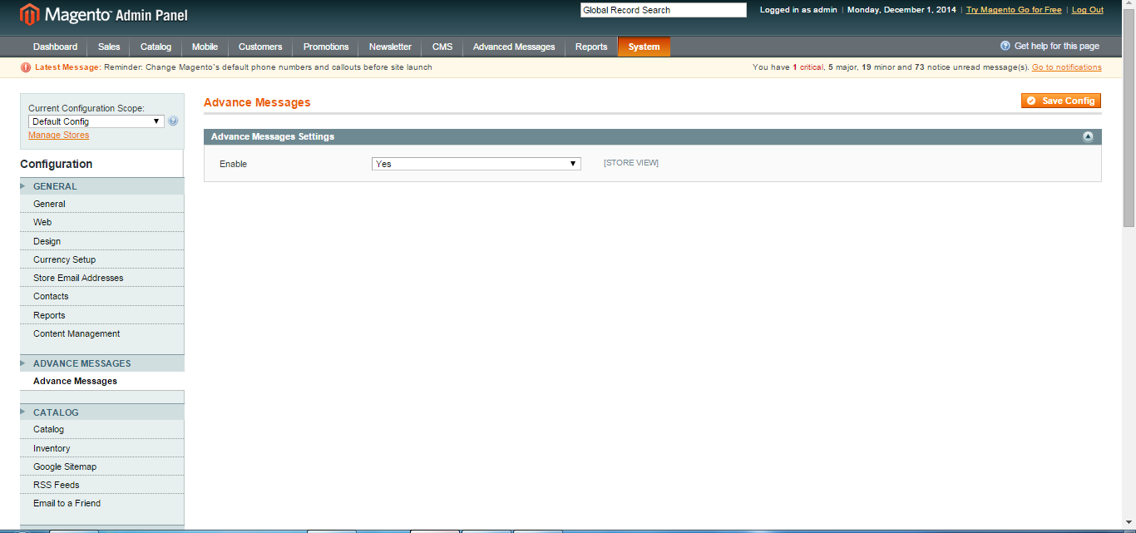

2. To access the Magento Frontend for Advance Message Box

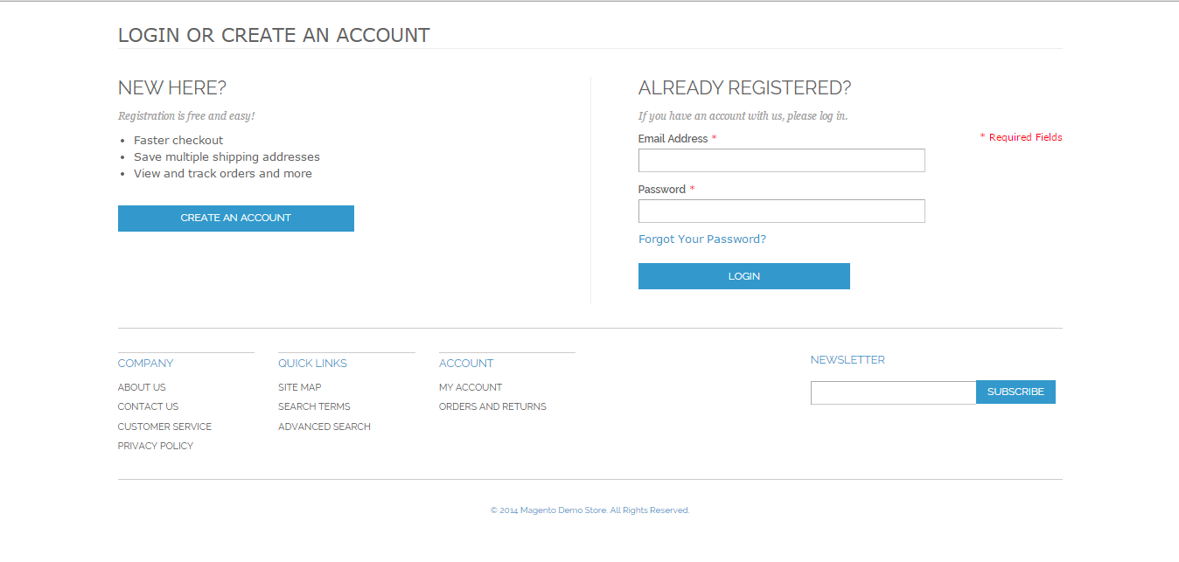

- Enter User login credentials to login to registered account
- User will be redirected to Home page
- From home page, select Account > My Account > My message Box in frontend
- My message box will displayed as shown below
- My message box section will contain both send and receive messages by user
- User will be able to view all messages

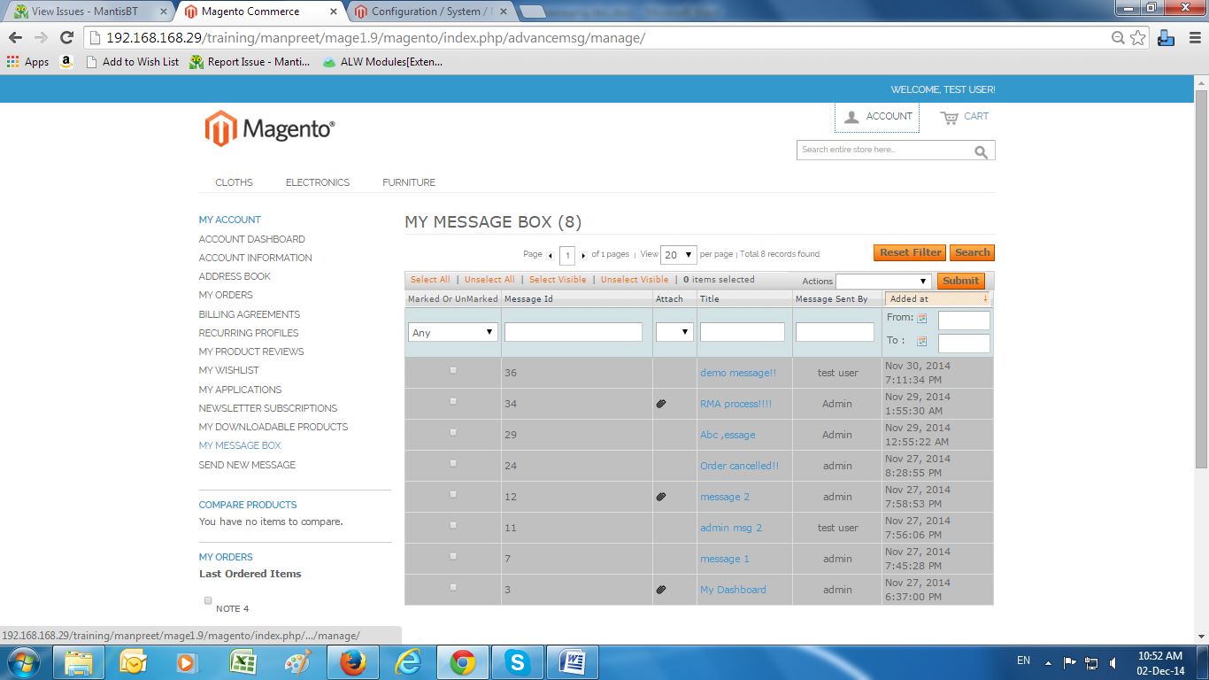

2.1 My Message box section (Frontend)
- Actions: User will be able to perform actions on messages like mark as read, unread or remove message
- Search: User will able to apply filter on messages through Message id, Attach or not, title, Message send by, Date wise
- Reset filter: This will reset applied filter on messages
- Select all: Select all messages in grid
- Unselect all: Unselect all messages in grid
- Select visible: Select only visible message in grid
- Unselect visible : Unselect all the visible messages in grid

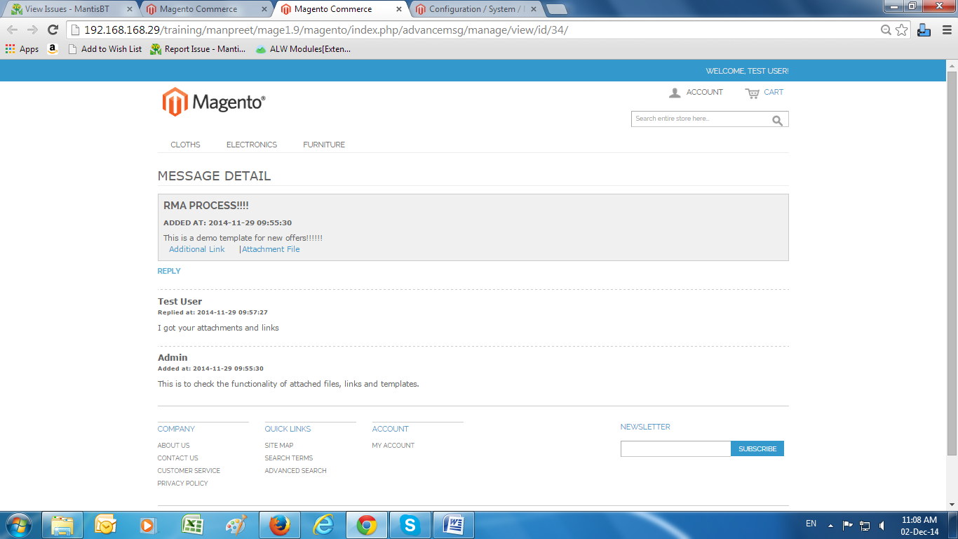
The Message will contain the following
- Message template details
- The thread will contain both send and receive messages along with their names
- Attachment file: User can view attached file
- Additional link: User can view additional link with the message
- Reply: User will be able to reply to same thread

2.2 Send New Messages section
- Select Account>My account>send new messages from frontend
- Send new messages section will be displayed
- In this section, user will be able to send new messages to admin
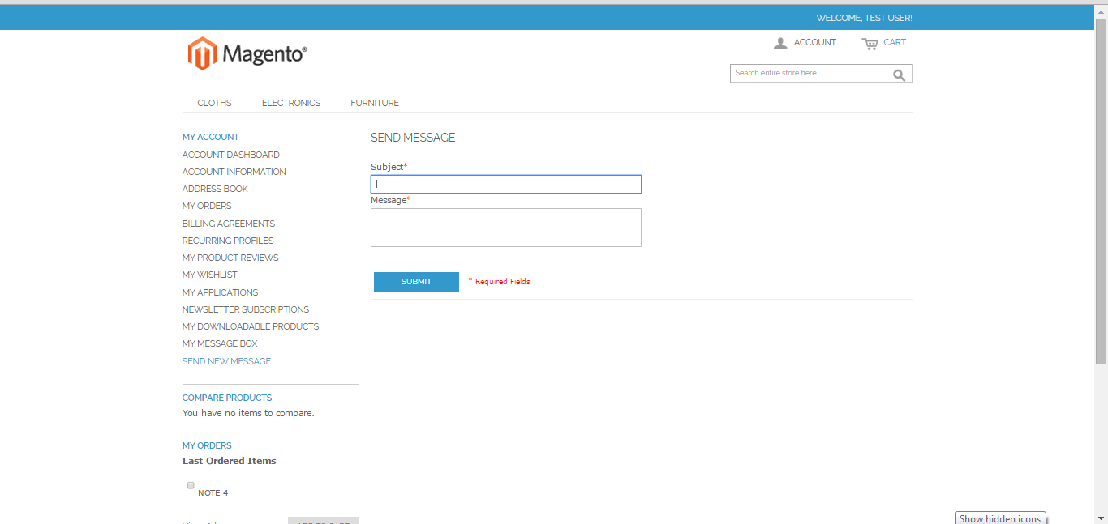

General Tabs
- Subject: Enter message subject to send messages
- Message: Enter message body for this field
- Submit: This will send message to admin when clicked

