Advance Message Box

Published: JANUARY 02, 2017

Advance Message Box
Extension User Guide

Module version: 2.1.1

Contents
Advanced Message Box 3
1. Configuration 4
1.1 Advanced Message configuration 5
1.2 Send message to customer from admin panel 5
1.3 Create Message Template 6
1.4 My Message Box Section 8
2. Frontend 9
2.1 My Message Box 9
2.2 User Send New Message section 11

Advanced Message Box

Overview
Advanced Message Box Extension provides a unique feature of communication between the customers and the Administrator. This extension adds a message box to customer’s dashboard, using which customers can send message to Admin and receive messages from Admin. The extension also allows Administrator to receive and send messages to a selected group of registered users. Admin can provide links and attachments with the messages. Advanced Message Box extension provides a medium of interaction between the customer and the Administrator and hence facilitates customers to easily contact the site owner if they have any concern in regards to the site.
Features
For Store Owners
- Admin can send messages to selected registered customers or group of customers
- Admin can preview the messages before sending
- Admin can provide links and attachments with the messages
- Admin can create message templates which will be used while sending messages to customers
- Admin can preview the message templates
- Admin can view the sent messages in the Message log
- Inbox show messages send to admin by the customer(s)
- Admin can export the customer’s messages to CSV or XML file

For Customers
- At frontend, the registered customers can view the messages sent to them by admin in “My Message Box” tab in the “My Account” section
- At frontend, the registered customers can view the message sent by them to admin in "Send Messages" tab in the "My Account" section
- Customers can also send messages to admin from “Send Messages” tab in “My Account” section

1. Configuration
To access the Magento backend administration environment
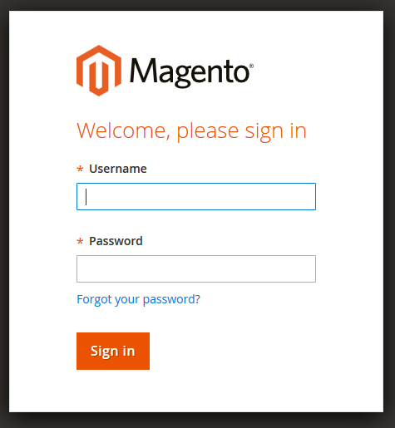

- Log in using the username and password
- Click the Login button to display the administration panel

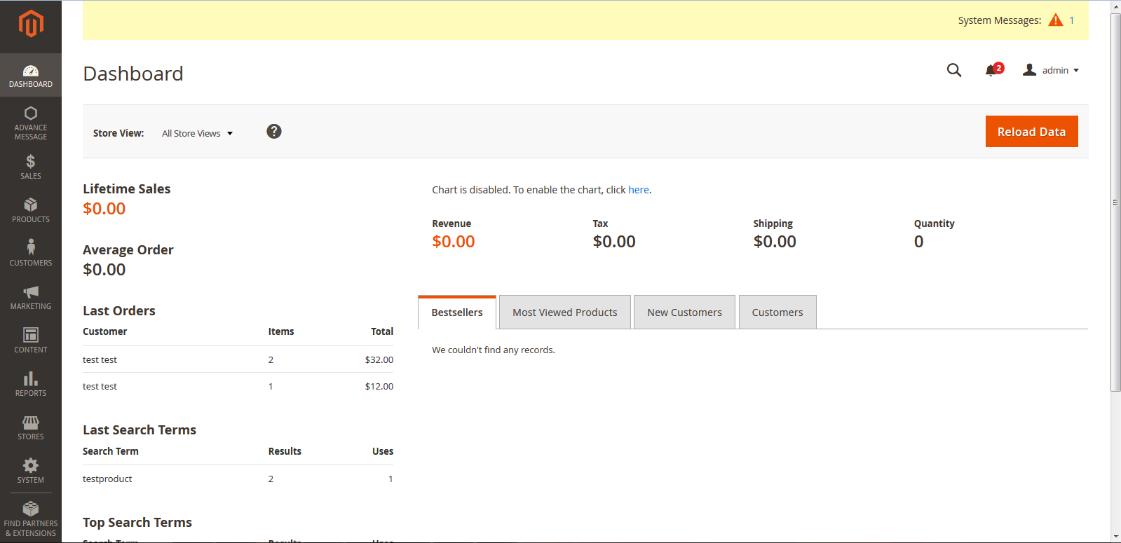

1.1 Advanced Message configuration
Select System> Configuration > Advance message from admin panel
Enable or disable Configuration catalog Extension

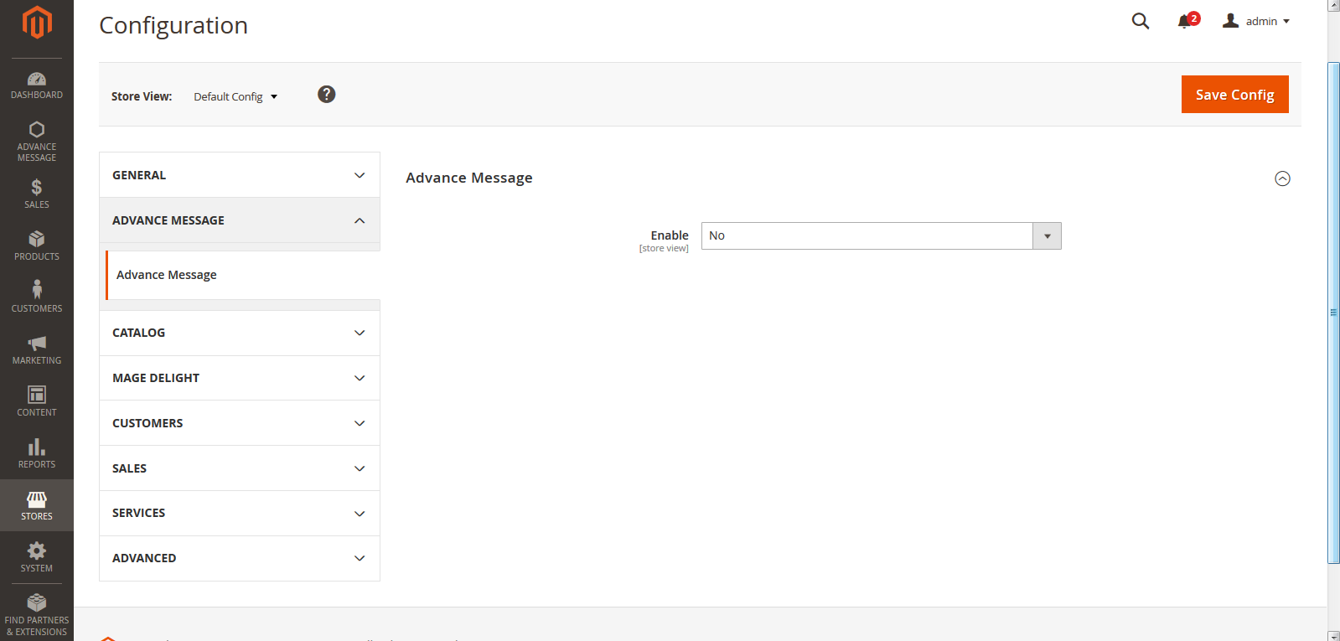

1.2 Send message to customer from admin panel
Select Advanced messages > send new messages from admin panel
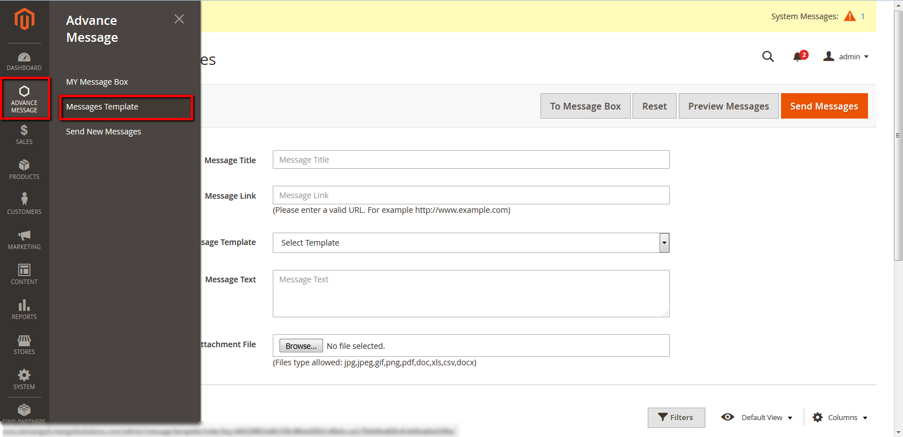
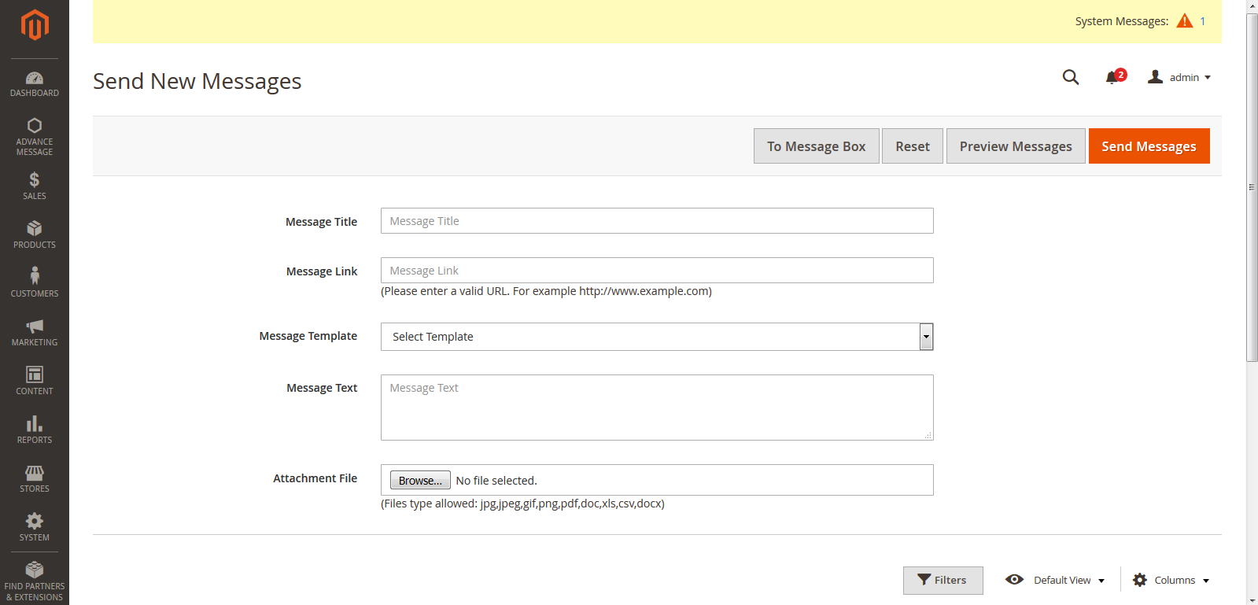
General tabs in send message section
- Message Title: Defines the message title which to be send
- Message link: To add a link along with message which is accessible
- Message template: Select the available template from dropdown
- Message Text: Defines the content of message to be send
- Attachment file: To attach file with the message
- Choose customer: Select customers from the list, to send messages
- Preview message: Admin can preview his typed message through this tab
- Reset: It will reset the filled entries

1.3 Create Message Template
Select Advanced Message > Message template from admin panel

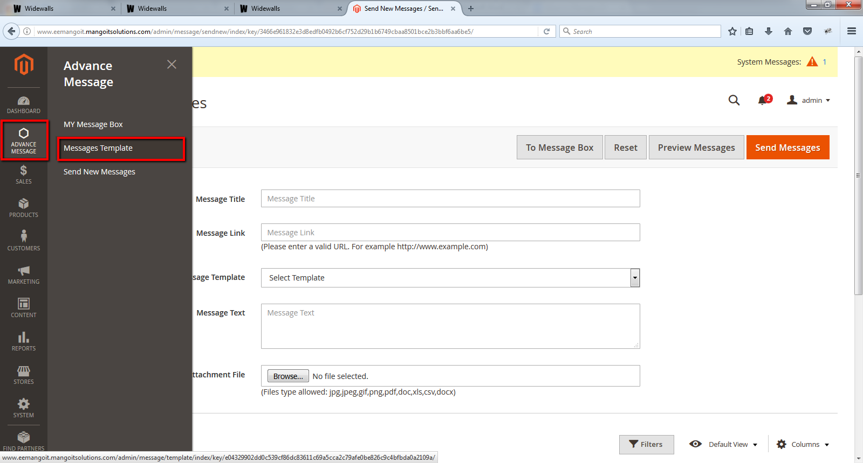

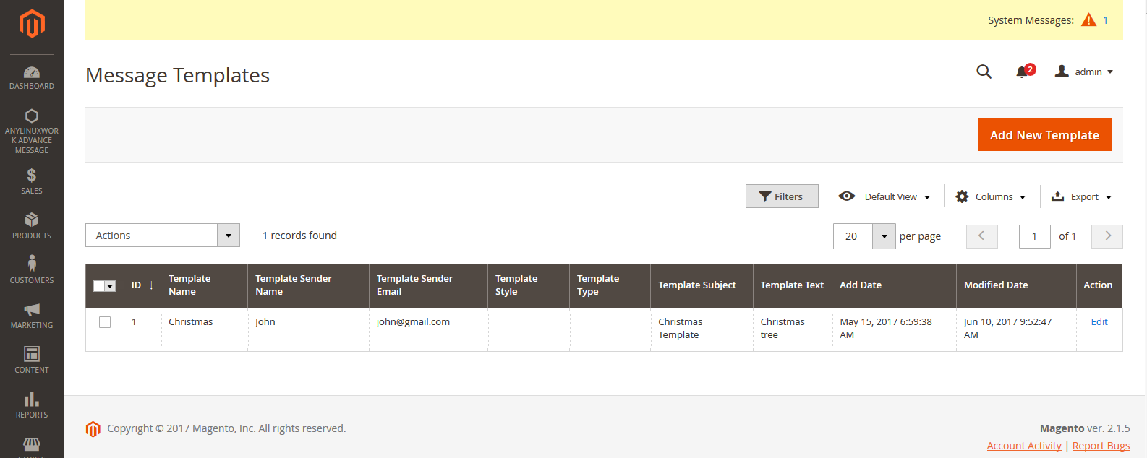

- A list of created template will be displayed here
- Click Add new template tab, to add a new template to the list
- The Add new template page will be displayed as shown below

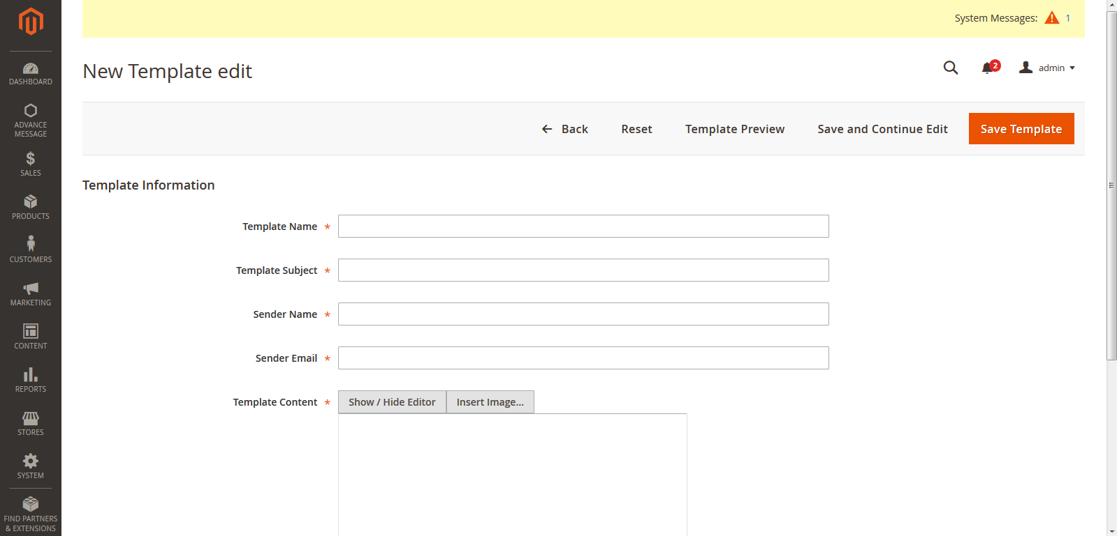

General Tabs
- Template Name: Name of template which will display
- Template subject: It defines the Subject of the template
- Sender name: It will display the name of sender along with message
- Sender Email: Sender’s email address will be display along with the message
- Template content: It displays the body of the template
- Template Styles: It will hide the HTML editor
- Preview Template : Admin can preview the created template through this
- Save template: It will save the created template

1.4 My Message Box Section
Select Advanced Message > My Message box section from admin panel

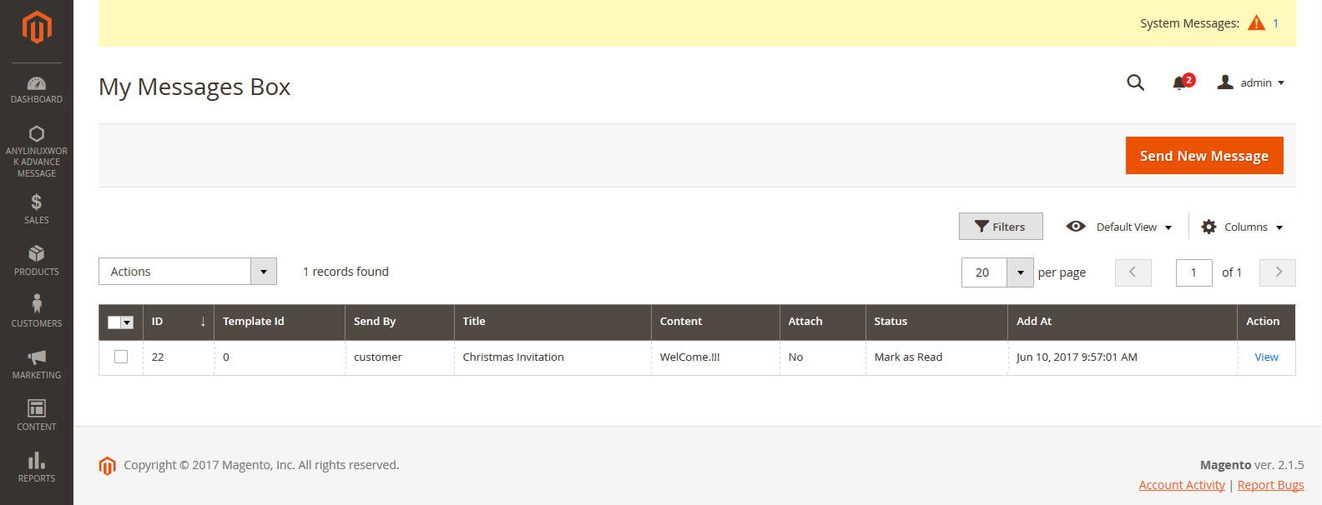

General Tabs
- View: Admin can view the messages both send and received
- Send new messages: This tab will take to the send new messages window
- Actions: Admin can perform the actions on send and receive messages
- Submit: It will submit the actions performed

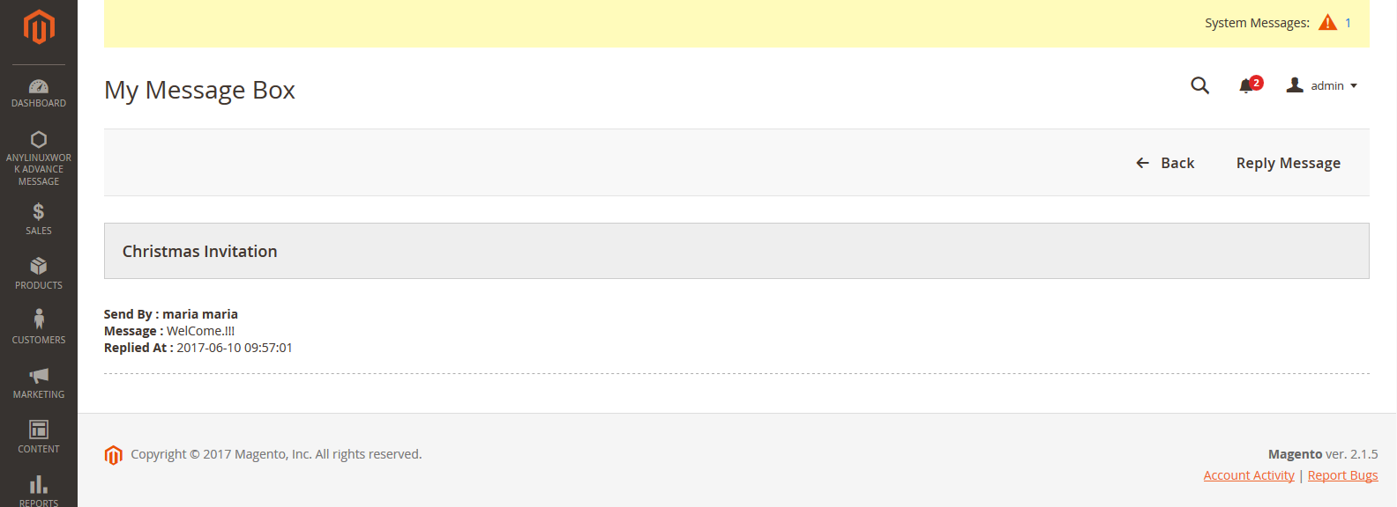

General Tabs
- The thread contains both send and receives messages with their respective names
- Reply: Admin can reply to the same thread
- Back: It will take back to the “my message” box section

2. Frontend
To access the Magento Frontend for Advance Messages
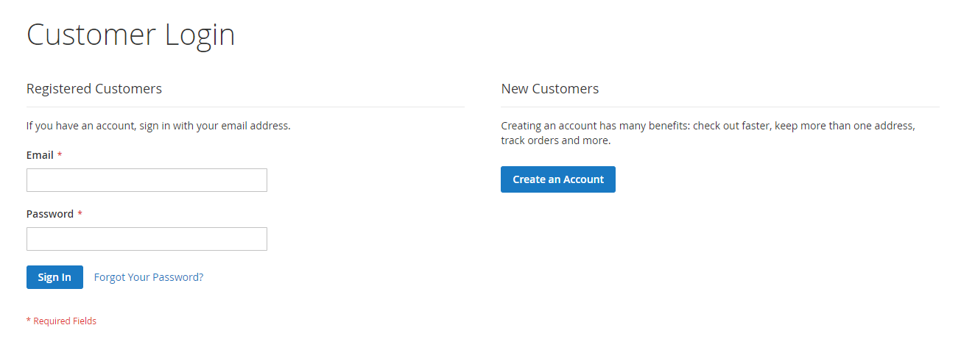

- Enter the User login credentials to login to the registered account
- The user will be redirected to the Home page

2.1 My Message Box
Login into account and it will redirect to 'My Account' page
Select Account > My Account > My Message Box in the frontend
- My message box will be displayed as shown below

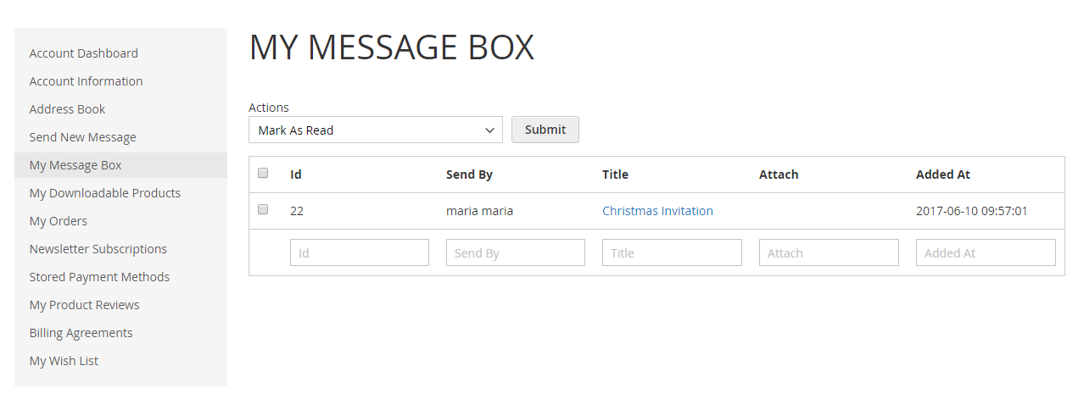

- My message box section will contain both send and receive messages by user
- User will be able to view all messages

General tabs for My Message box section
- Actions: User will be able to perform actions on the messages like mark as read, mark as unread or remove the message
- Search: User will be able to apply a filter on messages through Message-id, Attach or not, title, Message sent by, Date wise
- Reset filter: This will reset the applied filter on messages
- Select all: To select all the messages in grid
- Unselect all: To unselect all the messages in the grid
- The thread will contain both sent and received messages along with their names
- Attachment File: User can view the attached file
- Additional link: User can view the additional link with the message
- Reply: User will be able to reply to the same thread
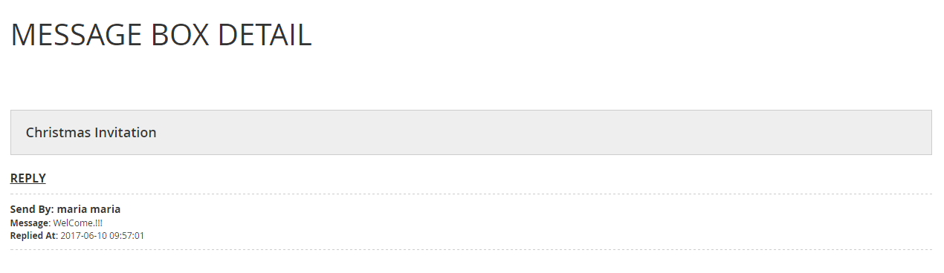

2.2 User Send New Message section
- Select Account > My Account > Send New Message from the frontend
- Send new messages section will be displayed
- In this section, user will be able to send new messages to admin
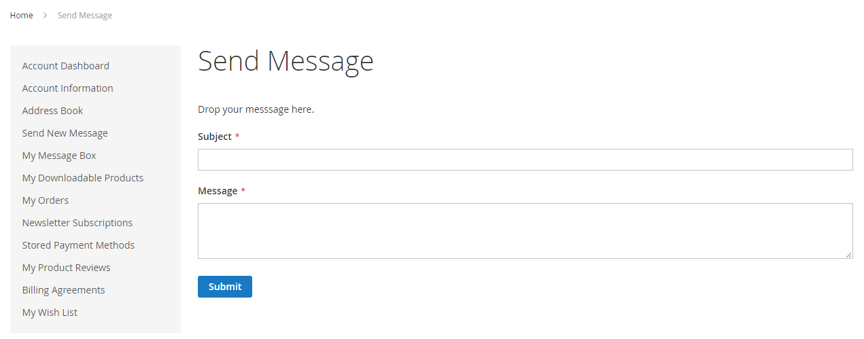
General Tabs
- Subject: Enter the message subject for this field
- Message: Enter the message body for this field
- Submit: This will send the message to the admin when clicked

