Advance Permission

Published: JANUARY 05, 2017

Extension User Guide

Module version: 1.9.1.1

Magento

Contents
Advance Permission 3
1. Configuration 5
1.1 Manage User roles 6
1.2 Manage Users 8
1.3 Manage Variables 9

Advance Permission

Overview
Advanced permission extension enables admin to assign permissions to users for editing products, managing product, and managing configurations within specific catalogs, store views and websites. This extension will be particularly useful for stores with big catalogs, for multiple store views and for businesses that need to allow users with restricted permissions to manage their own products.
Features
- Enables admin to assign permission on product editing per category, store view and website
- Enables admin to assign permission on categories editing per store and store view
- Enables admin to allow/forbid product deletion
- Allows for restricting order management per store view and website
- Allows for restricting configuration management per store view and website
- Enables to restrict customers’ management per website of the selected store view
- Enables to restrict access to the following CMS elements: pages, static blocks, widgets and polls and manage them per website and store-view
- Enables to restrict access to the following reports: sales, abandoned carts, products, customers, reviews and tags and manage them per website and store
- Allows to switch on/off the ability for restricted administrators to edit global attributes for their available products
- Info on the dashboard is displayed in accordance with user’s roles and permissions
- Allows to restrict access for a role to several store-views or websites
- Allows super-admin to configure sub-admin. Roles to view/edit own products
- Enables super admin to receive notifications about new products created by sub-admin, review and approve them to be displayed on the frontend
- The extension’s functionality is 100% Open Source
- Allow/deny sub-admin users deleting products
- Configure sub-admin user roles to view/edit only their own products
- Allow/Deny sub-admin users editing global attributes for their own products
- Change product owner if “allow manage only own product” setting is on
- Receive notifications about new products created by sub-admin user
- Review and approve products created by sub-admin user to be displayed on the frontend

1. Configuration
To access the Magento backend administration environment
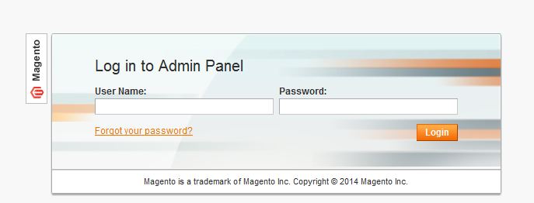

- Log in using the user name and password

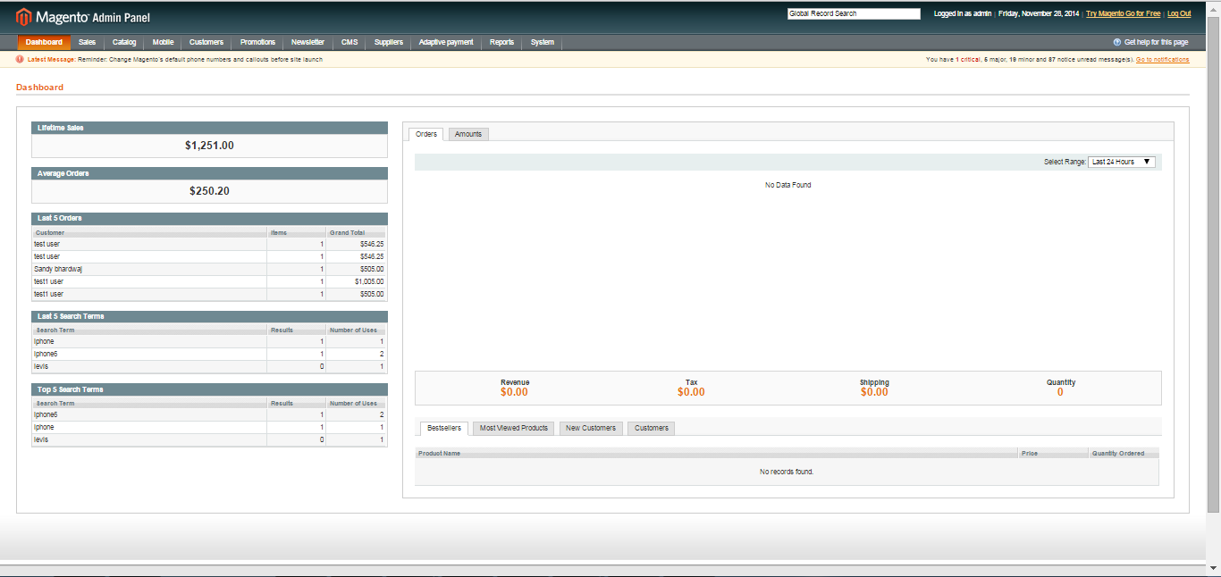

- Click the Login button to display the administration panel

1.1 Manage User roles
Select System > Permissions > Roles from admin panel

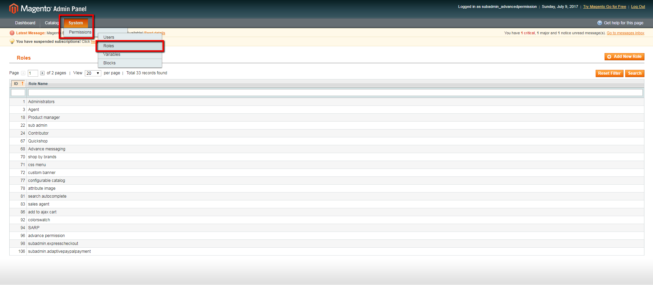

- A list of all the created roles shall be displayed in this section
- Admin can edit each role
- Click Add New Role tab, to add a new role to the list
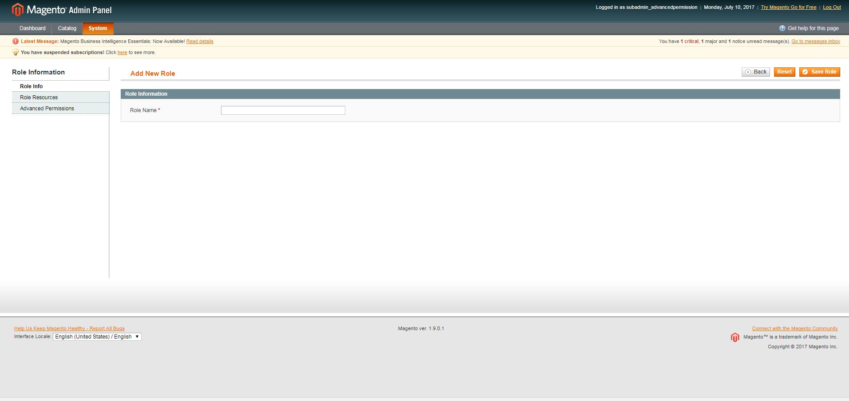

General Tabs
- Role name: Enter the name of the role
- Role Resources: Select either custom or all resources. In custom resources, check the resources available in the list
- Advanced Permissions: Advanced permissions to users can be Disabled or Limited access to store views/categories or Limited access to websites
- Save: It will save the created role
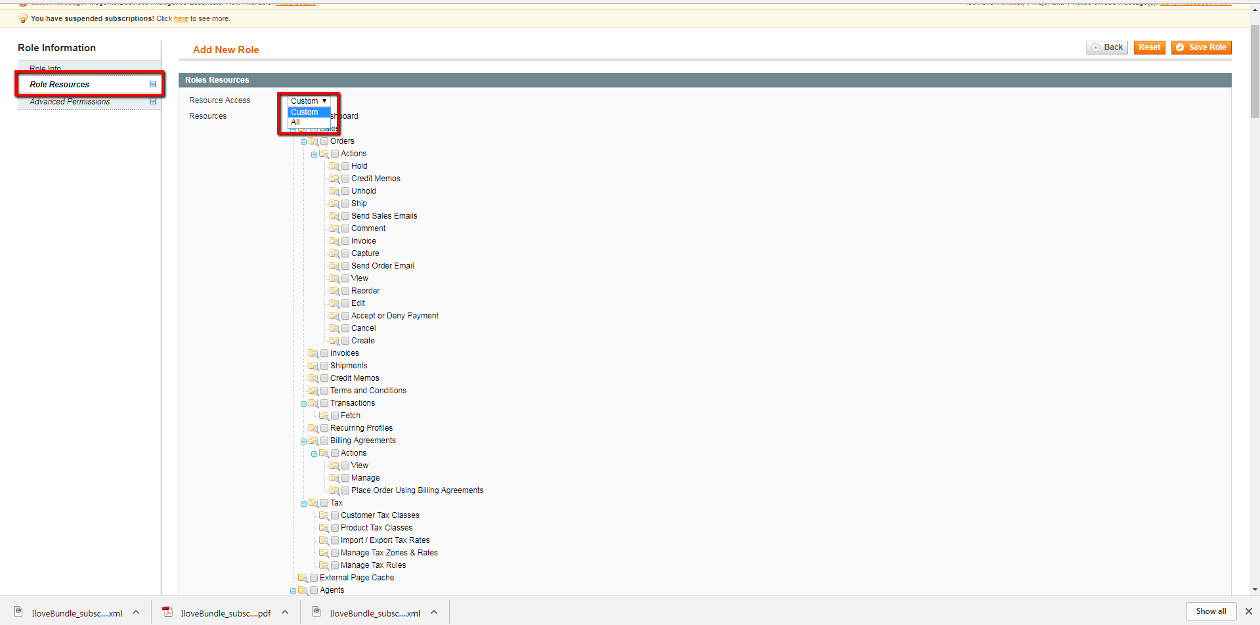
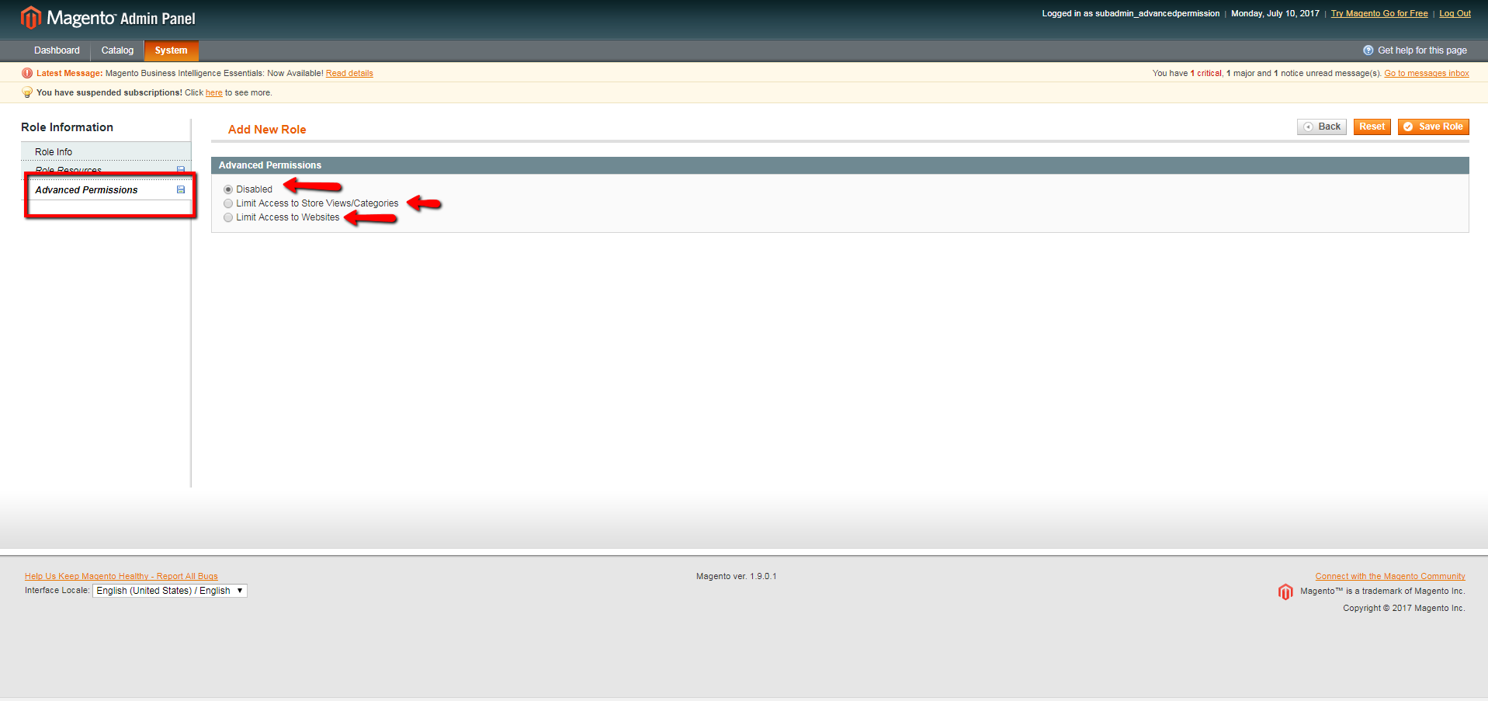

1.2 Manage Users
Select System > Permissions > Users from admin panel

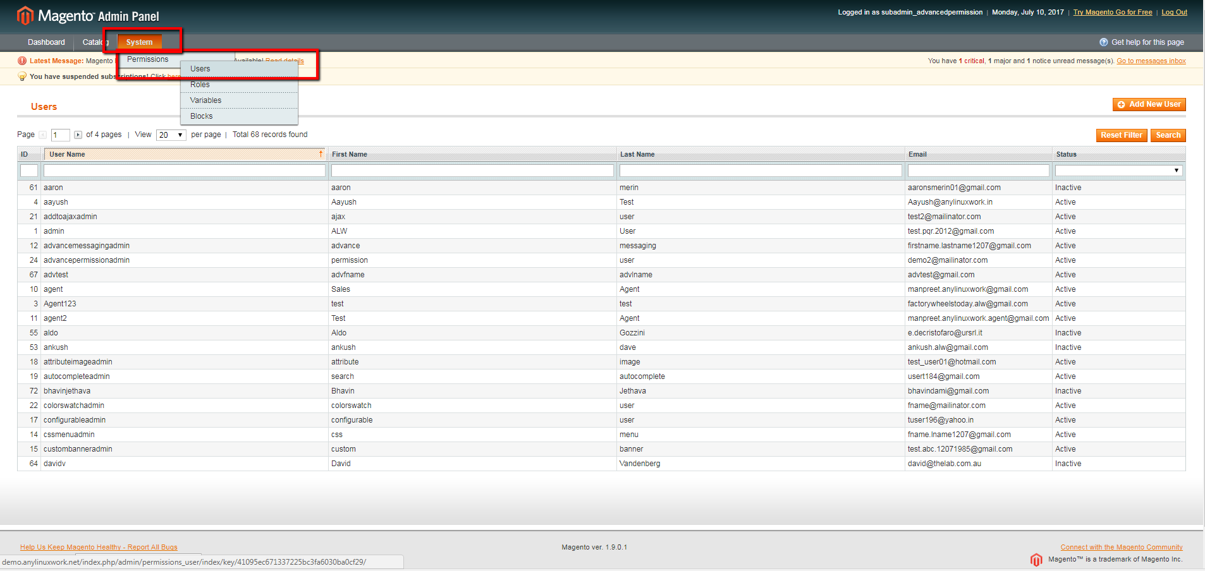

- A list of all the created users shall be displayed in this section
- Admin can edit each user
- Click Add New User tab, to add a new user to the list
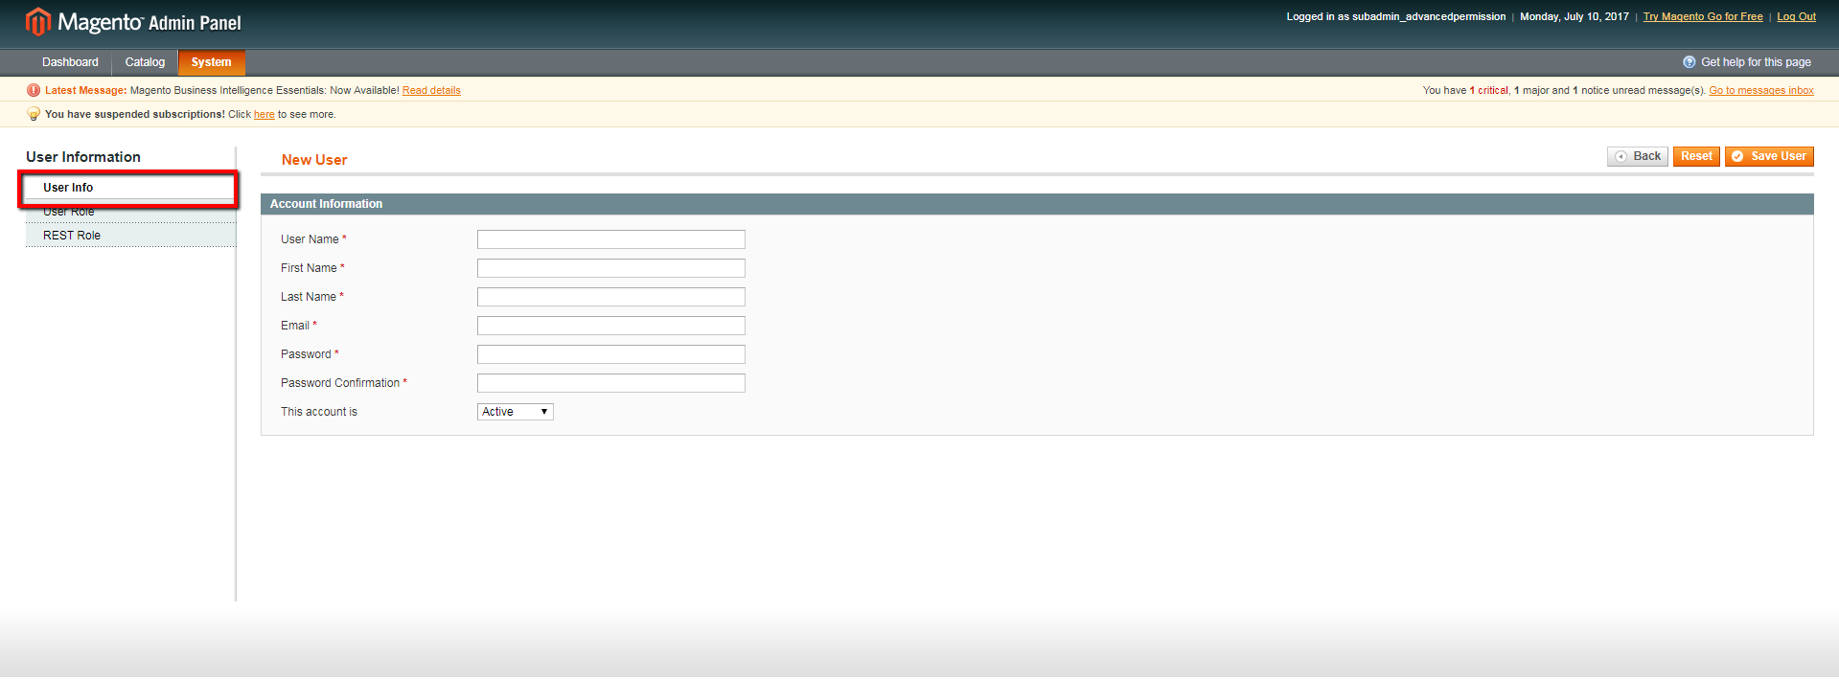

General Tabs
- Username: Enter username
- First name: Enter first name of the user
- Last name: Enter last name of the user
- Email: Enter email id of the user
- Password: Enter password details
- Password confirmation: Enter password to confirm
- The account : Select either active or Inactive status for the user’s account
- User role: Select any one role from the available roles
- Save user: Save the user details in the system

1.3 Manage Variables
Select System > Permissions > Variables from admin panel

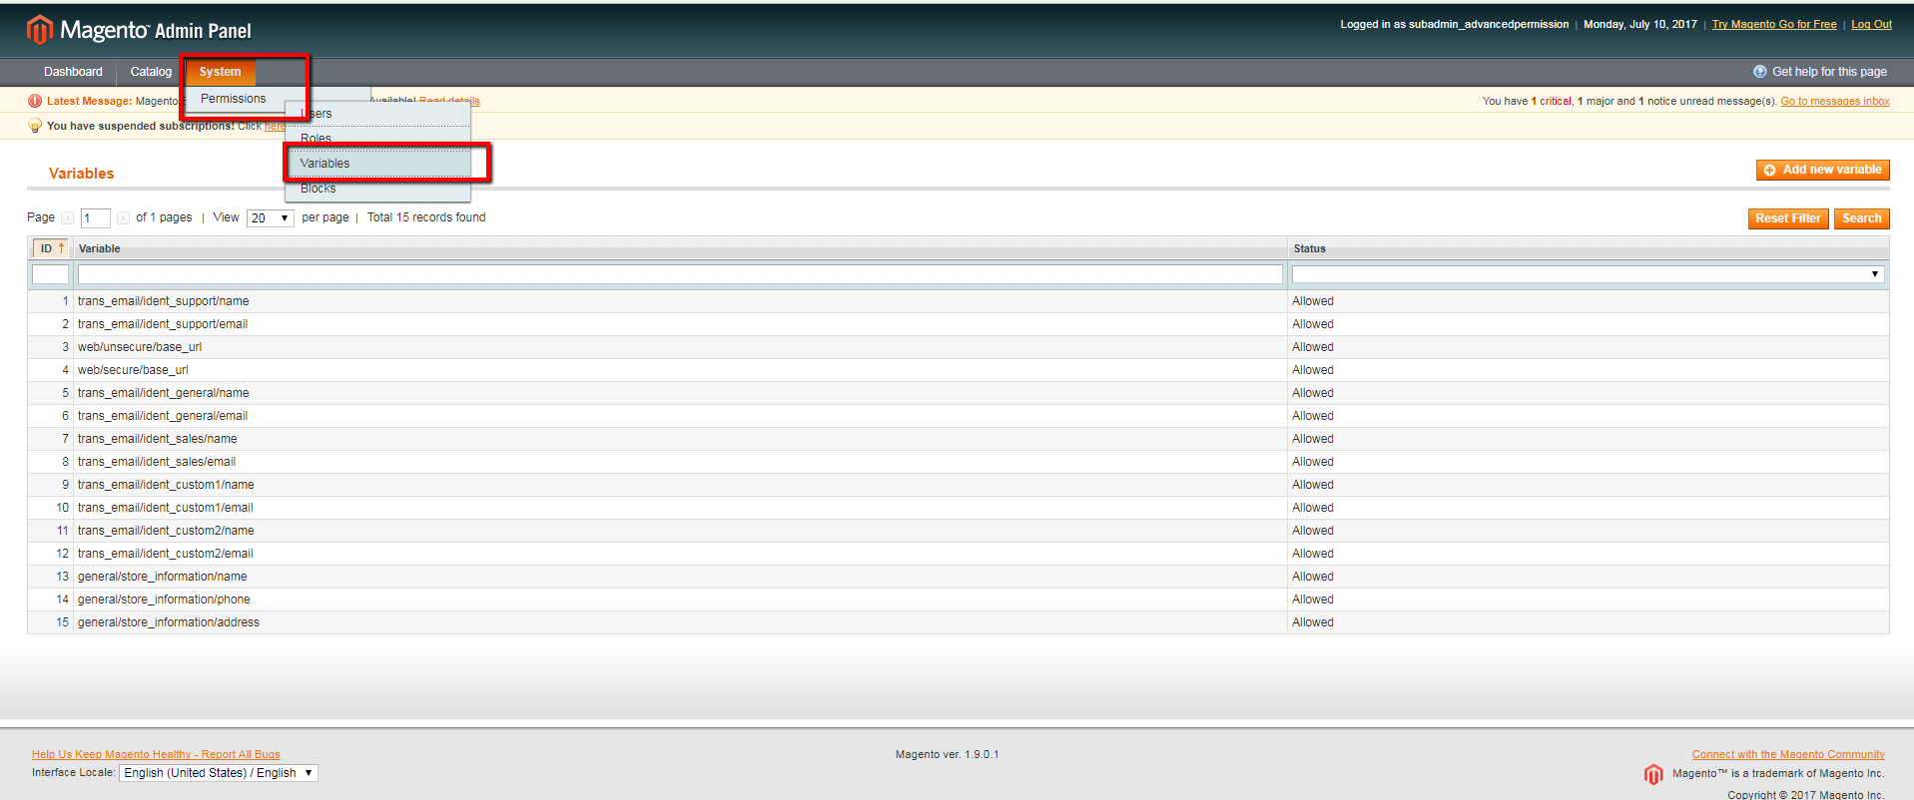

- A list of all the created variables shall be displayed in this section
- Admin can edit each variable
- Click Add New Variable tab, to add a new user to the list
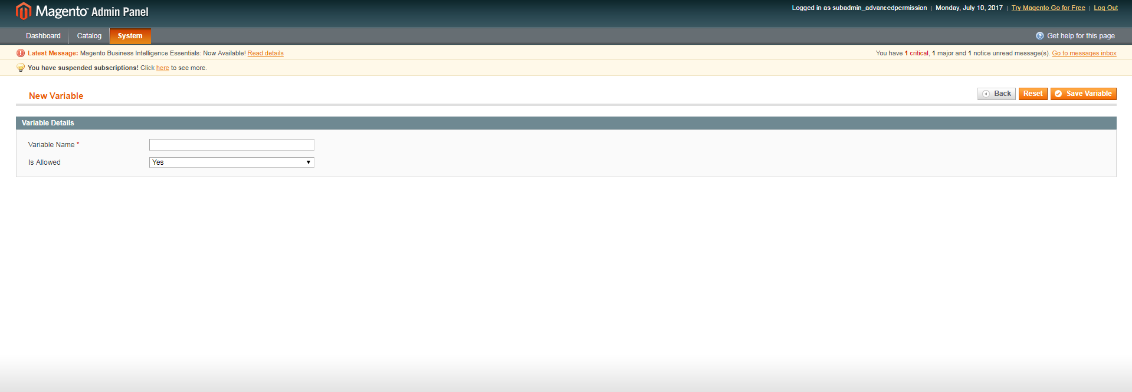
General Tabs
- Variable name: Enter variable name
- Is allowed: Select YES/NO to activate the variable

