Ajax Add to Cart

Published: JANUARY 09, 2017

Extension User Guide

Module version: 1.9.3.1

Magento

Contents
Ajax Add to Cart 3
1. Configuration 4
1.1 Ajax Catalog Settings 5
2. To access the Magento Frontend for Ajax Add to Cart 6

Ajax Add to Cart

Overview
The Ajax add to cart extension will help to add products to shopping cart directly from the category and the product pages without reloading the page every time, using Ajax operations. This extension also provides add to compare and add to wish-list feature by Ajax operations from product and category pages. In shopping cart page, users can add cross-sell products to cart, compare and wish-list directly using the Ajax add to cart extension without page reload. This extension also allows users to add products to cart directly from wish list page. User would be able to add all types of products: simple, configurable, bundled, grouped, virtual and downloadable from the category page itself. For the products which require options to be selected before adding to cart (configurable, bundled or grouped), a light box iframe window will come up showing the options to be selected by user before adding products to cart. Ajax add to cart extension increases your sales by allowing your customers to shop continuously without several page reloads.
Features
- Add to cart button for category listing page and product detail page
- Add to wish-list/add to compare buttons for category listing page and product detail page
- Apply Ajax on toolbar at product listing page for paging, sorting, previous and next buttons
- Apply Ajax on cart page for adding cross-sell products
- Delete products from cart page
- Delete/remove products from sidebar compare
- Add products to cart from wish-list page
- Configurable from admin area for all parts

1. Configuration
To access the Magento backend administration environment
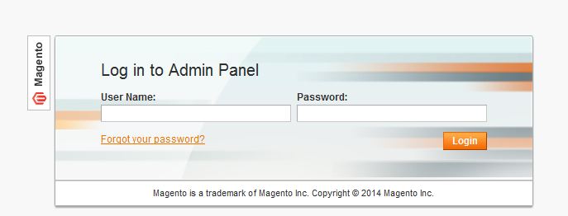
- Log in using user name and password

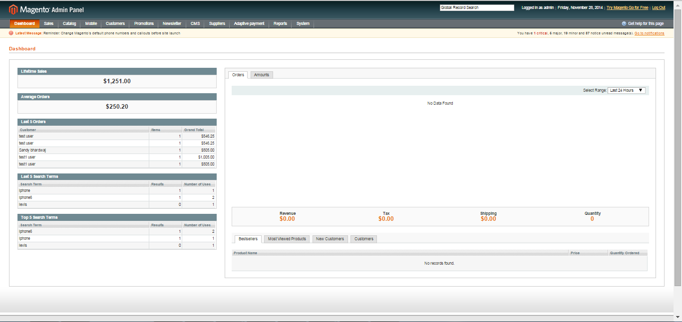
- Click Login button to display administration panel

1.1 Ajax Catalog Settings
Select System > Configuration > Ajax for Catalog from admin panel

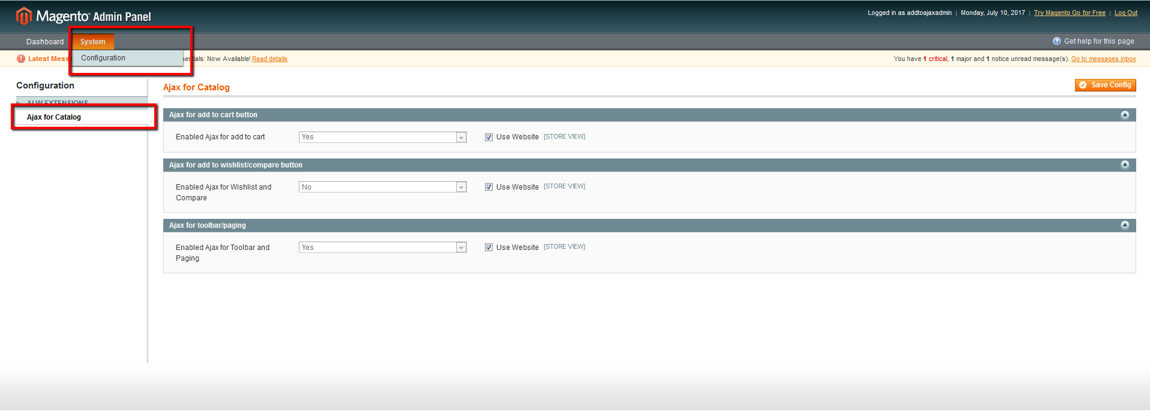
General Tabs
- Enable Ajax Add to Cart: Select YES/NO to enable to disable extension on frontend
- Enable Ajax for Wishlist and Compare: Select YES/NO to enable or disable Ajax add to cart for wishlist & Compare
- Enable Ajax for Toolbar & Pages: Select YES/NO to enable or disable Ajax add to cart for Toolbar & Paging

2. To access the Magento Frontend for Ajax Add to Cart

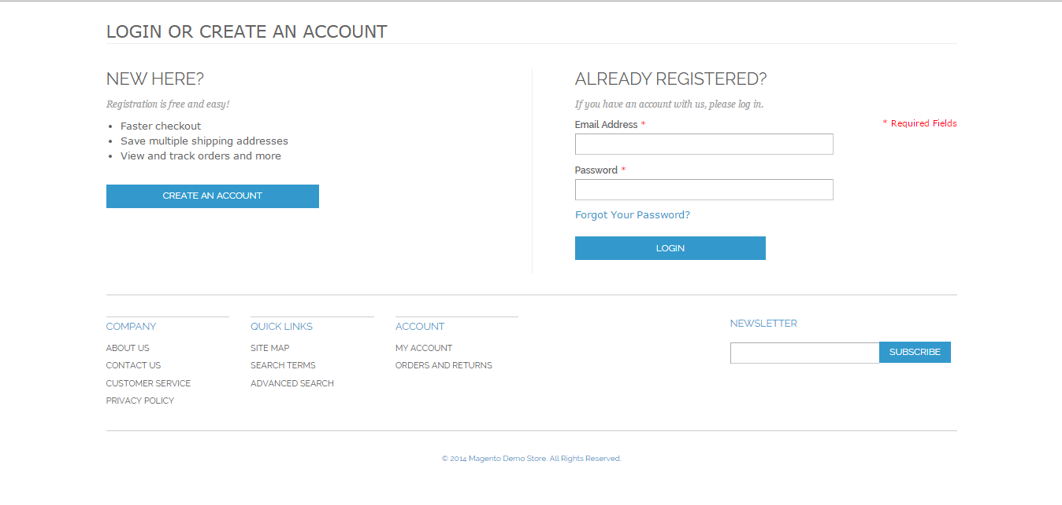

- Select product category from top navigation
- On product listing page, click ADD TO CART
- It shall show a loader and product gets added to cart
- Change pagination: It shows Ajax loading on changing the pagination on product listing page
- Add product to wishlist: Shows Ajax loading on adding product to wishlist
- Add product to compare: Shows Ajax loading on adding product to compare list
- Delete item from cart: Shows Ajax loading on deleting any item from the cart page
- Add cross-sell products: Shows Ajax loading on adding cross-sell products to cart
