Auto Complete Search

Published: JANUARY 12, 2017

Auto Complete Search

Extension User Guide

Module version: 1.9.1.1

Contents
Auto Complete Search 3
1. Configuration 4
1.1 General Settings 5
2. Frontend 6
2.1 To access the Magento Frontend for Search Auto Complete 6

Auto Complete Search

Overview
The Auto Complete Search extension provides suggestions and makes it simple for your customers to find exactly what they need; quickly and conveniently. This extension is AJAX-based, so it doesn’t load your full database of products; load only those which have been matched. It allows your store visitors to navigate directly to their desired product pages, completely by passing the search results page.
Features
- Shows product images in the search results
- Searches only after the third character has been entered
- Ability to hide out of stock products
- Option to show customizable header & footer of the search result, if there are no search results in header or footer
- Ability to search by any product text attribute
- Customizable product thumbnail dimension
- Customizable search delay
- Option to open search result link in a new window
- Sort search results in alphabetical order
- Uploadable pre-loader image
- Ability to limit items displayed in drop down list
- Customizable search item layout
- Searched keyword shows highlighted
- Store-wise enable/disable functionality for auto-search extension
- Allows default Magento search to work, if this auto search is disabled for a particular store

1. Configuration
To access the Magento backend administration environment
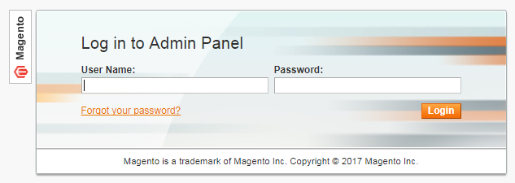
- Log in using user name and password
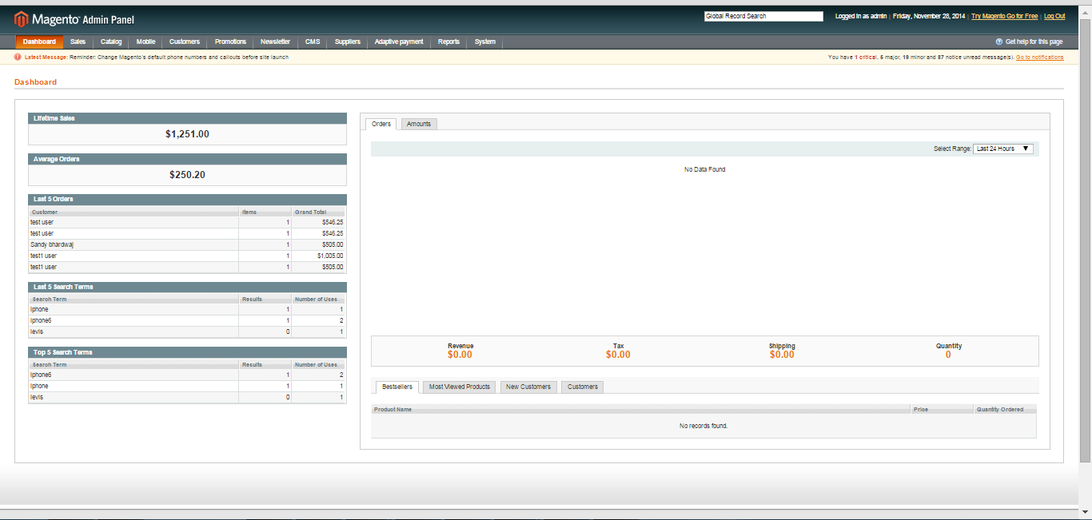
- Click the Login button to display the administration panel

1.1 General Settings
You can access following path System > configuration > Search Auto Complete and suggestion
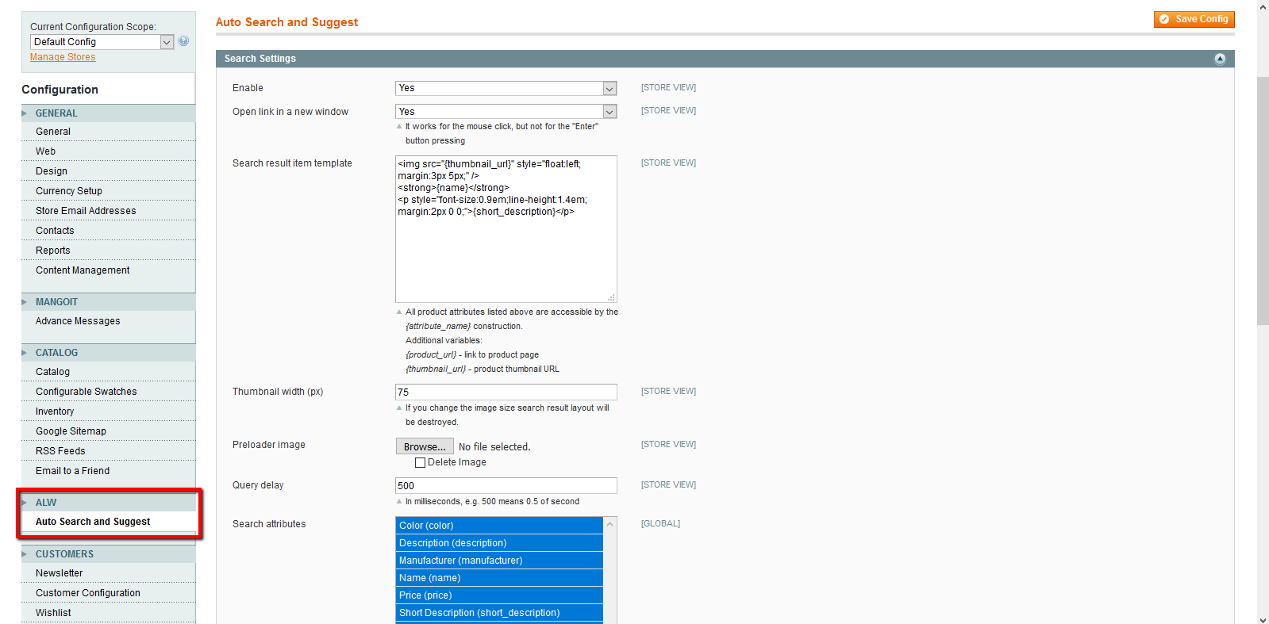
General Tabs
- Enable: Select Yes/No to enable or disable Auto Complete search extension
- Open link in a new window: Select Yes/No to open searched product on mouse click in same tab or new tab
- Search result item template: Setting to the layout of searched product grid
- Thumbnail width: Enter value in pixels to set thumbnail image width
- Pre loader image: Upload the image which will be displayed when the search result is getting load
- Query delay: Setting to delay searching in milliseconds after three words typing
- Search attributes: Setting to select search attribute. On the basis of attribute search result will be display

2. Frontend

2.1 To access the Magento Frontend for Search Auto Complete

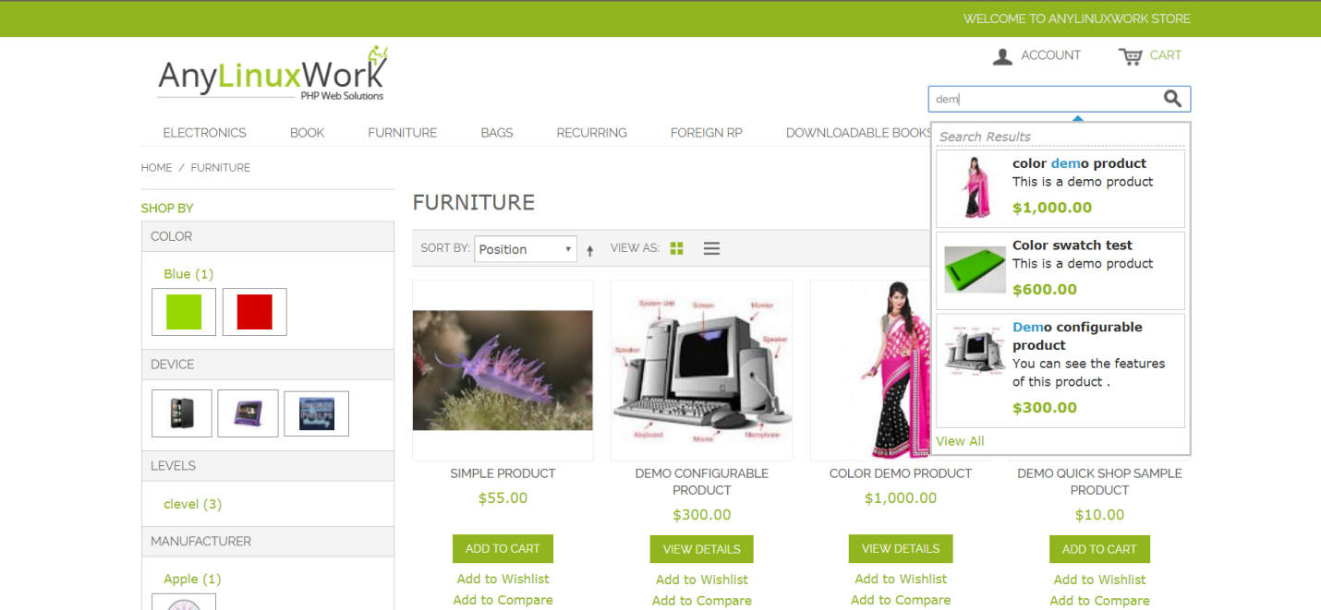
- Enter the Frontend URL
- Enter at least three keywords into the search field
- Search result test will display highlighted according to entered keyword

