CC Avenue

Published: JANUARY 13, 2017

Extension User Guide

Module version: 1.9.1.1

CC Avenue

Contents
CC Avenue Payment Gateway 3
1. Configuration 4
1.1 Details 5
1.1.1 CC Avenue Redirect Log 5
1.1.2 CC Avenue Response Log 6
1.1.3 Setting Up the CC Avenue Payment Gateway 6
2. Frontend 7

CC Avenue Payment Gateway

Overview
CC Avenue Payment Gateway Extension easily integrates your Magento store with the CC Avenue payment gateway. The CC Avenue Payment Gateway stores all transactions to and from CC Avenue, which are logged for future reference. This gateway helps to view all the previous transactions from CC Avenue in Magento Store admin.
All transactional logs can be exported to CSV or Excel XML to share with the technical support or any other reason. It works with all currencies, provided the base currency of your Magento store is the same as that of your CC Avenue currency.
Features
- Provides an additional Payment Gateway option to the customers
- Checkout using the CC Avenue Payment Gateway
- Stores all transactional details in separate log files for redirect as well as response URLs
- For applying this feature, you need to subscribe to CC Avenue account registration
- Once you verify your account on the site, you will have to fill an information form about your store on the CC Avenue website at the following link
Settings & Options > General Settings > Update details

1. Configuration
To access the Magento backend administration environment
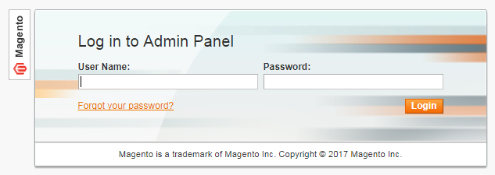
- Logging in with valid admin user credentials
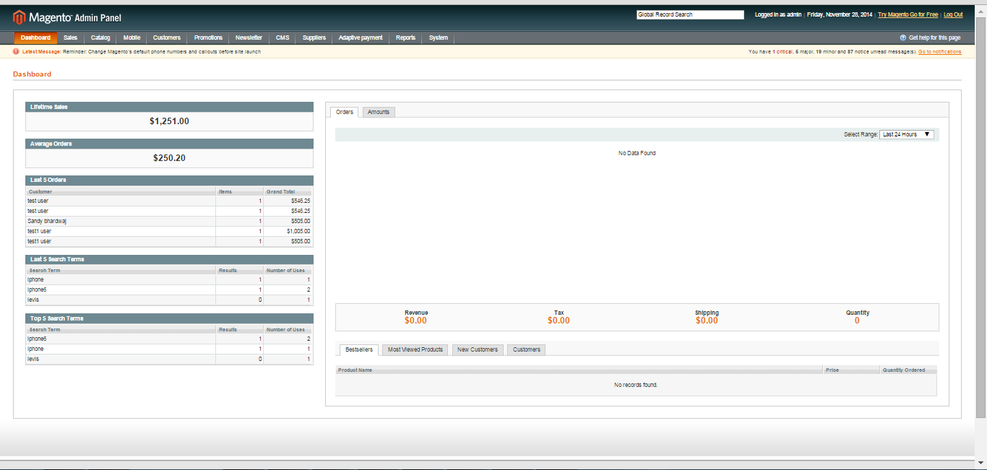
- Click the Login button to display the administration panel

1.1 Details
- All transactions to and from CC Avenue are logged for future reference. You can access these logs in the Magento admin in the new menu called "CC Avenue Logs" by navigating to
CC Avenue Logs>Redirect Log
Or
CC Avenue Logs>Response Log

- All transactional logs can be exported to CSV or Excel File

1.1.1 CC Avenue Redirect Log
This log saves the data for the transactions when the website is redirected to the CC Avenue URL for payment. It stores the redirect URL for the current store

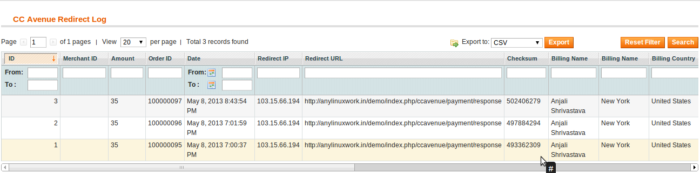

1.1.2 CC Avenue Response Log

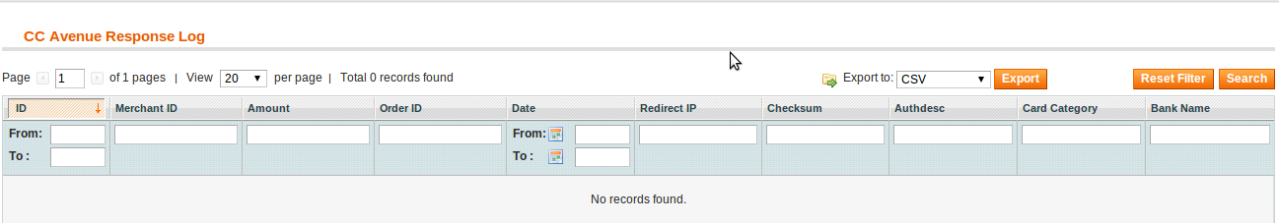
This log saves the data for the transactions when the control is redirected to the store website after successful payment from the CC Avenue Gateway. It stores the redirect IP for returning back to the website

1.1.3 Setting Up the CC Avenue Payment Gateway
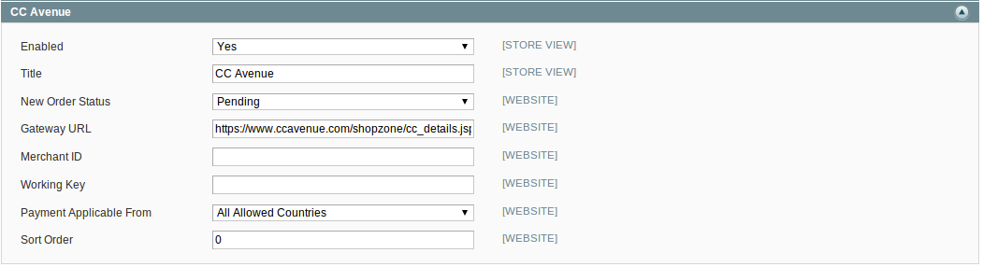

- Enabled: Select the option Yes to enable the payment method
- Title: Enter the name of the payment method that will be displayed to the customer in the Payment Information section of the Shopping Cart Checkout page. This parameter can be set up for each store view
- New Order Status: Select the order status of the new order placed
- Gateway URL: URL for the CC Avenue gateway
- Merchant ID: Enter the merchant account id registered with CC Avenue
- Working Key: Unique key of merchant provided by CC Avenue
- Payment Applicable From: Select the countries where this payment method can be used
- Sort Order: When using several payment methods, the Sort Order field will determine the order in which this method will be displayed in the Payment Information section on the checkout page

2. Frontend
In the checkout process, a customer will now be able to see “CC Avenue Payment Gateway” option along with other payment options like PayPal Checkout, Credit Card, and Internet Banking etc
