Module version: 1.9.1.1

Extension User Guide

Color Swatch

Color Swatch

Published: JANUARY 05, 2017

Contents
Color Swatch 3
1. Configuration 5
2. Manage Color Swatch 6
3. Configurable Color Swatch 7
4. Frontend 8

Color Swatch

Overview
The Color swatch is an extension for Magento that helps users to view different color option for a product. It is basically for configurable products. This extension allows customers to view color swatches on the product detail page as well as product listing page along with the drop down option. With this extension, the product attributes such as color, size, and types can be displayed as thumbnail images. Color swatch helps your customer to see how a product looks in different colors, shapes or designs. The product images and its more view will reload based on the selection. There’s a facility to zoom in the product image by magnifying it to have a proper look also you can enable pop-up window from admin to see larger product image by clicking on product main image.
Combined effectiveness of Color Swatch and zoom extensions gives an extension with multiple functionalities. Firstly, you get all the features of the color swatch extension of which the most important is– simplicity of installation, compatibility with all versions of Magento, the ability to show product attribute options as swatches on configurable products regardless of the type of the attribute (color, size, manufacturer, etc.), changing of product images and prices, the possibility of applying to multiple attributes of a single product with the possibility of uploading different swatch images for each of those attribute options.
It is an easy and flexible way to create the professional looking color swatch for your Magento store. This extension works with all versions of Magento and it comprises the functionality of color swatches and zoom.
Features
- Easy installation and integration
- Shows your product attribute options as swatches on configurable products on product listing page
- Shows your product attribute options as swatches on configurable products on product detailed page
- Changes the product images and prices as well as the more views images depending on the swatch selection
- Gives you option to upload different swatch images for your attribute
- Can be applied to multiple attributes on a single product
- Image size configurable via Magento administration
- Can be used together with Magento default drop down boxes on configurable products
- Shows zoom on all your products
- Also On changing the drop down, images and swatches will be changed
- Set up the size of the main product image in administration
- Enhances the Magento more view images functionality with zoom
- Set up more view thumbnail size in administration
- Set up zoom box size in administration
- Enable/disable pop-up box from administration
- Set up large image pop-up box size in administration
- Allow more view images to update the main image and can be enabled/disable this feature from administration
- Allow to change more view images when loading the main image and can be enabled/disable this feature from administration
- Gives facility to search attributes in administration

1. Configuration
To access the Magento backend administration environment
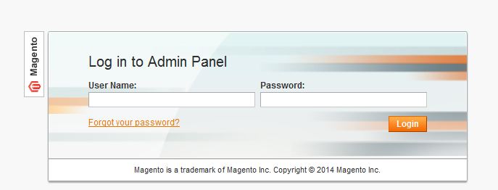

- Log in using user name and password

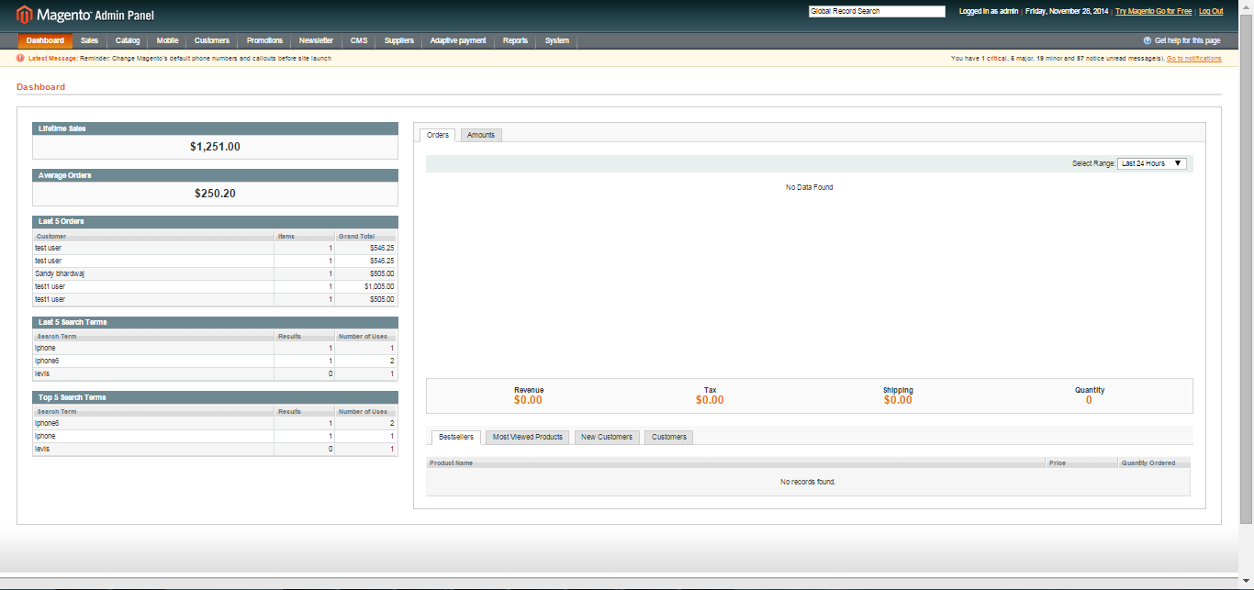

- Click the Login button to display administration panel

2. Manage Color Swatch
You can manage Color Swatch following path Catalog > Color Swatch
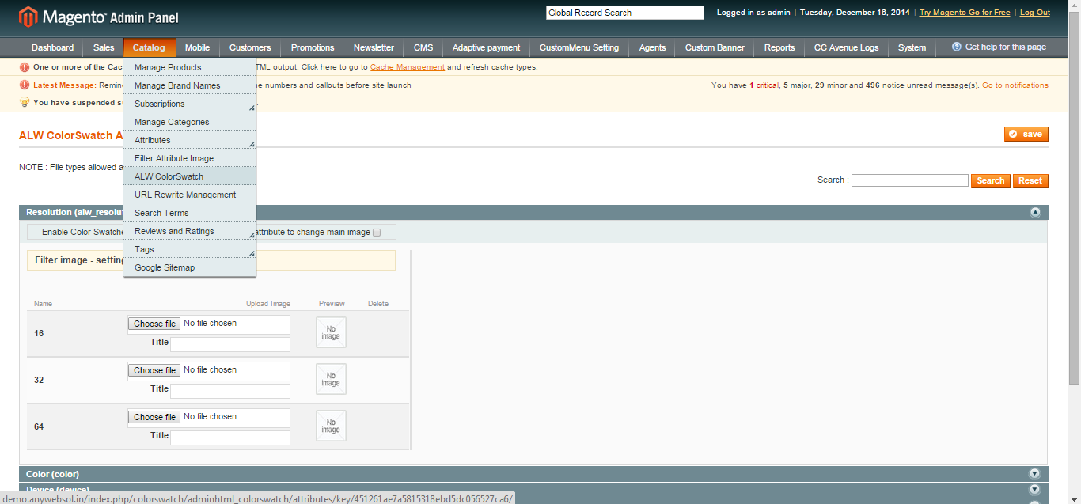
Color Swatch helps customer to see how a product looks in different colors, shapes or designs. The product images and its more view will reload based on the selection. There’s facility to zoom in the product image by magnifying it to have a proper look also you can enable pop-up window from admin to see large product image by clicking on product main image.
- You can browse and upload images for different attribute values
- Enable color swatch for this attribute: By checking this, you can enable color swatch for this attribute
- Allow attribute to change main image: By checking this, you can allow to change the main image on selection of different attributes

3. Configurable Color Swatch
You can access following path System > Configuration > Catalog > Color swatch
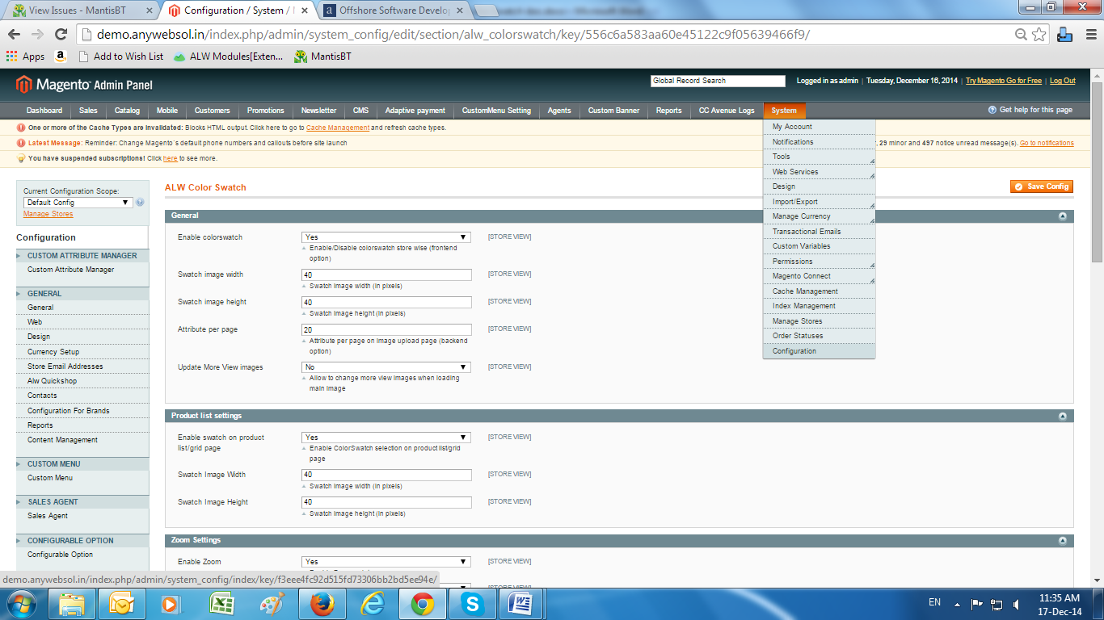
General Tabs
- Enter Details
- Enable/Disable color swatch
- Swatch image width
- Swatch image height
- Value for number Attribute per page
- Yes/No more view images on frontend

Product List Settings
- Enter Details
- Select Yes/No Enable swatch on product list/grid page
- Swatch image width
- Swatch image height

Zoom Settings
- Enter Details
- Yes/No to enable zoom on images
- Allow more view images to update main image
- Width of image
- Height of image
- Thumbnail width
- Thumbnail height
- Select Yes/No to enable popup window when zoomed
- Width of light box image
- Height of light box image

4. Frontend
- The product detail page shows the different color options available for the product
- The color options are displayed as thumbnail images
- On the selection of the color swatch, the product image, product price will be display for that color option. Also, the color gets selected in the drop down and vice versa on Product listing page
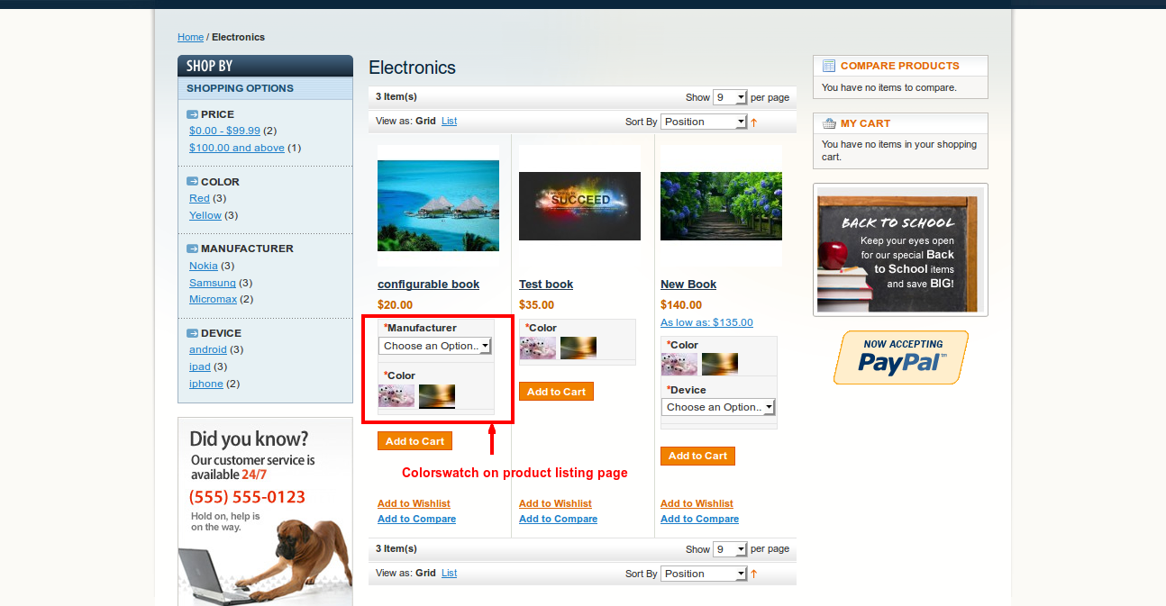

- Shows the pop up box on clicking on product image if zoom functionality enable
- Option to signify image with zoom in feature

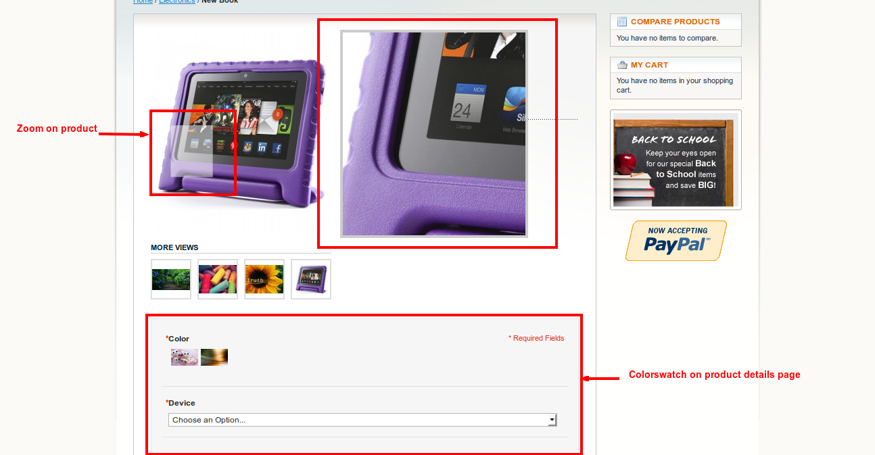
- On the selection of the color swatch, the product image as well as the different views, product price will be show for that color option. Also, the color gets selected in the drop down and vice versa on product details page

