Published: JANUARY 14, 2017

Configurable Catalog

Configurable Catalog

Module version: 1.9.1.1

Magento

Contents
Configurable Catalog 3
1. Configuration 4
1.1 Settings 5
2. Frontend 6
2.1 To access the Magento Frontend for Configurable Catalog Extension 6

Configurable Catalog

Overview
Generally we know that when a customer chooses a configurable product from an eCommerce site based on Magento, he will be able to actually choose the variants only on the product details page. He is not able to choose the variants on the product list. This makes the user browse an extra page like category page for choosing the variants. The configurable catalog extension serves as a solution to this.
This extension allows a customer to choose configurable products, get updated price according to the variants of the selected configurable product from drop down and then add product to cart directly from the product list page. This enables the purchase of configurable products directly from
- Product category page
- Search result page
Features
- Gives option to choose the product variants of a configurable product from the product category page itself and add it to cart directly
- Gives option to choose the product variants of a configurable product from the search result page itself and add it to cart directly
- User does not need to go to the product details page to choose the variants of the configurable product, thus saves browsing time

1. Configuration
To access the Magento backend administration environment
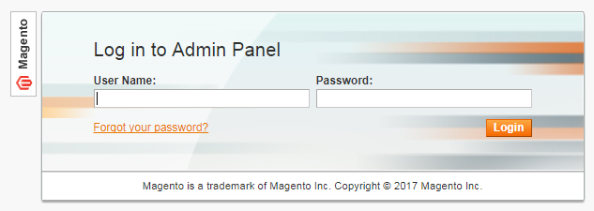
b) Logging in with valid Admin user credentials
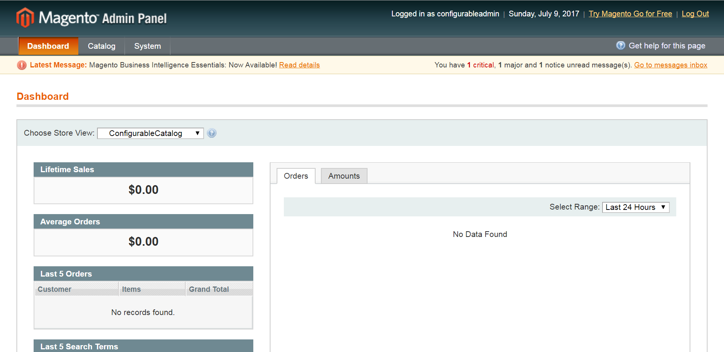
- Click Login button to display administration panel

1.1 Settings
You can access following path System> Configuration> Configurable Option Settings
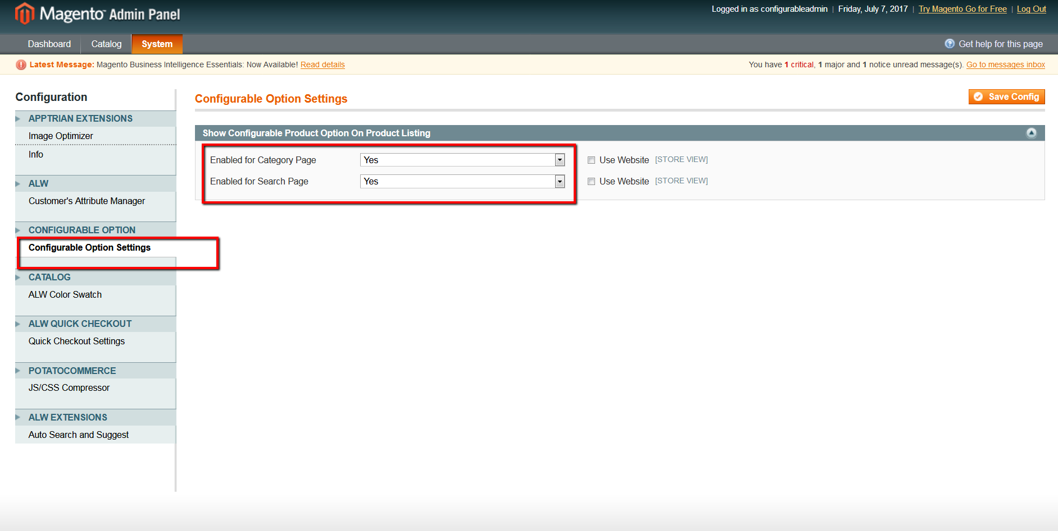
General Tabs
- Configurable options settings: System configuration option
- Enabled for Category Page: Enable/Disable functionality to choose variant/attribute from product category page
- Enabled for search Page: Enable/Disable functionality to choose variant/attribute from product search page

2. Frontend

2.1 To access the Magento Frontend for Configurable Catalog Extension
a) Variants/attributes to choose for the configurable product on product category page
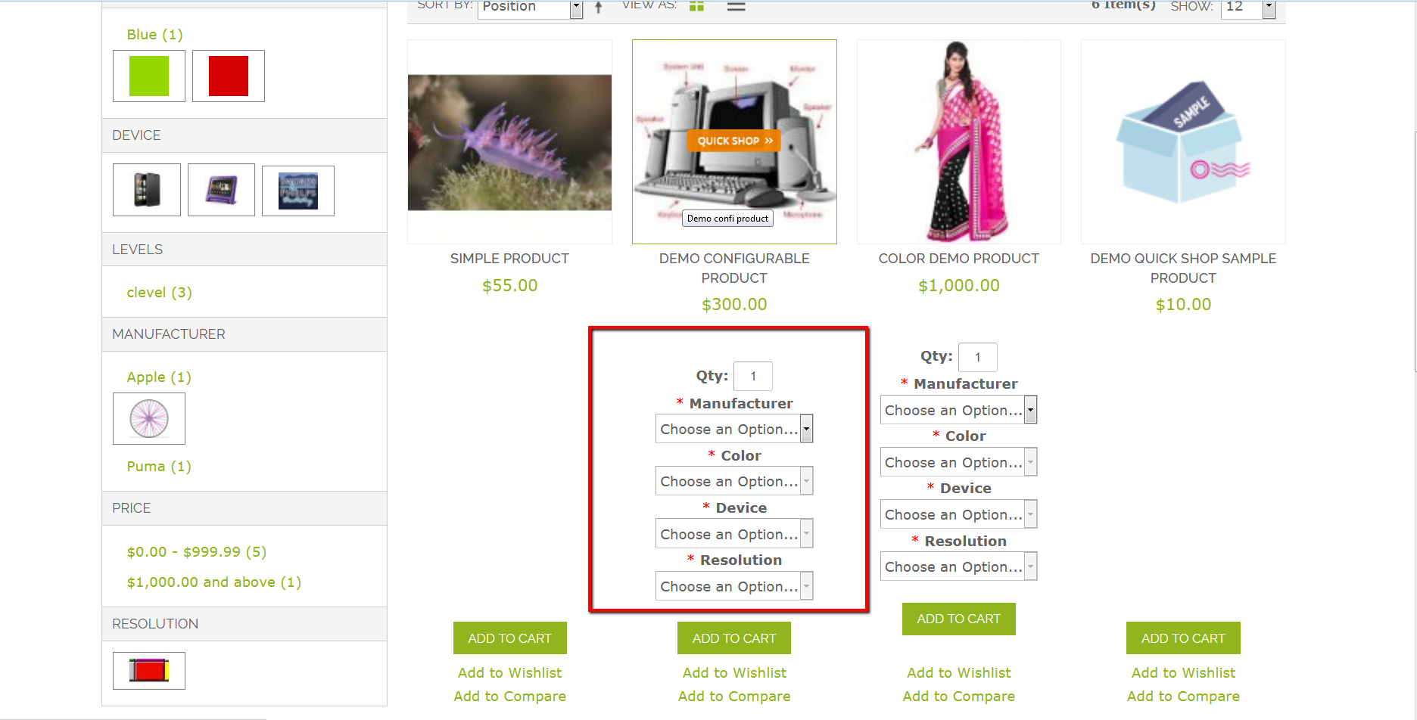
b) Choose variants/attributes from search result page