Module version: 1.9.8.1

Extension User Guide

Custom Banner With Lazy Loading
Custom Banner With Lazy Loading

Published: JANUARY 16, 2017

Contents
Custom Banner with Lazy Loading 3
1. Configuration 4
1.1 Manage Custom Banner 5
1.2 Manage Custom Banner groups 7
2. Custom Banner Configuration 9
2.1 Frontend 10

Custom Banner with Lazy Loading

Overview
All shop owners know that Custom Banner images play an important part. However, there is one problem with this. The more images the site has as banners, the slower the site loads and utilizes more bandwidth. A very good solution to this is to load the site’s banner images on demand, or what is most commonly known as lazy loading.
This extension is for Custom Banners With Lazy loading. It delays loading of images in long web pages. Images outside of viewport (visible part of web page) won’t be loaded before user scrolls to them. There is banner code for the banner to display on any CMS page. It uses Prototype and jquery JavaScript for lazy loading of banner images.
Features
- Applicable for simple Custom Banners manageable by admin
- Improves the site speed when using lazy loading for images of the banner
- Effective for banners with slide show having animated effects like fade in-fade out, blind up, puff, fold, grow etc.
- Uses image resizing to display the banner image so that the image is not distorted
- The Banner code can be used for different store pages

1. Configuration
To access the Magento backend administration environment

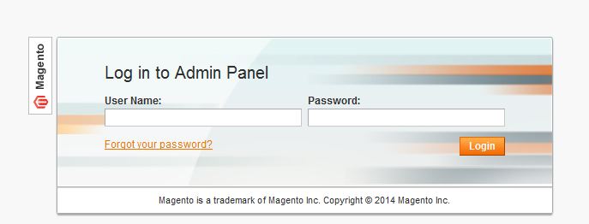

- Log in using the user name and password

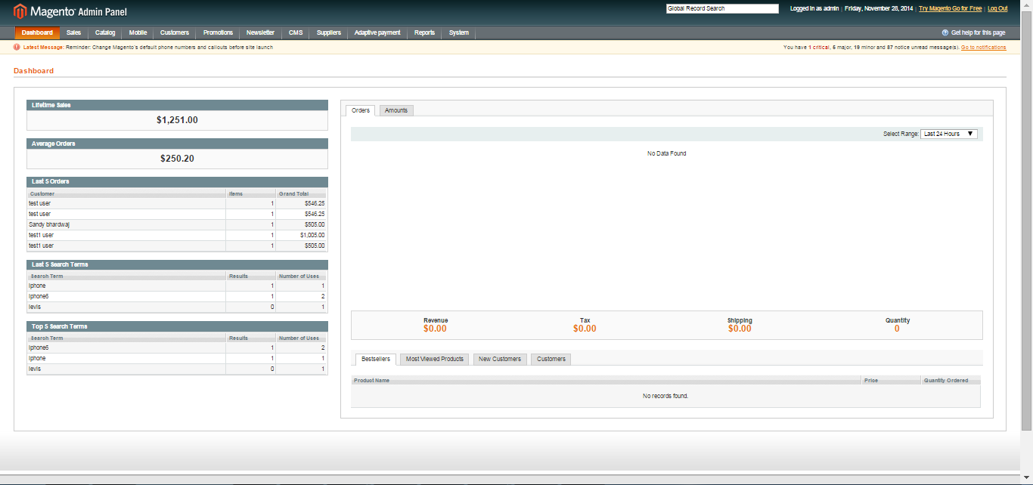

- Click the Login button to display the administration panel

1.1 Manage Custom Banner
You can access following path Custom Banner>Manage Custom Banner
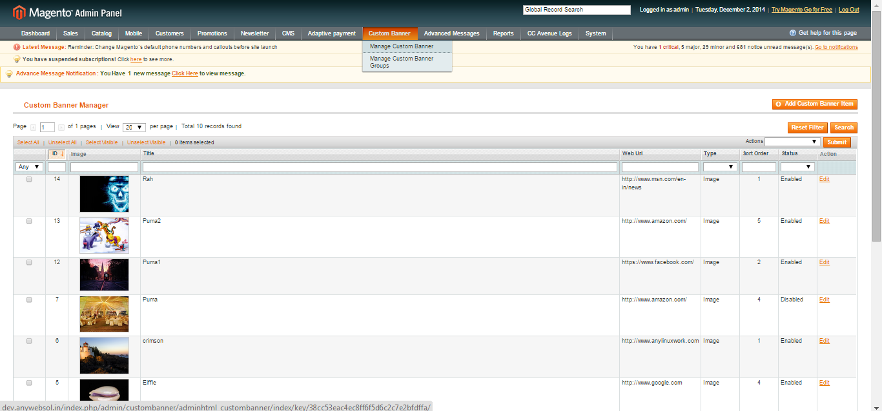

General Tabs
- Search: One can filter search on the basis of id, title; web URL, type, Sort order, status of banner
- Action: One can perform actions on the list of custom banners created like change status of selected or remove
- Reset Filter: To reset the filter applied on Custom Banner items
- Edit: To edit already created banners
- Add custom banner item: To create a new banner item to list
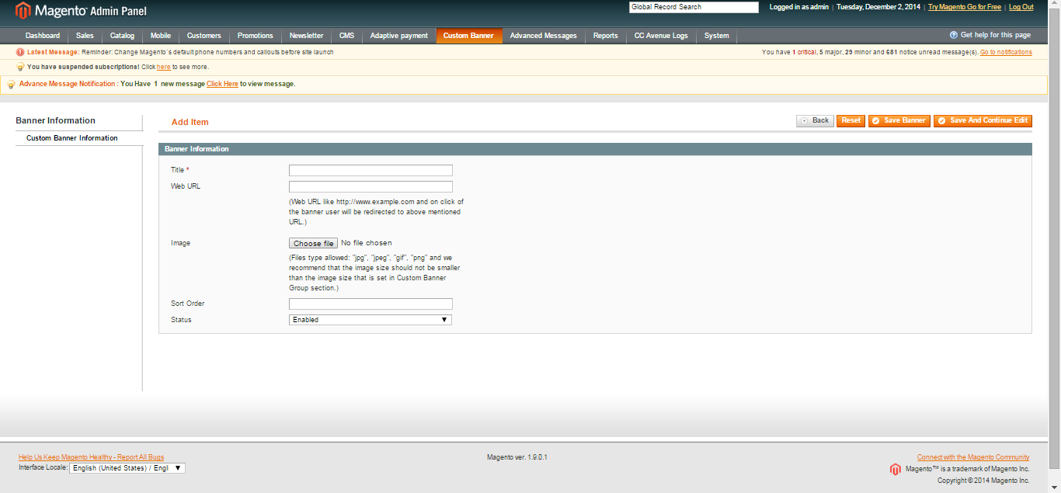
General Tabs
- Title: Defines title of banner item
- Web URL: Defines link, when clicked on banner images to which will redirect
- Image: Defines image to upload for banner
- Sort order: Defines order in which the images will be displayed when slide
- Status: Defines to enable the banner or not
- Save banner: It will save the created banner
- Reset: It will reset all entered fields

1.2 Manage Custom Banner groups
You can access following path Custom banner > Manage Custom Banner groups
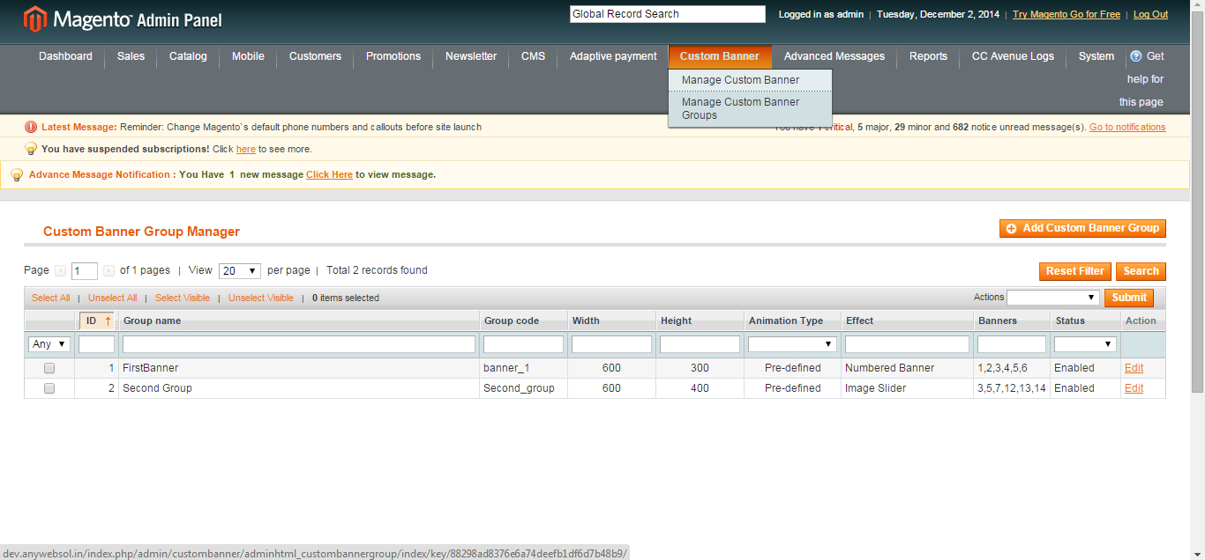
General tabs
- Actions: To perform actions on created brand products such as remove, change status of product
- Search: One can filter the created brands on basis of group name, group code, animation type, effect, banners, status, width & height
- Reset filter: To reset the applied filter on banners
- Edit: One can edit already created Custom Banner groups
- Add Customer group: To add new Custom Banner group

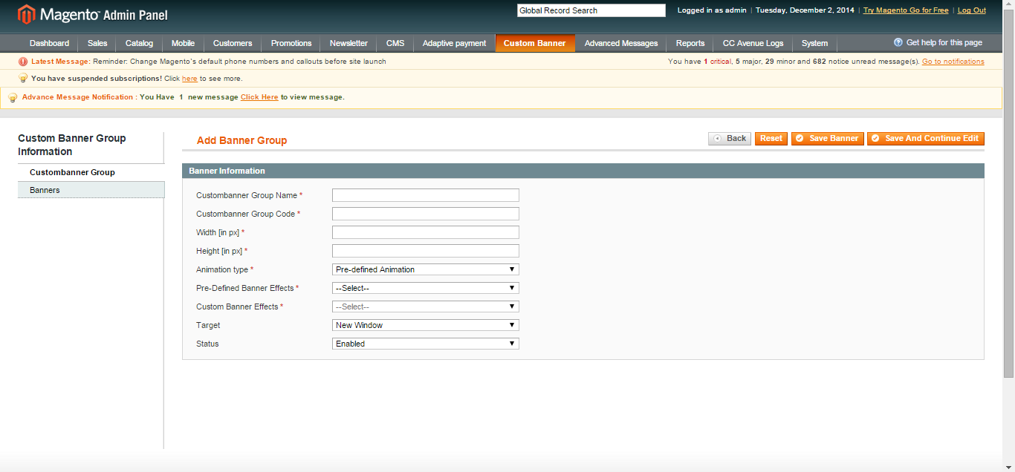

General Tabs
- Custom Banner group name: Name of group to be added
- Custom Banner group code: Code of created group
- Width: Enter width of banner group
- Height: Enter height of banner group
- Animation type: Select animation type from dropdown
- Pre-defined banner effects: Select and activate effect from dropdown
- Custom Banner effects: Select and activate effect from dropdown
- Target: Select from dropdown
- Status: Enable/disable group
- Banners: Select banners from list to be added in group
- Various search option for admin to search banners from list like title, link, type, sort order
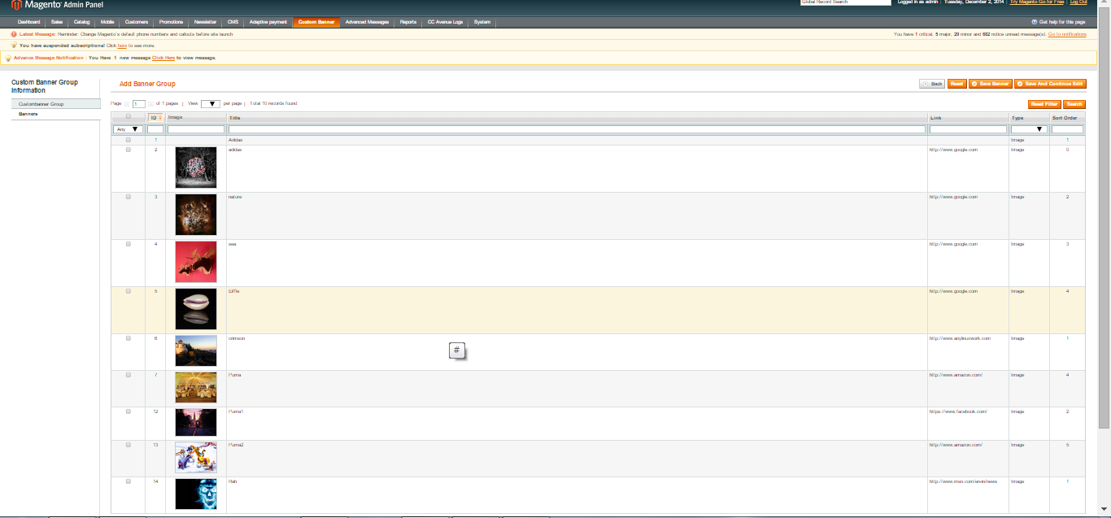

2. Custom Banner Configuration
You can access following path System > Configuration > Custom banner
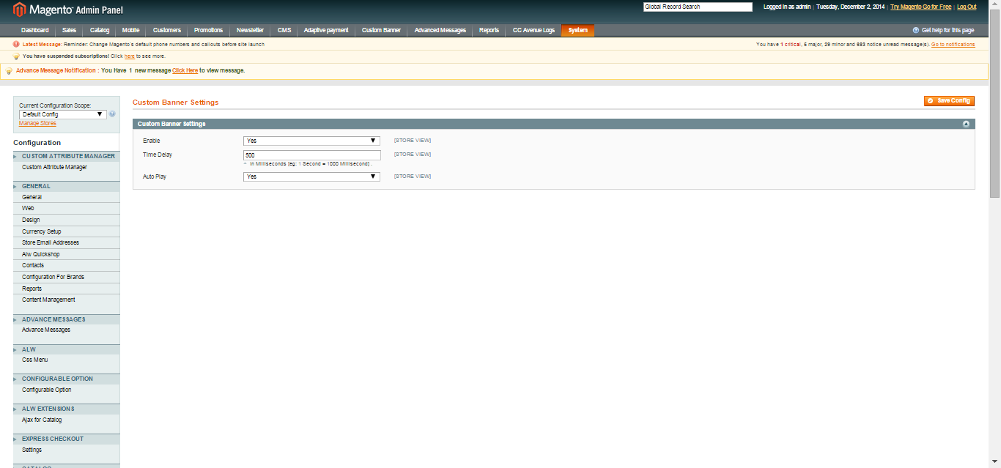
General Tabs
- Enable: Enable/disable custom banner extension
- Time delay: One can set the transition delay time in which images will slide
- Auto Play: Can Enable/disable auto play functionality for banner

2.1 Frontend

