Custom Menu

Published: JANUARY 17, 2017

Extension User Guide

Module version: 1.9.1.1

Magento

Contents
Custom Menu 3
1. Configuration 4
1.1 Settings 5
2. Frontend 8

Custom Menu

Overview
It allows displaying product categories in a more intuitive manner which enhances site design and hence makes it more attractive. The extension helps to decrease the loading time of website and hence increases an efficiency of the website. This not only increases the speed of the website but also an important factor when it comes to search engine rankings.

Features
- This feature displays all sub-categories at once
- By this feature, you can customize number of columns in drop-down
- Apply static block at bottom of each drop-down
- We can also set width of each static block
- Admin can decide to display empty categories: Yes/No
- Split categories left to right into columns: Allows changing the direction of columns filling with subcategories in the categories popup
- Right-to-Left format support
- Top offset is defined automatically if it is set to zero
- It displays product count for each sub categories
- Increase categories loading speed by creating its HTML at the time of category save before category page load
- Set visibility of category menu by enable or disable option

1. Configuration
To access the Magento backend administration environment
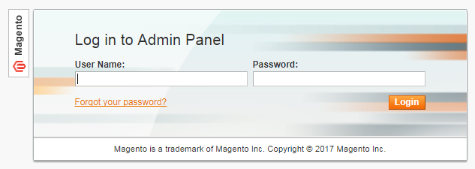
- Log in using the user name and password

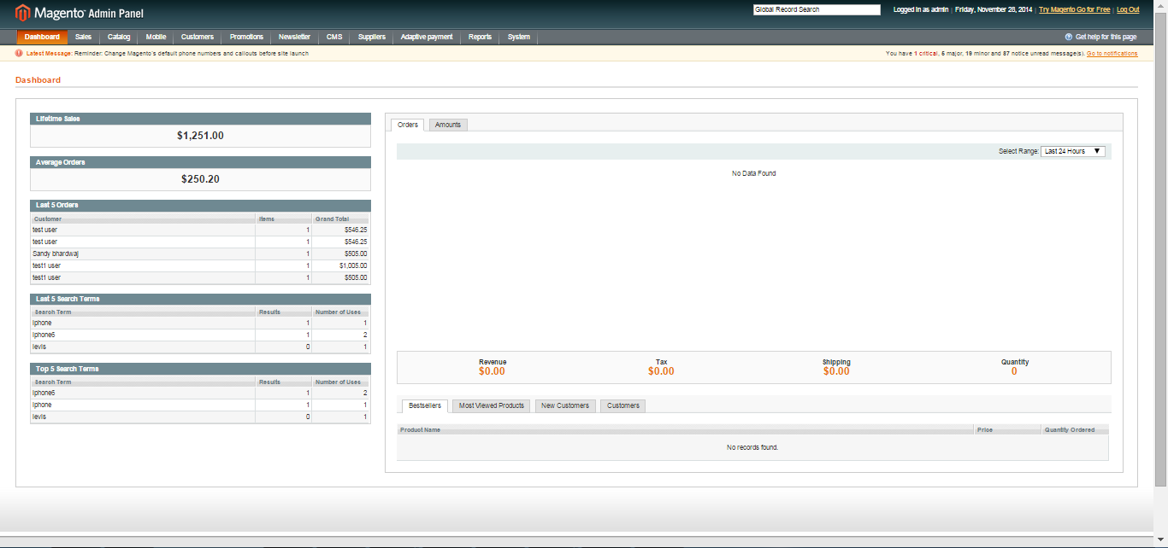

- Click the Login button to display the administration panel

1.1 Settings
Admin can access following the path- System > Configurations > Custom menu
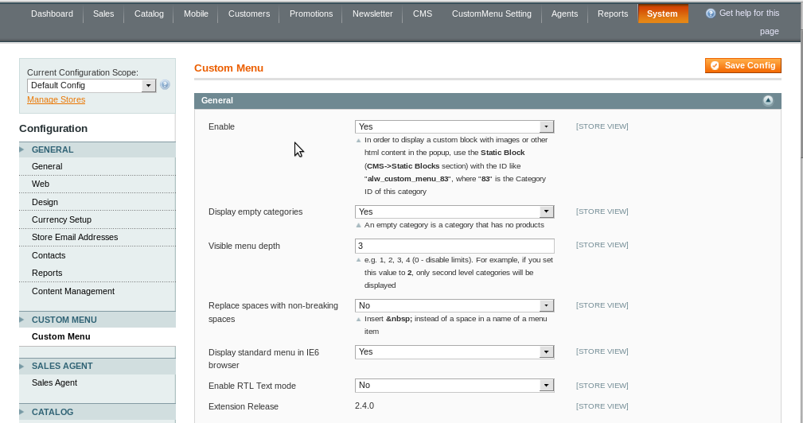
- Enable: This option enables or disables the custom menu on frontend
- Display Empty Categories: This option will enable or disable the view of categories if the category is empty. If an option is set to “Yes” then categories containing zero products will be displayed. If option is set to “No” then category with no or zero products will not be displayed on frontend

- Visible Menu Depth: Customises up to which category level should be displayed. For Example, if there are 4 level sub categories added i.e.

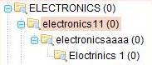
But if visible menu depth is set to 3 then it will be displayed as follows
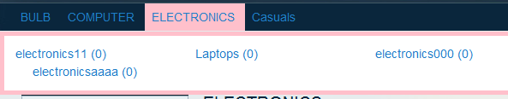
Column Tabs
- Number of Columns: In how many columns subcategories would be split up. For example, if sub-categories are 3 and number of columns field is entered as 3 then all the categories will be displayed in the individual column. For same categories as mentioned above, frontend view will be

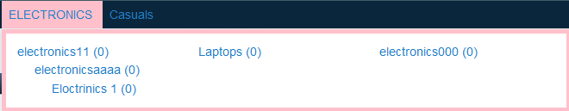

Note: “Number of columns” option will not work if “Merge small categories option” is set as “Yes”
- Split Categories Left to Right into Columns: This option splits the categories from left to right into columns if set to yes or else it set one by one depending on a number of columns selected

- Merge Small Sub-categories: The smart way to make columns fit more space effective. This option merges the subcategories into one column except for the extreme left categories. This options reflection changes according to “number of columns” value

Popup settings tabs
- Width (in pixels): This option is used to set the width of Pop up with subcategories. We recommend to set it to 0

- Top Offset (in pixels): This option is used to set the distance between top menu and pop up window. JavaScript uses this value for positioning, if you have a visible space between top menu and a pop-up you need to decrease top offset value. Do not forget to flush the cache after any change to custom menu settings

- Delay before Displaying (in milliseconds): This option is used to set the time delay in milliseconds before displaying the menu items

- Delay before Hiding (in milliseconds): This option is used to set the time delay in milliseconds before hiding the menu items

Note: After changing the values, the changed configuration needs to be saved and to reflect the changes on frontend according to saved configuration admin mandatorily needs to click on Custom Menu Setting > Update Custom Menu

2. Frontend
The new menu added as Custom Menu will be visible on Menu Bar
