Module version: 1.9.10.1

Extension User Guide

Custom Registration Fields

Published: JANUARY 18, 2017

Custom Registration Fields

Contents
Custom Registration Fields 3
1. Configuration 3
1.1 Settings 5
2. Frontend 8

Custom Registration Fields

Overview
Custom Registration Fields Extension allows admin to create custom fields for customer registration to fetch more information from a customer. Admin can add custom fields of input type text field, text area, dropdown, date, Yes/No field and multi-select type. Custom field’s values will be saved in customer database of store. The provided information will be visible and editable in my account area of the customer login. Admin can also view & update customer information in admin login in manage customer module.

Features
- Add new custom registration fields for users
- Define input type for the fields
- Completely manageable from admin section

1. Configuration
To access the Magento backend administration environment
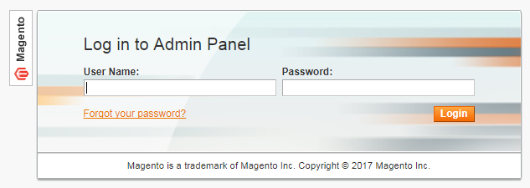
- Log in using user name and password

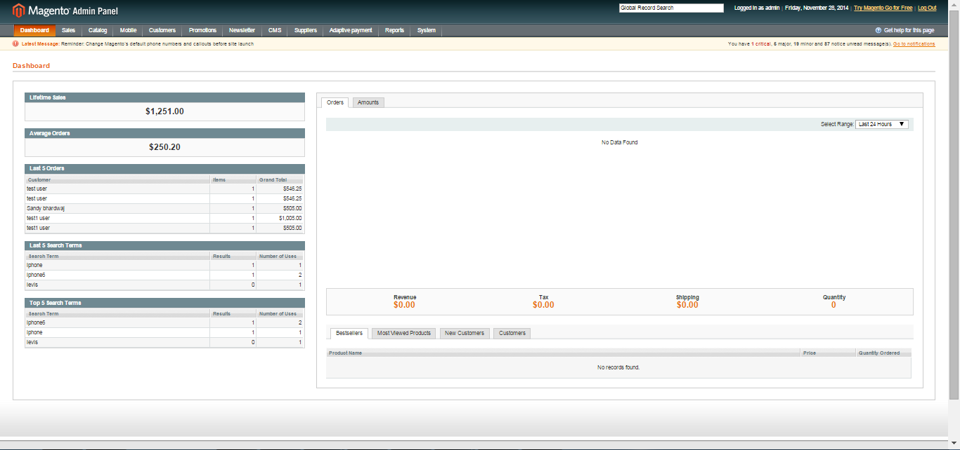

- Click Login button to display administration panel

1.1 Settings
a) Manage Properties- Customers > Attribute Manager > Customer’s Attributes > Properties

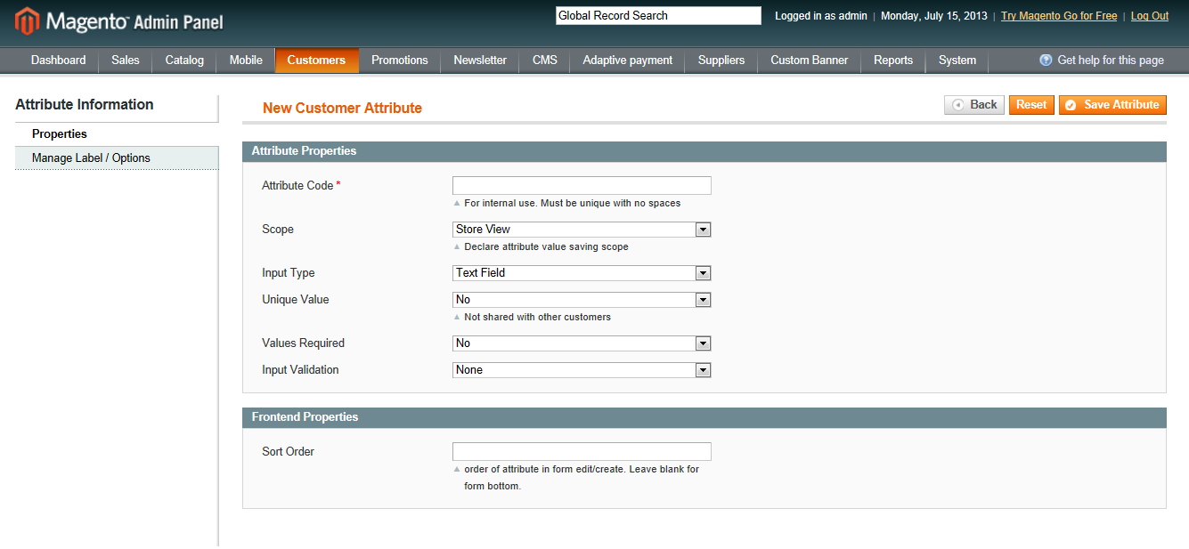
General Tabs
- Attribute Code: A unique code needs to provide for every new custom registration field defined by admin. This code should not have space

- Scope – Website/ Store view/Global: The defined customer attribute shall be displayed in relevant stores as defined by admin

- Input type : Admin can define a new customer attribute of the following types :
- Text field
- Text Area
- Date
- Yes/No
- Multi-select
- Drop down
- Unique Value: This option will define whether entered value in field should be unique or not

- Values Required: This option defines whether it is mandatory for customer to enter values in field or not

- Input Validation: This option defines what kind of values the customer can enter in defined customer attribute. The input value options are displayed based on the input type selected by admin. It has following options :
- None
- Decimal Value
- Integer
- Letters
- Email
- URL
- Date
- Letters or Numbers

- Sort Order: The sort order of the field shall sort newly customized registration fields in defined sort order
b) Manage Label- Customers > Attribute Manager > Customer’s Attributes > Manage Label/Options

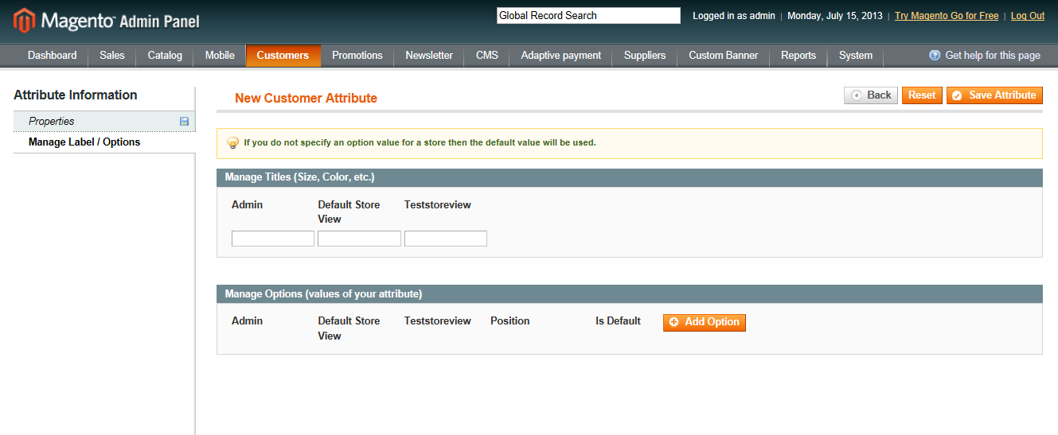
- Manage Titles: The field titles shall display field label as defined for store/global view here by admin
- Manage options – In case of drop down & multi-select field types, the options to be displayed in drop down/multi-select are defined here. The labels to be displayed can be defined store view wise
- Manage options – Position: In case of drop down & multi-select field types, the position of options to be displayed in drop down/multi-select are defined in this option
- Manage options – Default: In case of drop down & multi-select field types, the default selected value of options to be displayed in drop down/multi-select are defined in this option
- Admin will be able to add, edit and delete custom registration fields from this module. Also CSV export option is available to admin

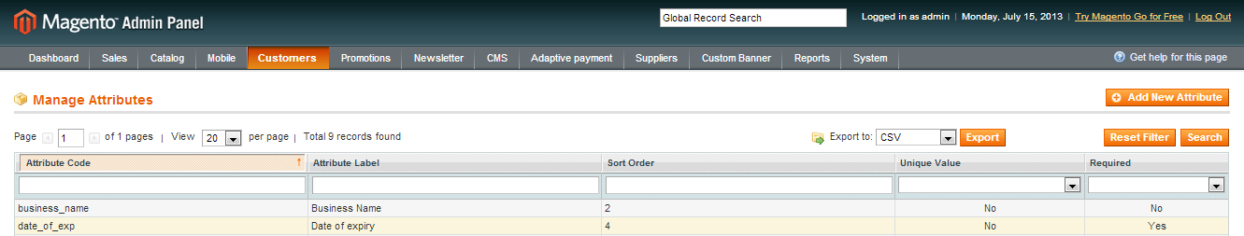

2. Frontend

The new fields added as custom registration field will be visible on customer registration form under last section
