Filter Attribute Option Image

Filter Attribute Option Image

Module version: 1.9.11.1

Published: JANUARY 19, 2017

Extension User Guide

Contents
Filter Attribute Option Image 3
1. Configuration 3
2. Manage Filter attribute Option image 4
3. Configuration for Filter Attribute Option Image 6

Filter Attribute Option Image

Overview
Filter Attribute Option Image Extension allows admin to upload images for filter attributes option. Admin can upload, delete or edit images for filter attribute option which has frontend input type select (e.g. colour, size, manufacturer, etc.) and can preview the uploaded images as well. The uploaded images will be visible in layered navigation block. Also, admin can easily search attribute by its name to upload images. If admin will not upload any image of attribute options, default name of attribute option will show up in layered navigation on frontend.
Features
- Easy installation and integration
- Option to upload images for your attribute options
- Shows your product attribute options images on frontend
- Gives you option to set attribute option image width and height from admin system configuration
- Provides you option to enable filter option images store wise from admin system configuration
- There is option to set attribute per page display in admin upload image page and apply pagination on basis of option value which you will set
- Gives you search option on upload image page and through this option you can easily search attribute by their name for which you want to upload images

1. Configuration
To access the Magento backend administration environment
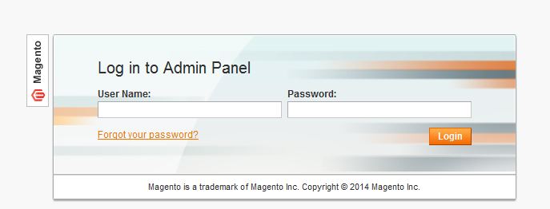
- Log in by using user name and password

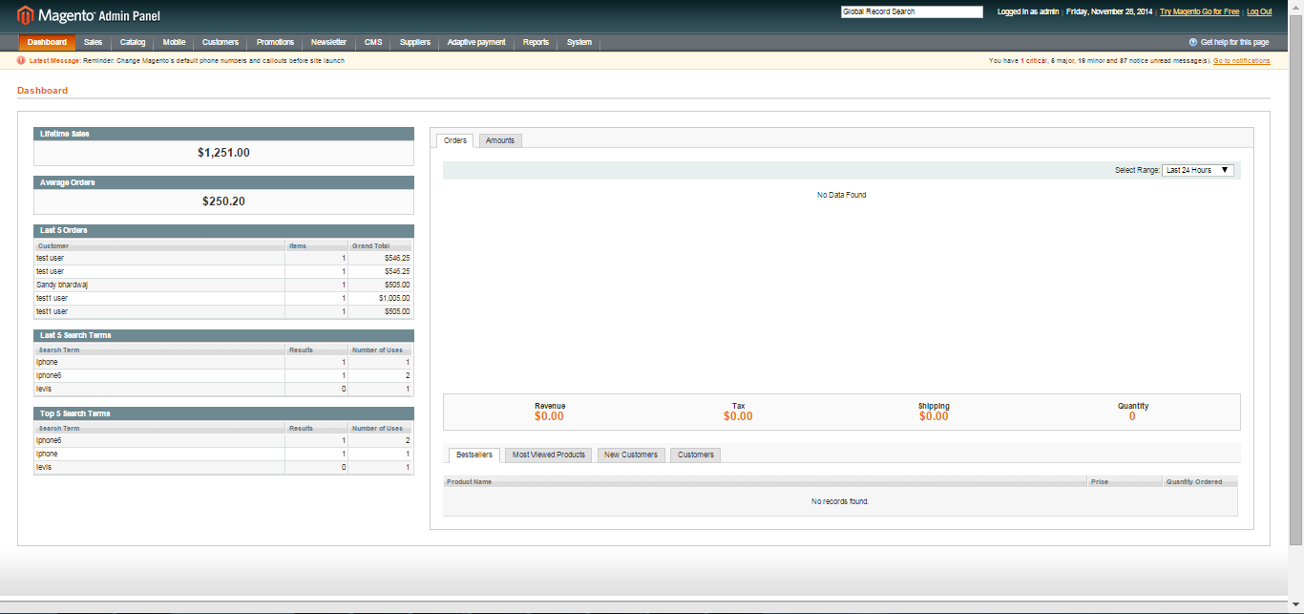

- Click Login button to display administration panel

2. Manage Filter attribute Option image
You can access this section from Catalog > Filter attribute image
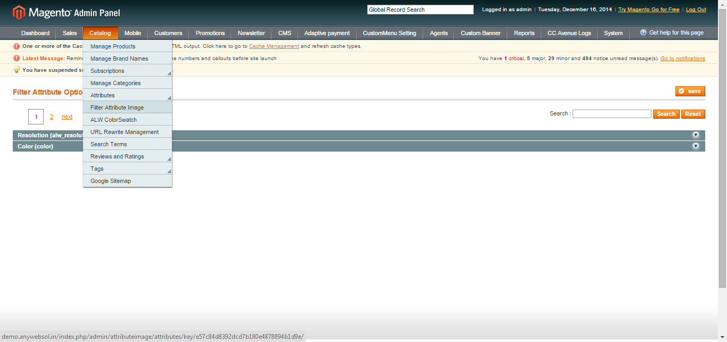
- Browse and upload images for attributes and their values
- You can set images for individual attributes and their values

3. Configuration for Filter Attribute Option Image
You can access this section from System > Configuration > Catalog > Attribute filter option Image settings
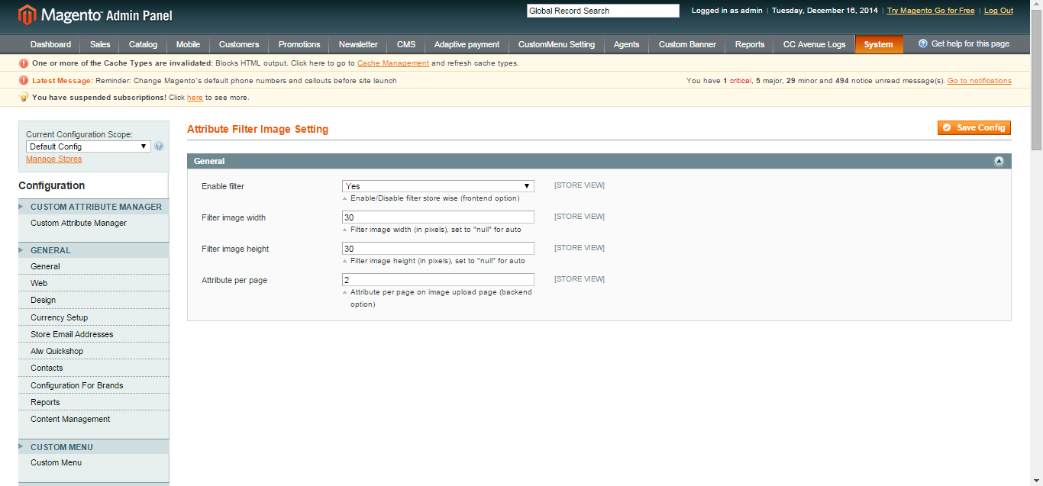
General Tabs
- Enable Filter: Select YES/NO to enable or disable filter attribute image extension
- Filter image width: Enter width of image
- Filter image height: Enter height of image
- Attribute per page: Put value for number of attributes you want to show on filter attribute option page

