Module version: 1.9.15.1

PayPal Adaptive

Published: JANUARY 20, 2017

PayPal Adaptive

Extension User Guide

Contents
PayPal Adaptive Payment Extension 3
1. Configuration 5
2. Manage PayPal adaptive extension 6
3. Manage Products 7
4. Frontend 8

PayPal Adaptive Payment Extension

Overview
PayPal Adaptive Payment Extension of Magento allows parallel payment method in PayPal. A parallel payment is a payment from a sender that is split directly among more than one receiver i.e. a set of multiple payments made in a single pay request. It is useful in cases when a buyer wants to make a single payment for items from multiple sellers. For example you are a merchant who owns an online store and some of your products are related to different suppliers. With parallel payments, the sender can see the transaction to each receiver.
Features
- Parallel payments enable a sender to send a single payment to multiple receivers
- Enables users to send money in many different scenarios
- Handles payments between a sender of a payment and one or more receivers of the payment
- So here the sender knows the receivers and the amount paid to each one
- Parallel payments are useful in cases when a buyer intends to make a single payment for items from multiple sellers

Parallel Payments
Parallel payment is a payment from a sender that is split directly among 2-6 receivers. Technically, a parallel payment is a set of multiple payments made in a single pay request. Parallel payments are useful in cases when a buyer intends to make a single payment for items from multiple sellers.
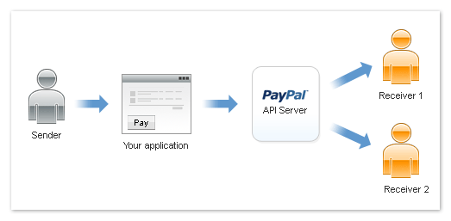

For example an application owner, such as a merchant that owns an online store has some of the products of the online store that are of different suppliers. In this situation when the customer purchases the product which is put up by the supplier, the payment shall be split between supplier and the online store owner

1. Configuration
To access the Magento backend administration environment
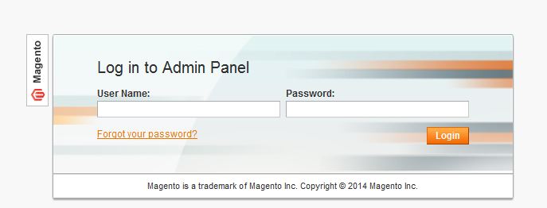

- Log in using the user name and password

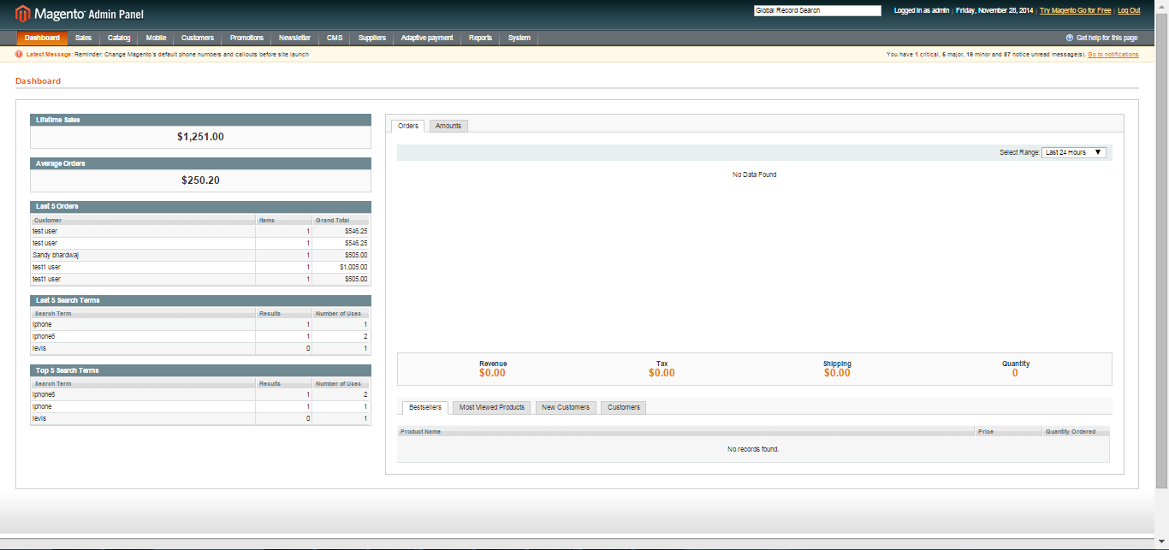
- Click Login button to display administration panel

2. Manage PayPal adaptive extension
Admin needs to enable the PayPal adaptive extension after registering as a business account with adaptive PayPal System > Configurations > Payment methods > Adaptive PayPal
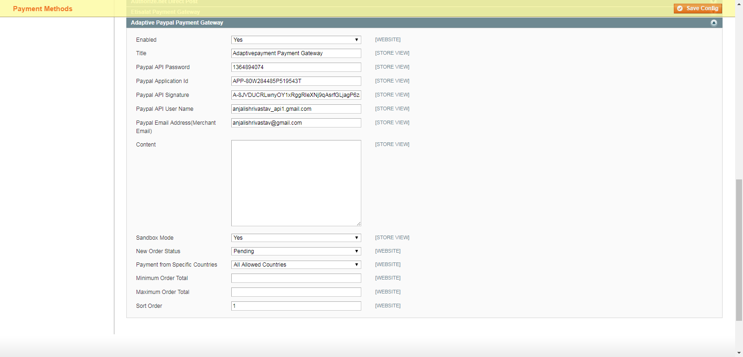

General Tabs
- Enter Details
- Enable/Disable Payments Extension
- Title to Show on Checkout
- Online Store Owner PayPal Email
- Username
- Password
- Signature
- Application ID
- Description
- Choose the New Order Status (Pending, Processing)

3. Manage Products
If product is created by supplier then supplier have to enter these fields in Catalog > Manage products > Supplier details

- Supplier Name
- Supplier Email id: Which is registered with adaptive PayPal & is the account in which the payment shall be received
- Supplier Percentage: This is the supplier ratio in the customer payment

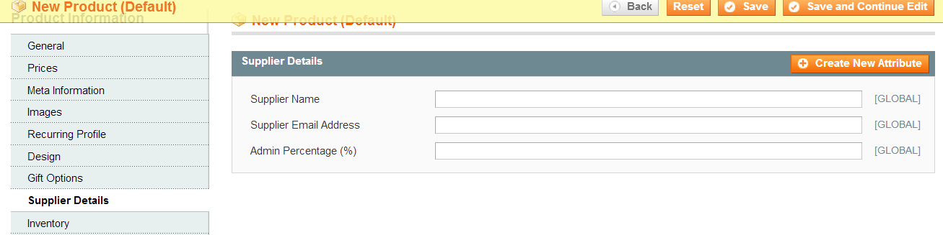
General Tabs
- Enter Details
- Supplier name
- Email address
- Admin percentage (%)

4. Frontend
At the time when customer will checkout, the adaptive PayPal adaptive method is displayed simultaneously
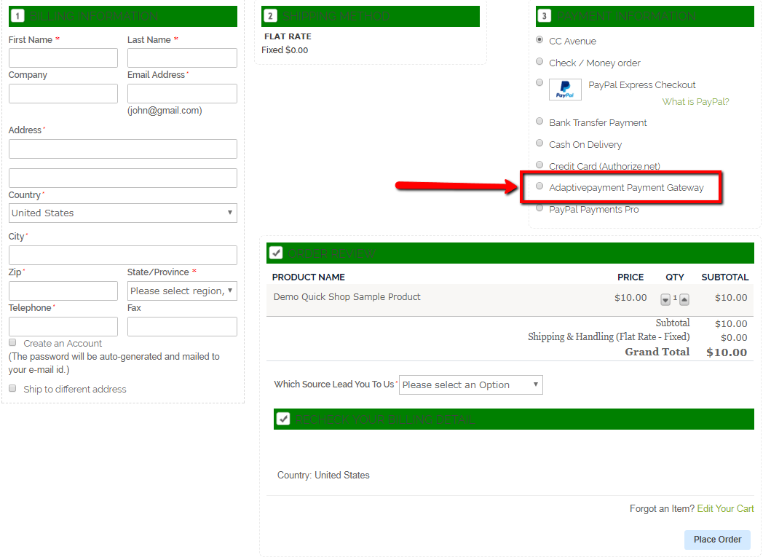

On selecting the adaptive PayPal method, the parallel payments to store owner & supplier[s] is indicated & customer is guided provide his adaptive PayPal details/register with PayPal to make payments

