Module version: 2.3.1

Extension User Guide

Product Attribute Sort

Product Attribute Sort

Published: JANUARY 20, 2017

Contents
Product Attribute Sort 3
1. Configuration 4
1.1 Product attributes 5
1.2 Create product attributes 5
1.3 To provide sorting order for the attribute 7
2. Frontend 8

Product Attribute Sort

Overview
Product Attribute sort for Magento 2.x is a very effective tool for store-owners who care about content placement. Increase the usability of important attribute by arranging them in a specific order. Allow your potential clients to see the important and valuable attributes of the product first so they can find the major attribute for specification on top.
Features
- Admin can create and manage (edit/delete) the product attribute
- Admin can arrange the attribute using sorting order ID

1. Configuration
To access the Magento backend administration environment

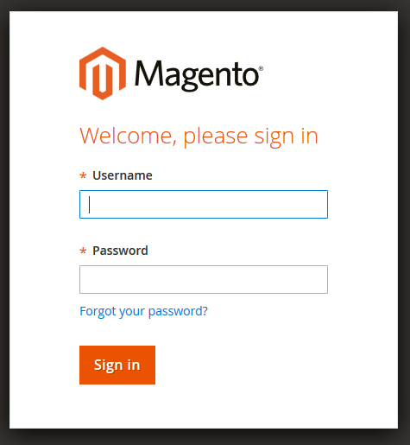

- Login using the user name and password
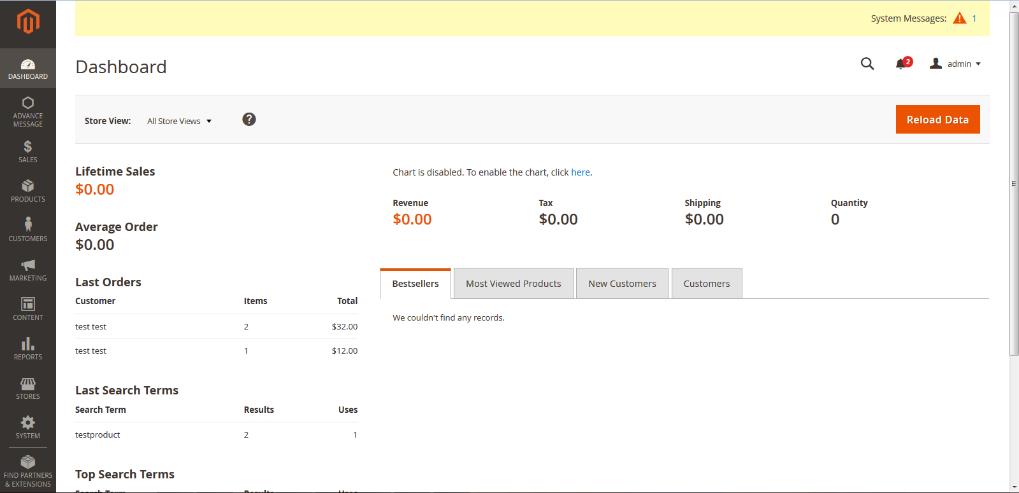
- Click the Login button to display the administration panel

1.1 Product attributes
Select Stores > Product from admin panel
The entire product attribute available in list view
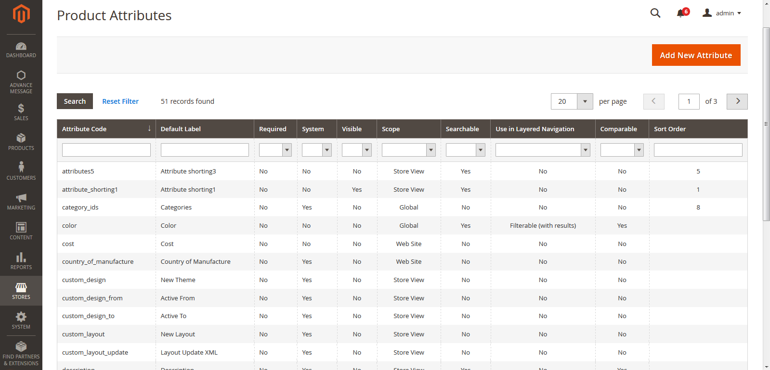

1.2 Create product attributes
Select Stores > Product from admin panel
Admin can create product attribute and can provide sorting order for the attribute from admin area

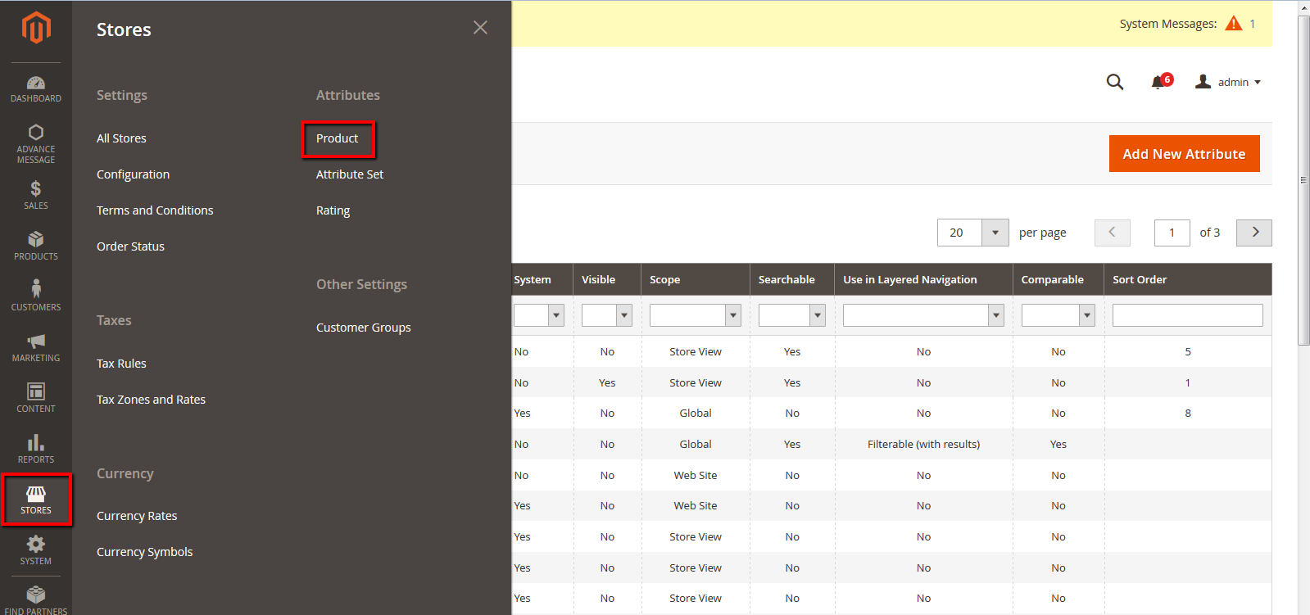
Admin can edit/delete the attribute from admin area
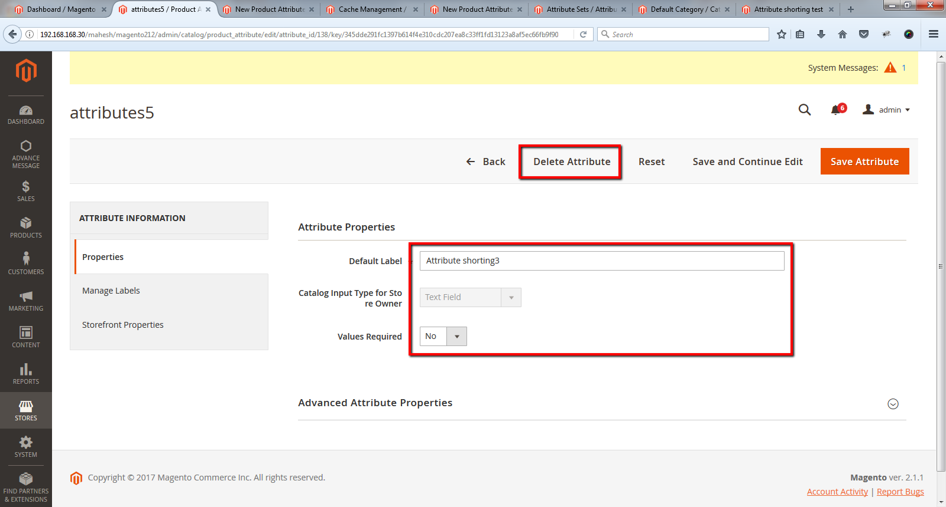
General tabs in Attribute properties
- Default Label: To add the attribute title
- Category input type for store owner: To select the category type
- Values Required: To select the category value is required “Yes” or “No”
- Sort order: Enter sort order to provide the position of the attribute

1.3 To provide sorting order for the attribute
Select Stores > Product > Edit Product > Store front properties from admin panel

Admin can provide attribute sorting order for all attribute by filling “Sort Order”
For e.g. 1, 2, 3 …

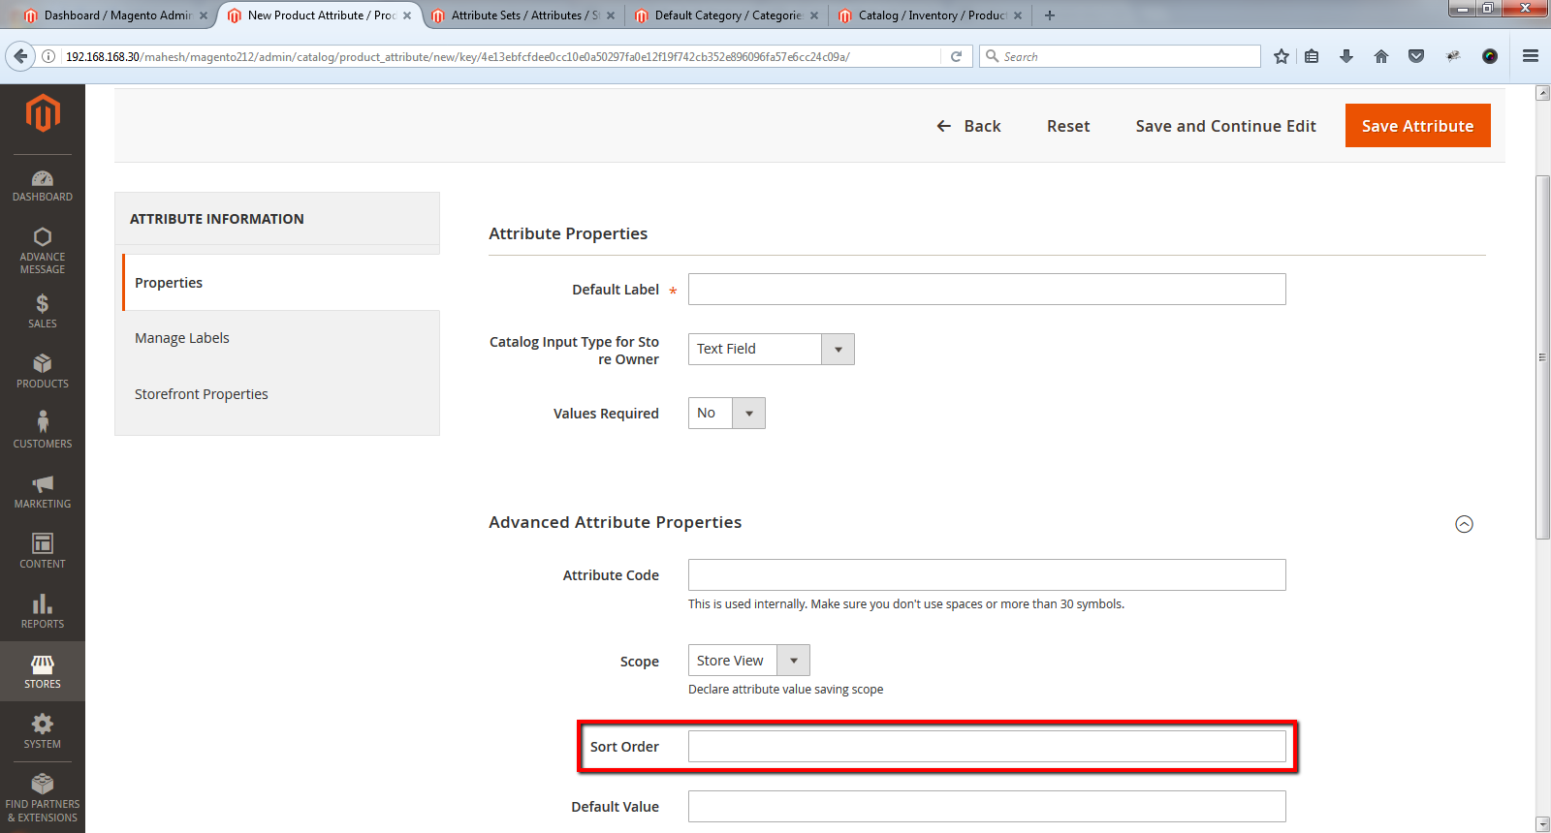

2. Frontend

Sorted attribute on the products detail page
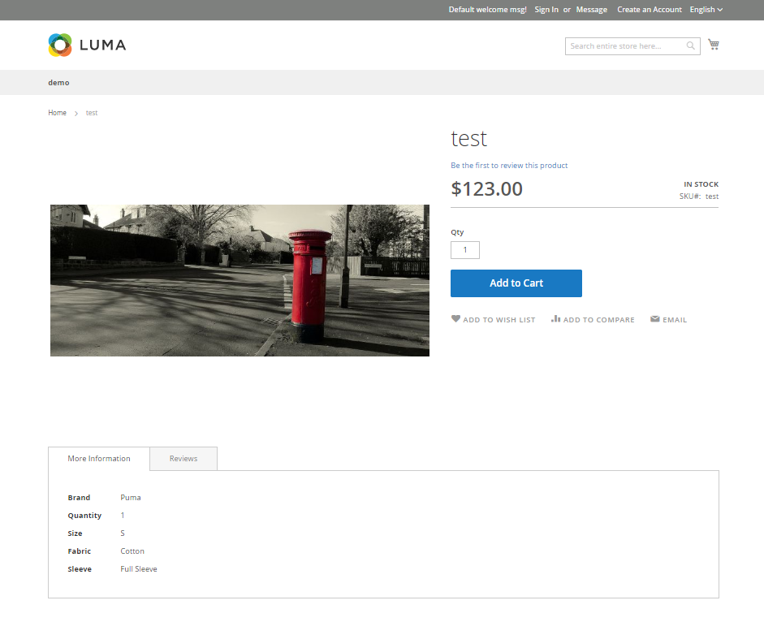
Once attribute sorting will done, frontend user can see the sorted attribute with value in the more information tab on product detail page

