Published: JANUARY 21, 2017

Quick CheckOut

Extension User Guide

Module version: 1.9.13.1

Magento

Contents
Quick Checkout 3
1. Configuration 5
1.1 Admin details 6
2. Frontend 9
3. Steps of Quick Checkout 10
3.1 Name & Address 10
3.2 Shipping Method 11
3.3 Payment Method 12
3.4 Order Review 13

Quick Checkout

Overview
Quick Checkout is a one step checkout extension to simplify the checkout process. It ensures your checkout process is now easier, faster and simpler to increase user experience, sales and revenues. This extension will help to reduce the six standard Magento checkout steps down to one. The Quick Checkout also provides customers a link to login/register, to opt for gift wrap option, increase/decrease product quantity and add any comments during the checkout step. All the prices and totals in the order review section are dynamically updated via Ajax when shipping/payment method or gift wrap option is selected. The user simply fills in their address and chooses delivery/payment methods on the same page, rather than having to do a separate step for each.
Features
- Extension can be enabled/disabled by the admin
- Reduce checkout steps from six to one
- Just a single step to complete checkout
- Simplify the checkout process
- Set title for the Quick Checkout page
- Full support for registration (creating new account and logging in)
- Able to set the text for the login link
- Give the content of Quick Checkout of your own choice and enable/disable the content
- Options to enable/disable following sections on checkout page: login link, billing detail, coupon usage, newsletter subscription, and customer registration, express heard, product quantity increment and decrement functionality, customer’s comments and auto password generator
- Allow customer to enter a coupon code directly in the checkout page
- Enable checkbox for newsletter subscription
- Allow customer to enter comment for the order
- Allow customer to select gift wrap option for the order
- Auto-update prices and totals when choosing gift wrap and shipping/payment method
- Auto-update available for shipping rates when user chooses country, zip code or region or changes the product quantity
- Able to add different messages for Ajax loader used to update each field
- Easily modify CSS / layout with regular Magento templates and CSS file

1. Configuration
To access the Magento backend administration environment
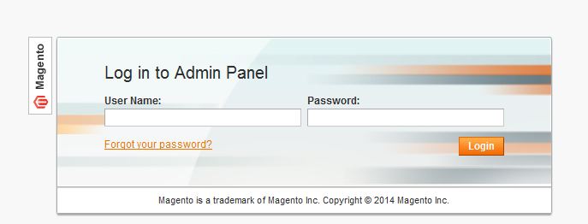

- Log in using the user name and password
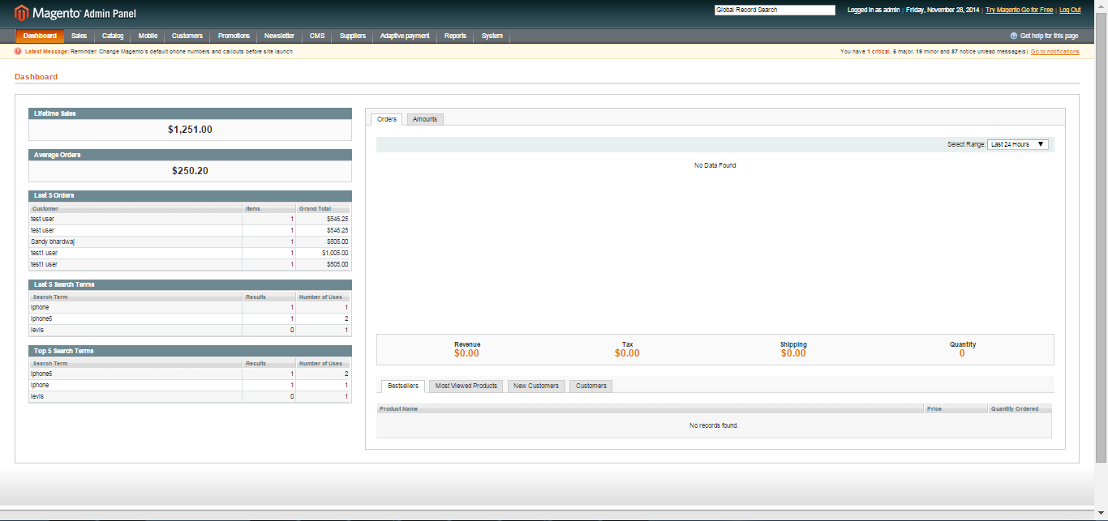
- Click the Login button to display the administration panel

1.1 Admin details
System > Configuration > Quick Checkout > Settings
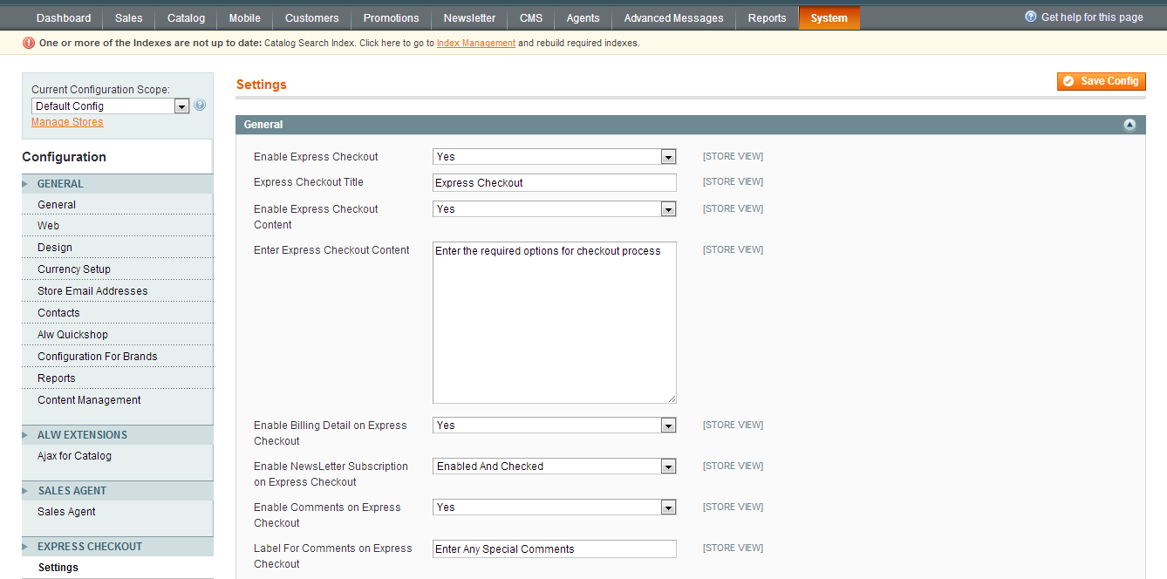
- Option to enable/disable the extension
- Set title for checkout page
- Enable/disable content on checkout page
- Add content on checkout page
- Enable/disable billing detail review on checkout page
- Enable/disable newsletter subscription option
- Enable/disable option to add comments on checkout page
- Add label for comments

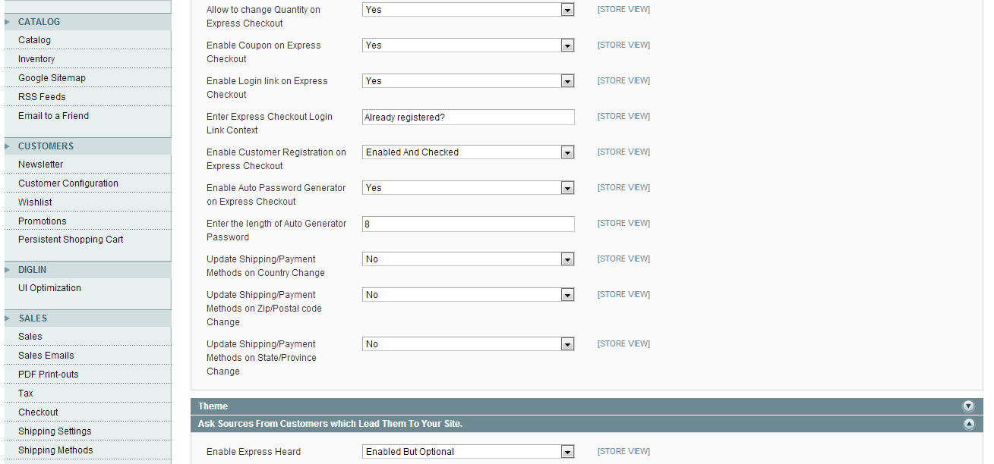

- It allows changing quantity of products on checkout page
- Enable/disable use of coupon on checkout page
- Enable/disable login link on checkout page
- Add content for login link
- Enable/disable customer’s registration on checkout page
- Enable/disable auto password generator in case of registration
- Admin can set length for auto password generation
- Enable/disable the update of shipping/payment methods on change of country, zip/postal code and state/province

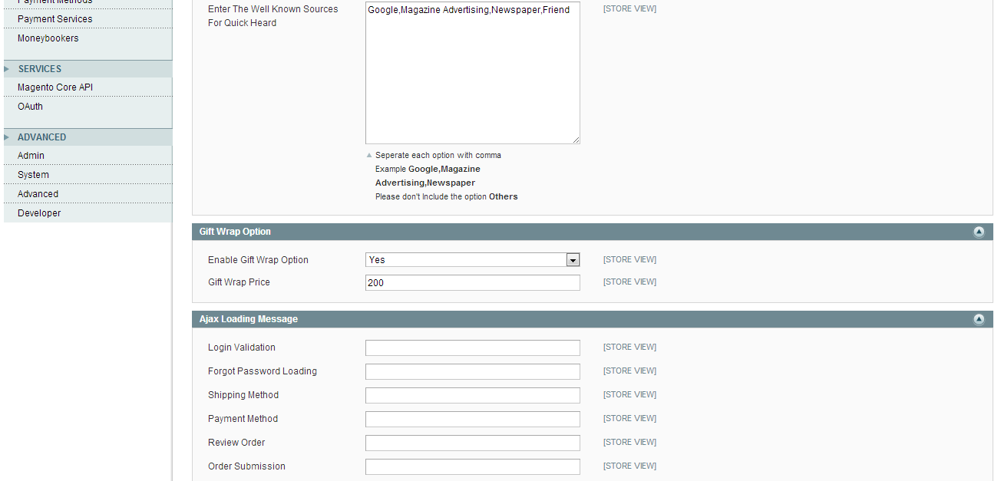

- Enable/disable option for source which leads users to the site(express heard)
- Admin can set label for express heard
- Enter the well known sources for express heard with each option separated by comma
- Enable/disable gift wrap option for order
- Admin can set gift wrap price for the order
- Admin can apply Ajax loading messages on login validation; forget password loading, update of shipping method, payment method, order review and order submission

2. Frontend
After hitting on process to checkout, customers will be redirect into the Secured checkout page
The checkout page includes 3 steps: Billing Information, Shipping Method, Payment Method and Order Review
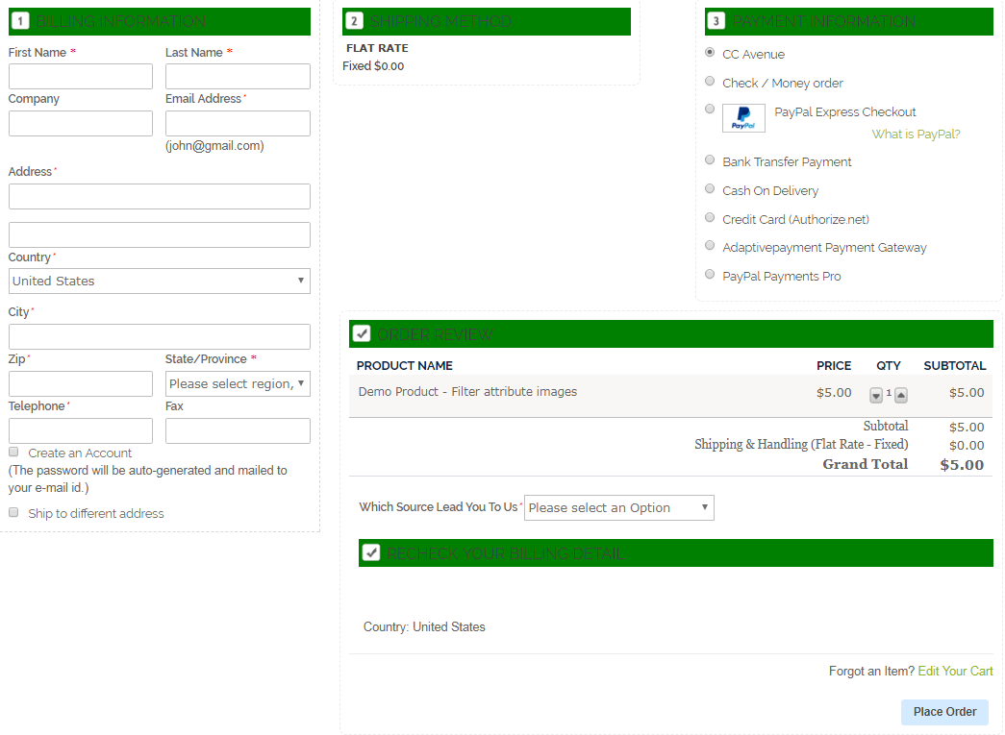

- Name & Address: Customers can enter shipping address
- Shipping Method: Can select shipping method, discount code and can comment using comment box
- Payment Method: When customer will enter shipping address and shipping method after that payment method will enable for the payment options
- Order Review: Customer order detail will display with subtotal, shipping amount and order total

3. Steps of Quick Checkout

3.1 Name & Address

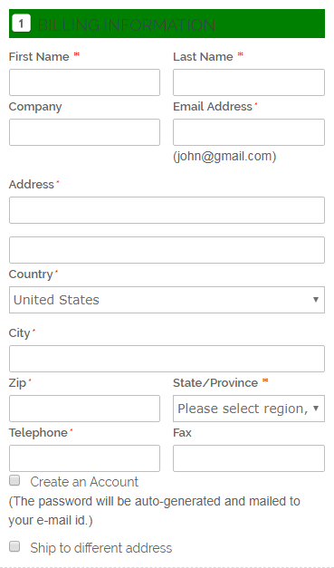

General tabs in Name & Address
- First name: Enter first name of the customer
- Last Name: Enter last name of the customer
- Company: Enter company name of the customer
- Street Address: Enter full address for shipping
- City: Enter city name for shipping address
- State/Province: Select state or Province
- Country: Select country for shipping
- Zip/Postal Code: Enter Zip/Postal code
- Phone Number: Enter phone number of the customer

3.2 Shipping Method

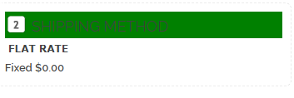

General tabs in Shipping Method

- Shipping method: All the shipping method which are enabled by admin

3.3 Payment Method

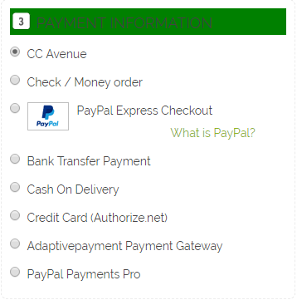
All the payment methods which are enabling from admin area will be display on checkout page

3.4 Order Review

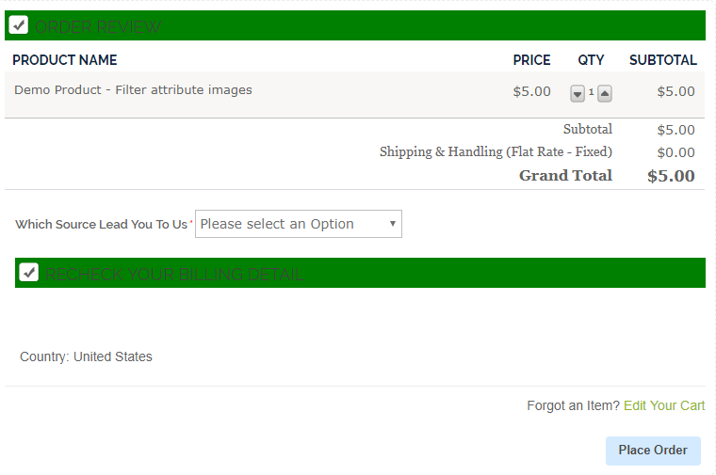
Order detail with product name, QTY, subtotal, shipping amount and order total will display in order review section.

