Quick CheckOut

Published: JANUARY 23, 2017

Extension User Guide

Module version: 2.2.1

Magento

Contents
Quick Checkout 3
1. Configuration 4
1.1 Quick Checkout Configuration 5
1.2 Shipping Methods 6
1.2.1 Flat rate shipping method 6
1.2.2 Free Shipping 6
1.2.3 Table rates 6
1.2.4 UPS 7
1.2.5 USPS 7
1.2.6 FedEx 7
1.3 Frontend Functionality 8
1.3.1 Steps of Quick Checkout 9
2. Shipping Method 10
3. Payment Method 11
4. Order Review 11

Quick Checkout

Overview
Quick Checkout extension simplifies one-step checkout process for the Magento 2.0. This extension helps you increasing both user experience and sales revenue. Single page that gives you each and everything like dynamic product price, shipping, payment method, and gift wrap option and shipment address. The extension provides customers
- Login/register URL
- Gift wrap option
- Change product quantity
- Additional comments during the checkout
Features
- Easy installation
- Extension can be enabled/disabled by the admin
- Reduce checkout steps from six to one
- Just a single step to complete checkout
- Simplify the checkout process
- Set title for the Quick Checkout page
- Full support for registration (creating new account and logging in)
- Allow customer to enter a coupon code directly in the checkout page
- Enable checkbox for newsletter subscription
- Allow customer to enter comment for the order
- Auto-update available for shipping rates when user chooses country, zip code or region or changes the product quantity

1. Configuration
To access the Magento backend administration environment

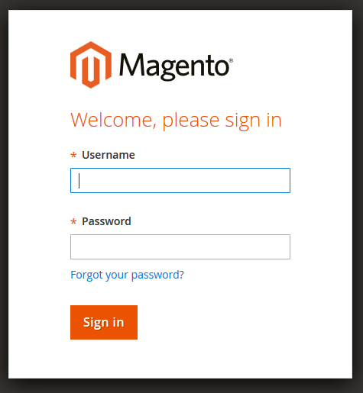

- Login using the user name and password
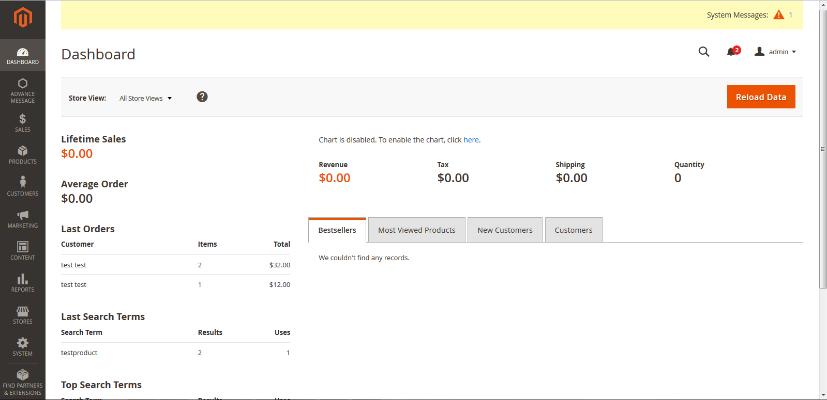
- Click the Login button to display the administration panel

1.1 Quick Checkout Configuration
Select Stores > Zalw > Quick Checkout from admin panel
- Enable: Admin can enable or disable Quick Checkout
- Meta Title: Admin can set the meta title
- Display Discount field: Admin can enable or disable discount field on checkout page
- Enable Order comments: Admin can enable or disable order comments field on checkout page
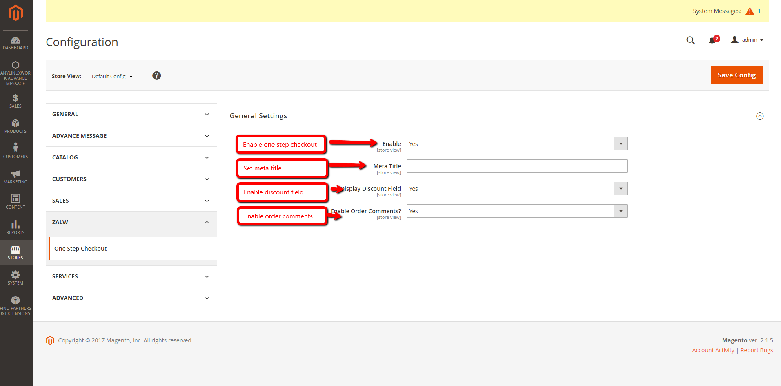

1.2 Shipping Methods
There are various shipping methods available from where admin can choose which methods to be enable on checkout page
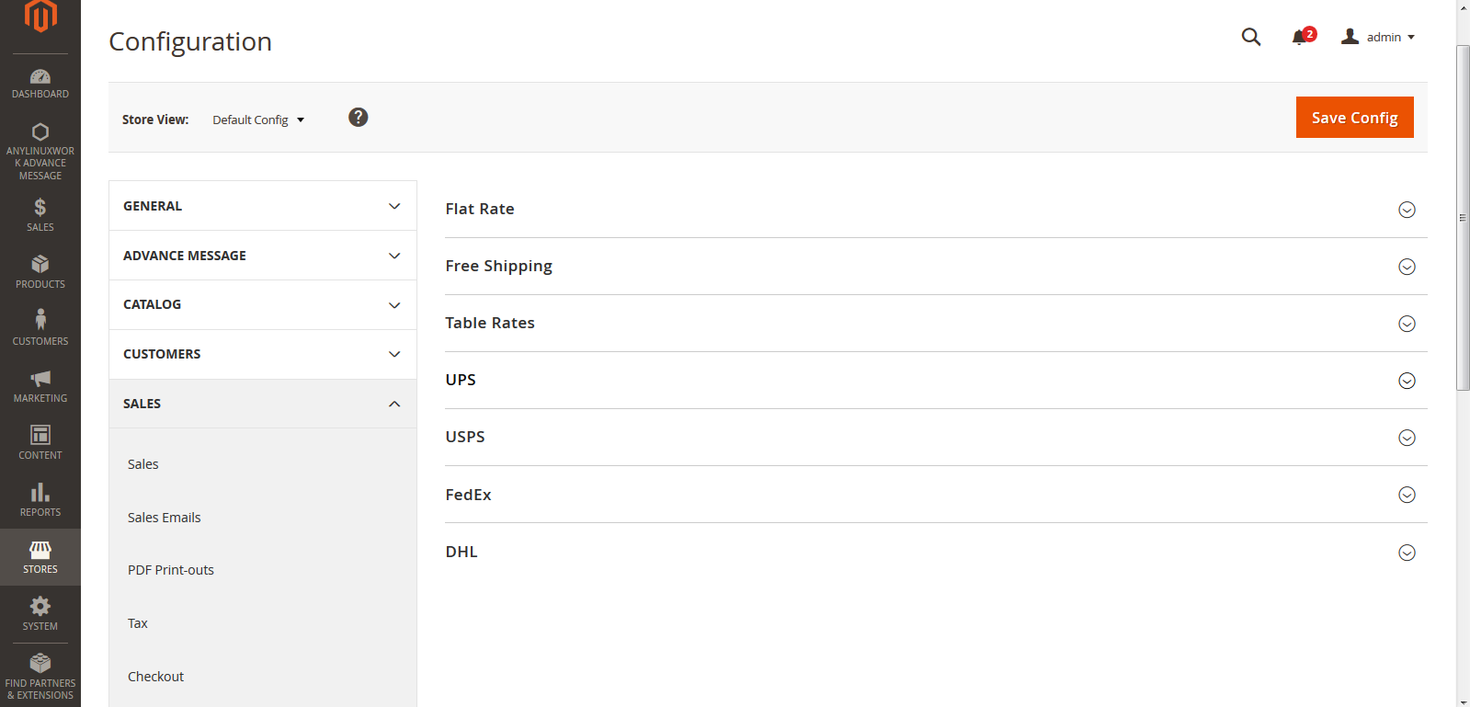

1.2.1 Flat rate shipping method
- You can enable or disable flat rate shipping method on checkout page
- Set the title of payment method to be displayed on checkout page
- Set the method name
- Set flat rate applied on per item or per order
- Set handling fee as fixed or percent
- Set error message to be displayed on checkout page
- Set if the shipping method is applied to all countries or only specific countries
- Set order in which the method will be displayed on front end

1.2.2 Free Shipping
- You can enable or disable free shipping method on checkout page
- Set the title of payment method to be displayed on checkout page
- Set the method name
- Set minimum order amount
- Set error message to be displayed on checkout page
- Set if the shipping method is applied to all countries or only specific countries
- Set order in which the method will be displayed on front end

1.2.3 Table rates
- You can enable or disable table rate shipping method on checkout page
- Set the title of payment method to be displayed on checkout page
- Set the method name
- Set condition for free shipping
- Enable Include Virtual Products in Price Calculation
- Set handling fee as fixed or percent
- Set error message to be displayed on checkout page
- Set if the shipping method is applied to all countries or only specific countries
- Set order in which the method will be displayed on front end

1.2.4 UPS
- You can enable or disable UPS shipping method on checkout page
- Set UPS, Live account, Gateway URL, Package request type, container, weight unit, destination type, max package weight details
- Set the title of payment method to be displayed on checkout page
- Set the method name
- Set flat rate applied on per item or per order
- Set handling fee as fixed or percent
- Set error message to be displayed on checkout page
- Set if the shipping method is applied to all countries or only specific countries
- Set order in which the method will be displayed on front end

1.2.5 USPS
- You can enable or disable UPS shipping method on checkout page
- Set USPS, Gateway URL, Secure gateway URL, Package request type, container, weight unit, destination type, max package weight details
- Set the title of payment method to be displayed on checkout page
- Set the method name
- Set flat rate applied on per item or per order
- Set handling fee as fixed or percent
- Set error message to be displayed on checkout page
- Set if the shipping method is applied to all countries or only specific countries
- Set order in which the method will be displayed on front end

1.2.6 FedEx
- You can enable or disable UPS shipping method on checkout page
- Set UPS, Live account, Package request type, weight unit, destination type, max package weight details
- Set the title of payment method to be displayed on checkout page
- Set the method name
- Set flat rate applied on per item or per order
- Set handling fee as fixed or percent
- Set error message to be displayed on checkout page
- Set if the shipping method is applied to all countries or only specific countries
- Set order in which the method will be displayed on front end

1.3 Frontend Functionality
After hitting on Process to checkout, customers will be redirect into the Secured Checkout page.
The Checkout page includes 3 steps: Name & Address, Shipping Method, Payment Method and Order Review
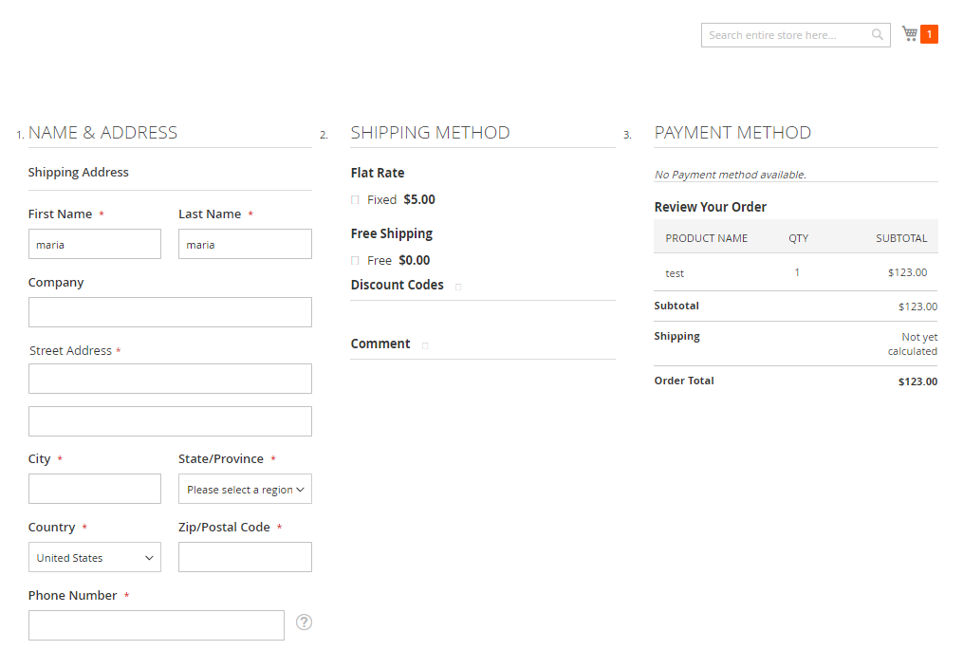
- Name & Address: Customers can enter shipping address
- Shipping Method: Customer can select shipping method, discount code and can comment using comment box
- Payment Method: When customer will enter shipping address and shipping method after that payment method will enable for the payment options
- Order Review: Customer order detail will display with subtotal, shipping amount and order total

1.3.1 Steps of Quick Checkout
Name & Address
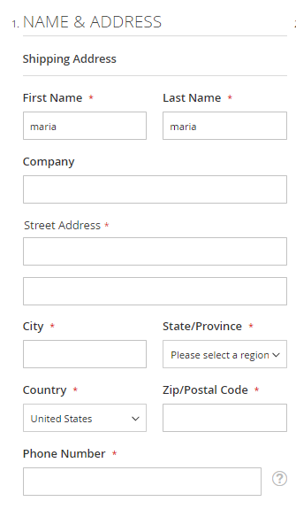
General tabs in Name & Address
- First name: To enter first name of the customer
- Last Name: To enter last name of the customer
- Company: To enter company name of the customer
- Street Address: To enter full address for shipping address
- City: To enter city name for shipping address
- State/Province: Select state or Province
- Country: Select country for shipping address
- Zip/Postal Code: To enter Zip/postal code
- Phone Number: To enter phone number of the customer

2. Shipping Method

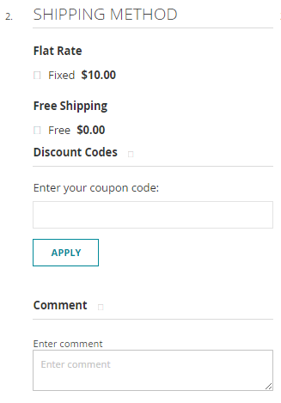

General tabs in Shipping Method
- Shipping method: All the shipping method which are enabled by admin
- Discount codes: Customer can use active discount code
- Comment: Customer can comment for related order+

3. Payment Method

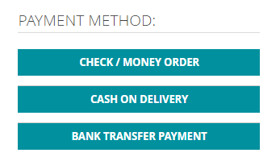
All the payment methods which are enabling from admin area will be display on checkout page

4. Order Review

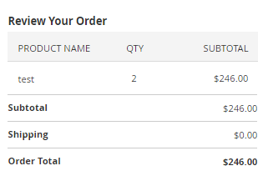
Order detail with product name, QTY, subtotal, shipping amount and order total will display in order review section.

