



|  |
| --- |
|  |

**Quick Shop**

**Published: JANUARY 13, 2017**

**Extension User Guide**

Module version: 1.9.14.1

**Quick Shop**

Contents

Quick Shop 3

1. Configuration 4

1.1 Manage Quick shop 5

2. To access the Magento Frontend for Quick Shop 6

2.1 Quick shop option for products 6

# Quick Shop

**Overview**

Shopping becomes easier for the customers with the aid of this Quick Shop extension. Whenever you will mouse hover on any product image a Quick Shop icon gets displayed which will show product details on the same page in a fancy quick view popup.

A Quick Shop icon gets displayed which will show product details on the same page in a fancy quick view popup.  
This extension will work on all the pages of your site which will help you sell related products as well as do up-selling and cross selling.

**Features**

* Helps your customers to quickly navigate through products
* Support all types of product
* Display all product options in the quick view popup
* Ability to add product to cart quickly
* Follow Magento layout and template structure, hence it’s super easy to change template layout just by updating the xml file
* No core hacks
* Add compare product and wish list products in quick view popup
* Nice designed extension
* Support all Magento 1.5.x
* Ability shows Quick Shop button on all product grids, product widgets, product blocks not only the product category pages

# 1. Configuration

**To access the Magento backend administration environment**

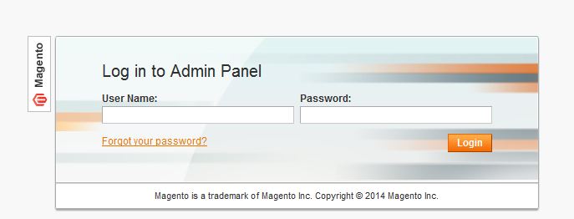

1. Log in using the user name and password

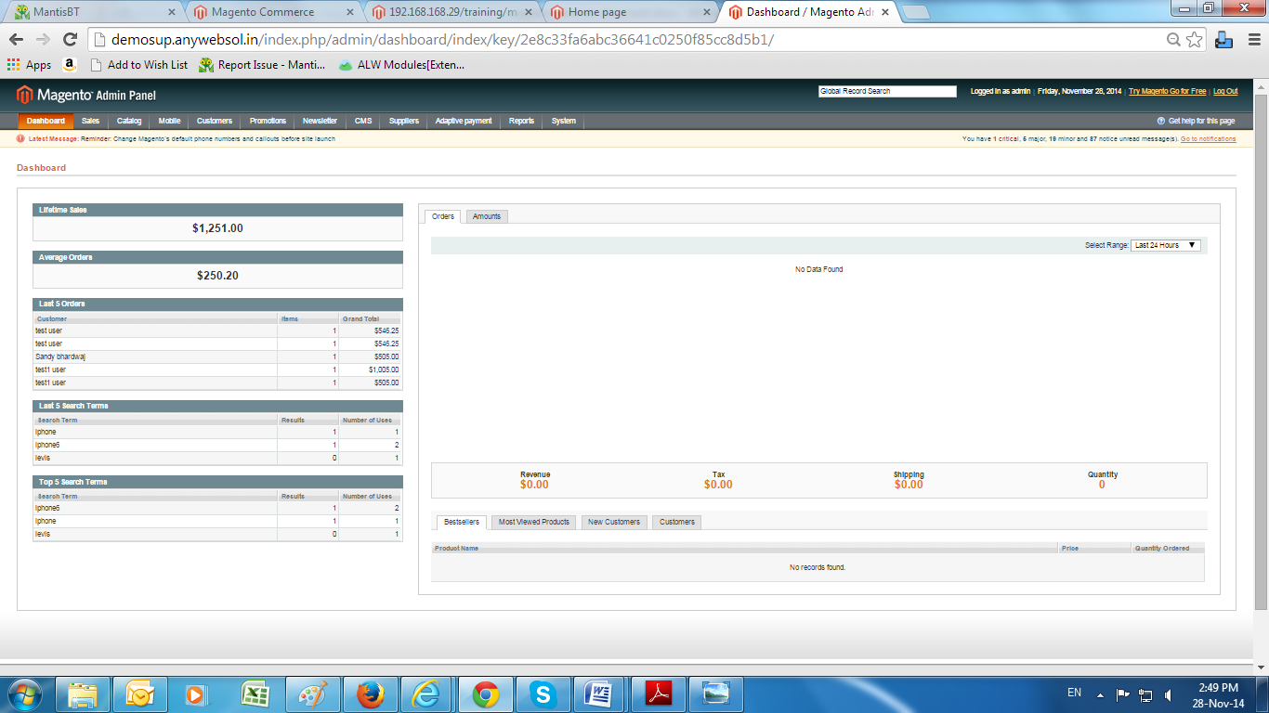

1. Click the Login button to display the administration panel

## 1.1 Manage Quick shop

You can access following path **System> Configuration> Quick shop**

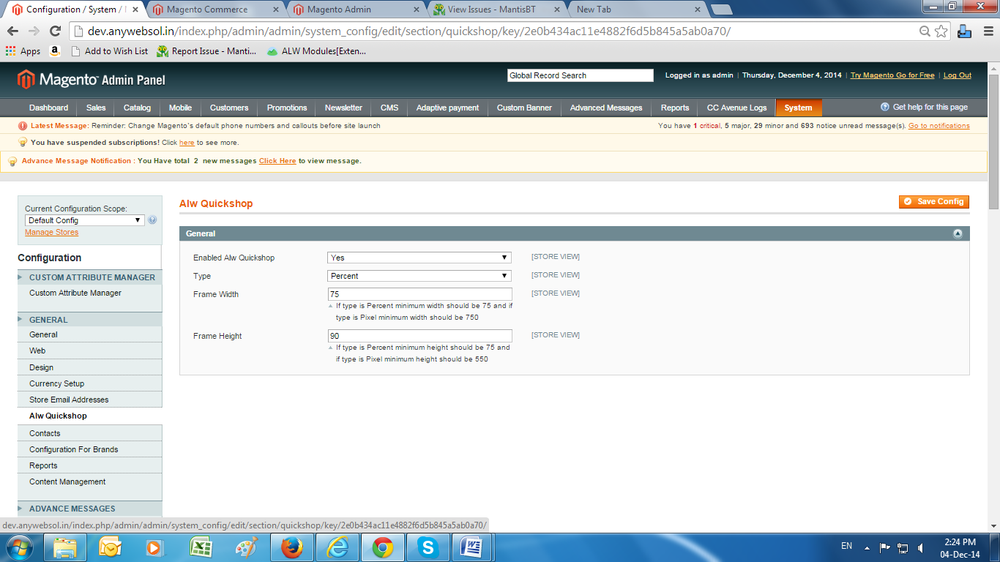

**General Tabs**

* **Enabled Quick Shop:** Select from dropdown YES/NO to enable or disable quick
* **Type:** Select from drop down percent/pixel
* **Frame Width:** Enter desired width of frame
* **Frame Height:** Enter desired height of frame

# 2. To access the Magento Frontend for Quick Shop

Select product category from top navigation

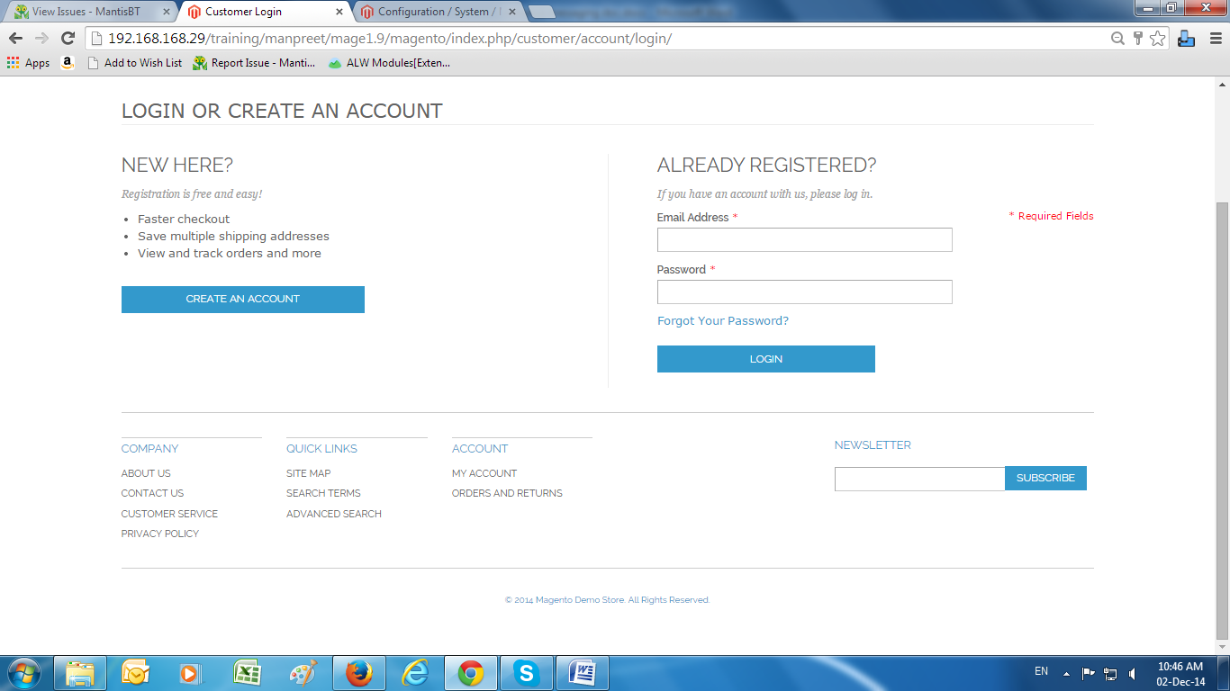

## 2.1 Quick shop option for products

* **Product category page:** Hover on products and click ‘Quick Shop’ button
* It will open pop-up where you can see product details
* **Add to Cart:** Click ‘Add To Cart’ to add product to cart
* **Configurable products:** Select product configuration and add product to cart

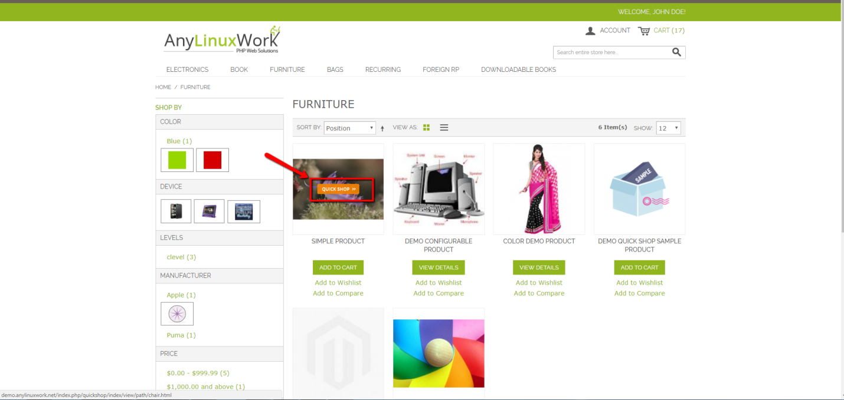

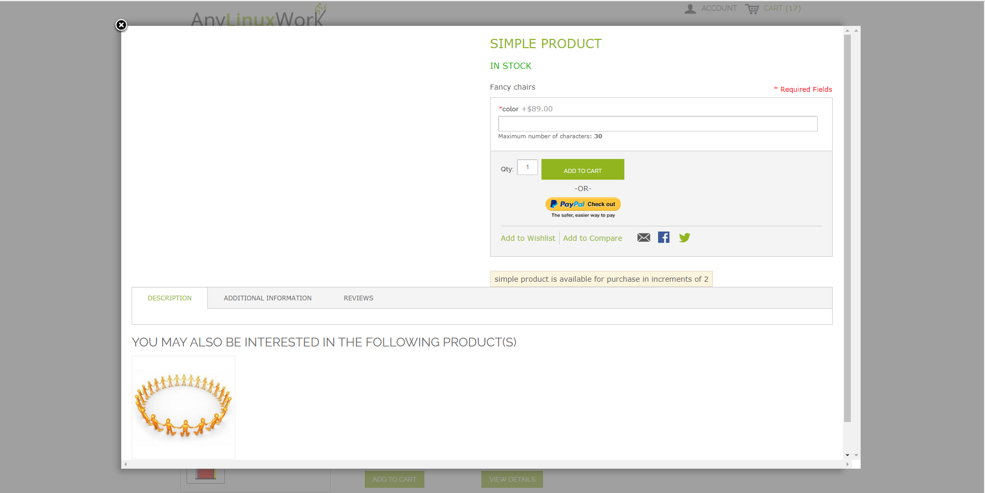

* Cross sell products: Hover on products and click ‘Quick Shop’ button
* It will open up a pop-up where you can see product details

