Module version: 1.9.15.1

Sales Agent

Published: JANUARY 28, 2017

Extension User Guide

Sales Agent

Contents
Sales Agent 3
1. Configuration 4
1.1 Manage Agents 5
1.2 Create New Agent from Frontend 6
1.3 To access the Magento backend Sales Agent environment 7
1.4 Manage customers 8
1.4.1 Create New Customers 8
1.5 Manage Agent commission 9
1.5.1 Order Commission 10
1.5.2 Withdrawal requests 10
1.6 Manage Accounts 11

Sales Agent

Overview
The Sales agent extension helps to monitor and increase the sales for your store by appointing agents to bring up sales. This extension will help to make agents who in turn will get customers for your store which will increase the store orders and revenue. These agents can create and manage their customers and orders put forth by them. They in turn will get a commission on each order on the basis of a commission percentage set by the Admin. This extension lets you mange access permissions to orders and customers for agents. The agents can view and edit only customers assigned to them; they can view and process orders only of their customers; they can create orders from their account only for their customers. Also, they can create new customers, who are automatically assigned to them. Agents can also request for withdrawal of their commission once they have a minimum commission amount in their account as set by Admin. This withdrawal request will further be approved by Admin using PayPal and will get credited to Agents account online. This extension gives you more control over order processing.

Features
- Allow to create, view, edit and delete sales agents
- View orders for each sales agent
- Enable/disable front end registered agents
- Customizable and automated email reporting to agents and admin
- Allot a default commission percentage for agents
- Tabulate and compile commissions earning
- Track commission earning as Paid, Unpaid or Cancelled
- Customise commission percentage for each agent
- Set a minimum amount for commission withdrawal
- Manage and approve the commission earnings of agents
- See sales for any specified time period
- Show commission earning and status in each order
- Ensure that orders put in manually through your admin panel are also credited to the appropriate agent
- Create fun and motivational sales competitions within your company

1. Configuration
To access the Magento backend administration environment
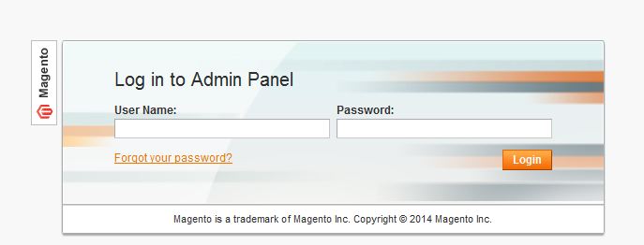

- Log in using the user name and password
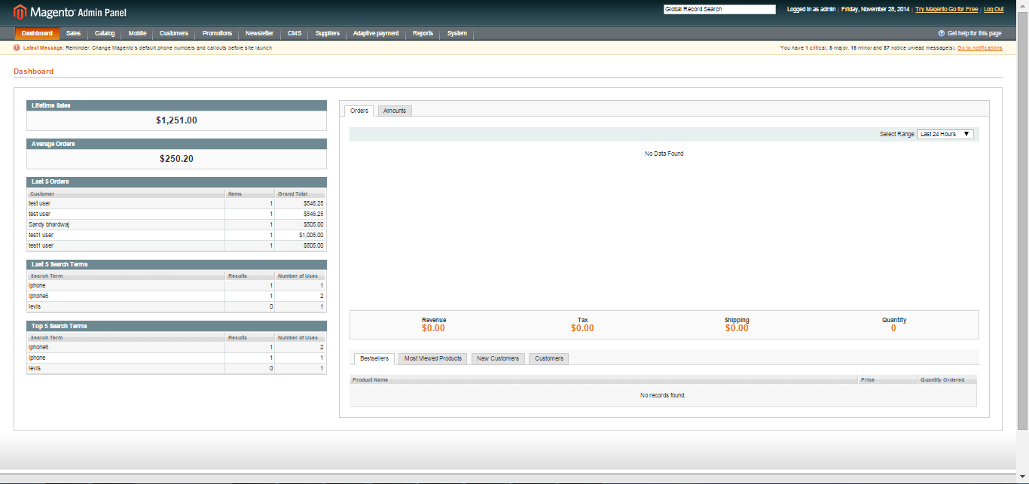

- Click the login button to display the administration panel

1.1 Manage Agents
You can access following the path Agents > Manage Agents
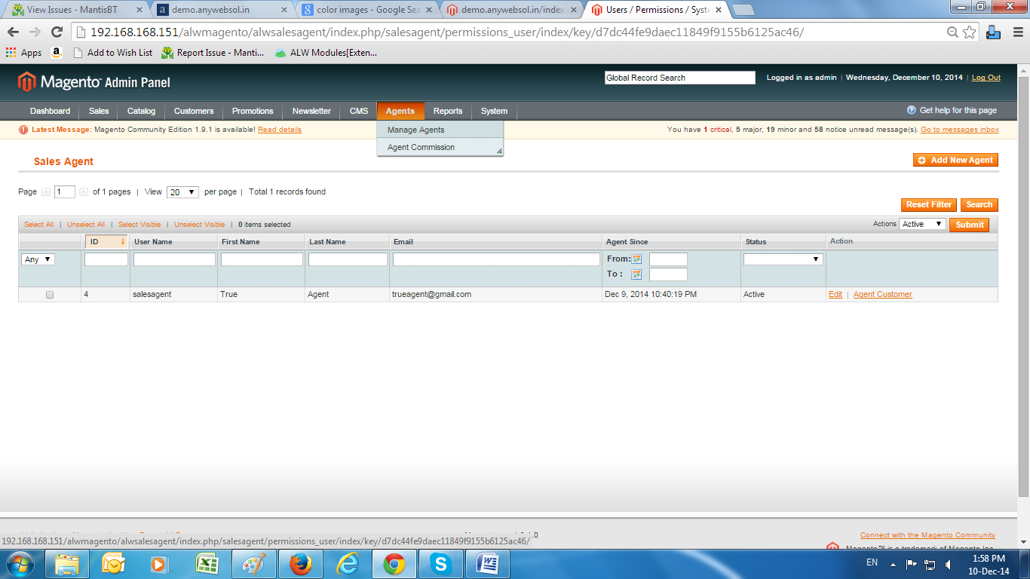
- Edit: Admin can edit the agent information
- Agent Customer: It will display the customers under each agent
- Actions: Admin can perform actions such as active ,inactive, and delete the registered agents from the list
- Search: Search the agents on basis of User name, First name, last name, email etc
- Add New Agent: Add a new agent from admin area
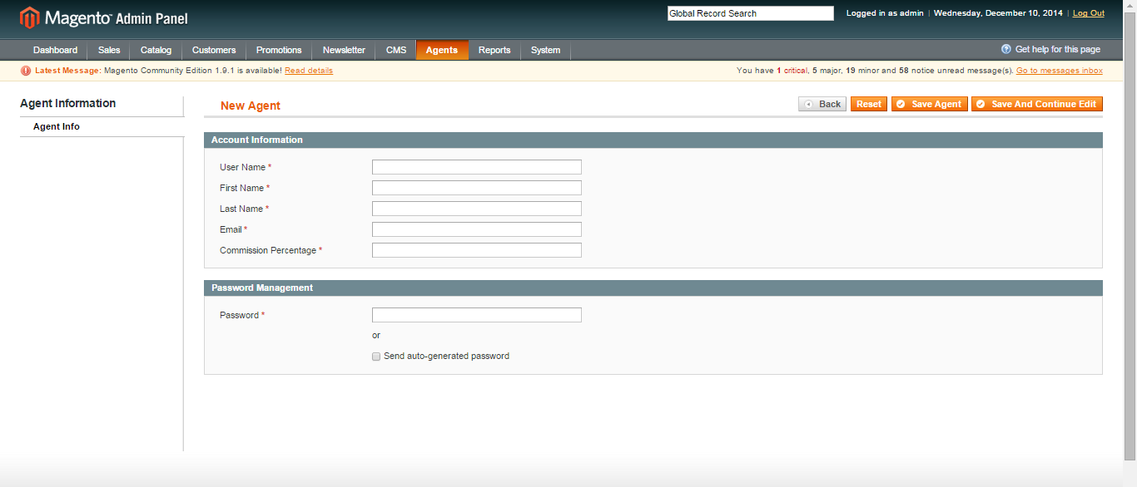

General Tabs
- Enter Agent Details
- Username
- First Name
- Last Name
- Email
- Commission percentage agent will receive
- Sign in password
- Save to create Agent account

1.2 Create New Agent from Frontend
- Enter the URL
- Select from Account > Sales Agent Registration in frontend

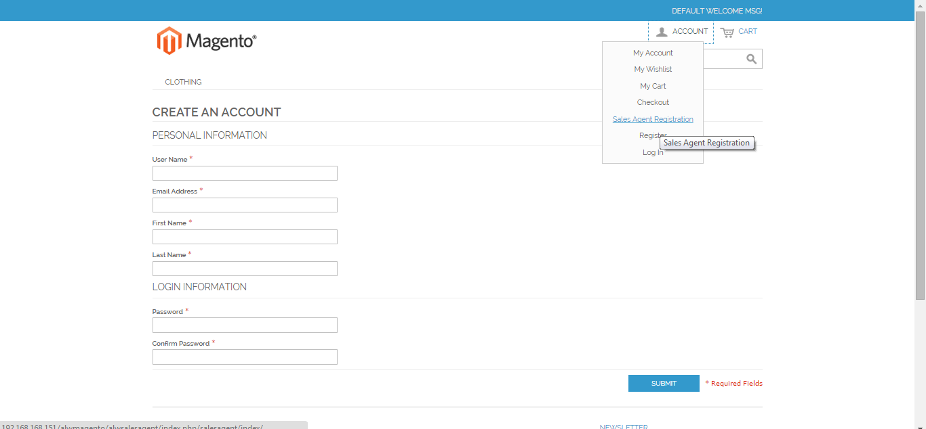
General Tabs
- Enter Agent Details
- Username
- First Name
- Last Name
- Email
- Commission percentage agent will receive
- Sign in password
- Confirm Password
- Save to create Agent account

1.3 To access the Magento backend Sales Agent environment

- Log in using the user name and password of sales agent
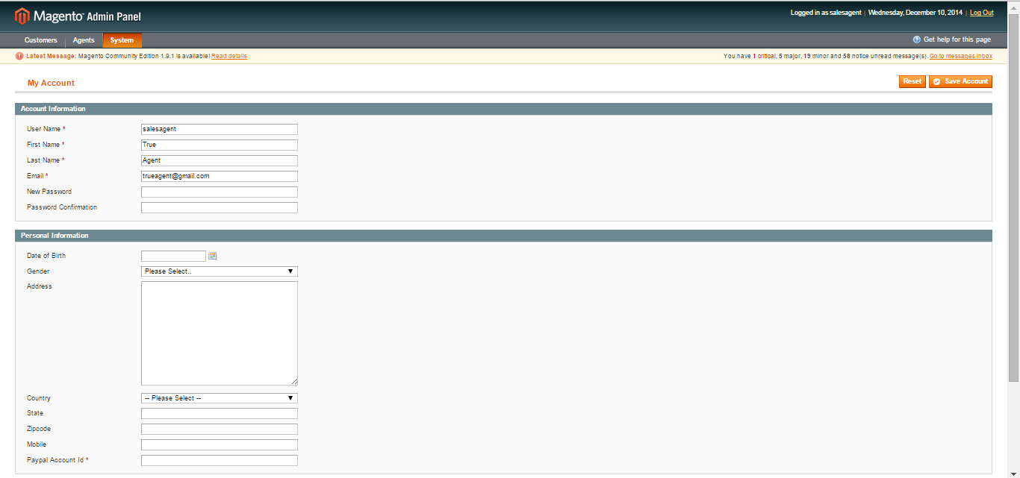
- Click the login button to display the agent backend

1.4 Manage customers
You can access following the path Customers > Manage customers
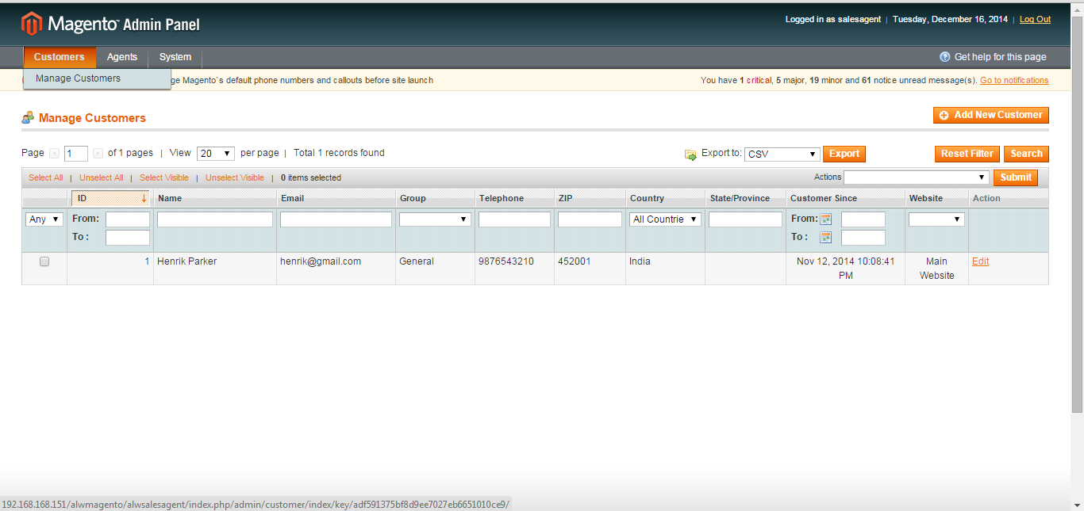
- A list of already created customers will be displayed
- Edit: To update the customer information

1.4.1 Create New Customers
- Click to add new customer
Fill Account Information
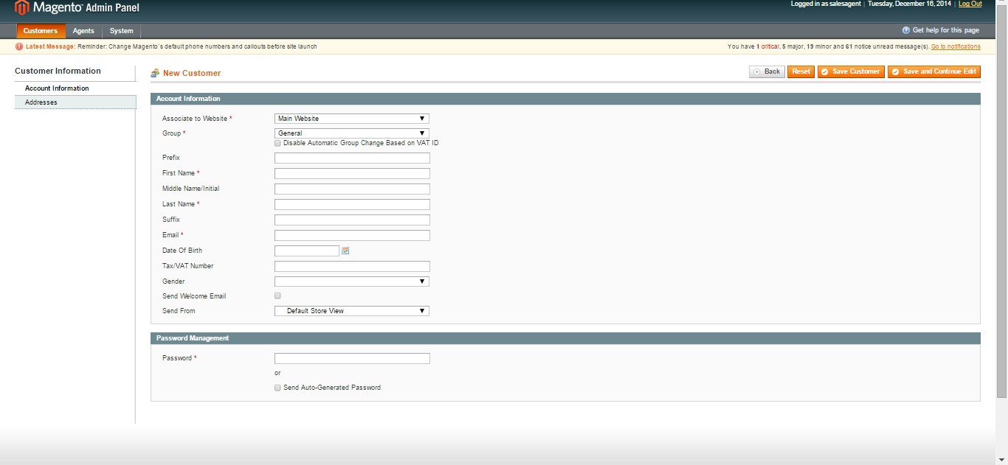

General Tabs
- Associate to website: Select the website from dropdown
- General: Select from dropdown the group
Enter customer details
- Prefix
- First Name
- Middle Name/Initial
- Last name
- Suffix
- Email
- Date of Birth
- Tax/Vat Number
- Gender
- Send Welcome Email
- Send From
- Password

1.5 Manage Agent commission
You can access manage agent commission from Agents > Agent commission
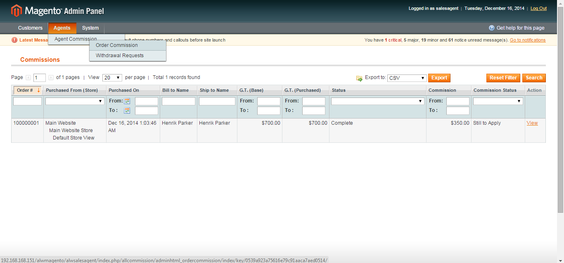

1.5.1 Order Commission
- A list of orders will be displayed in this section, from where the agent has received some commission
- View: Agent can view each order
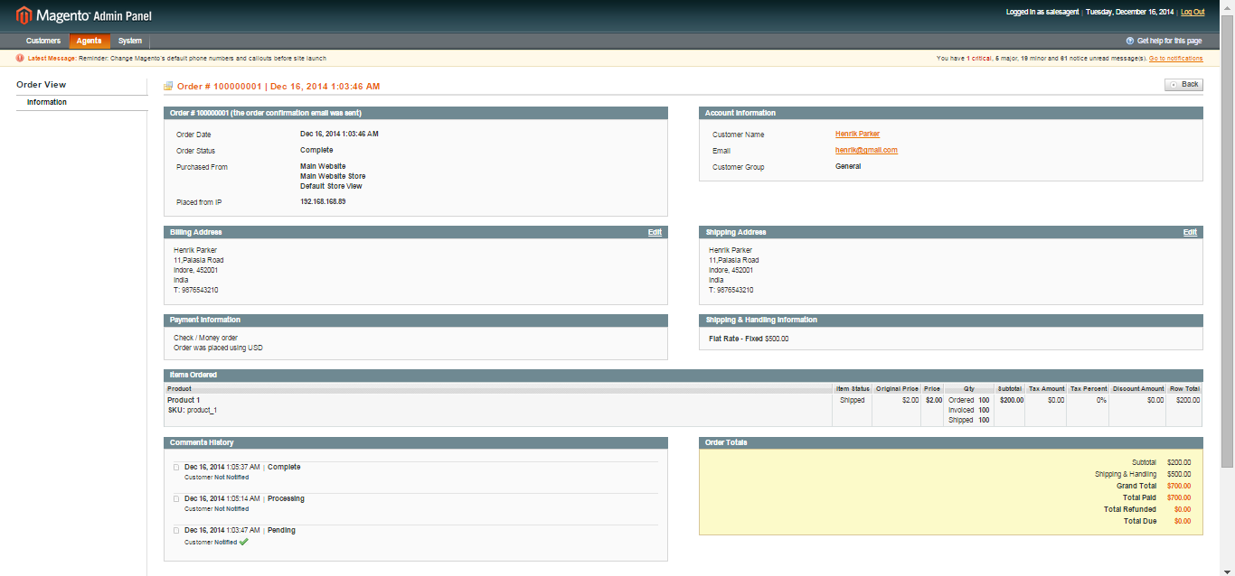

1.5.2 Withdrawal requests
- A list of commissions withdraw from admin will be visible
- View: Agent can view his requested commission
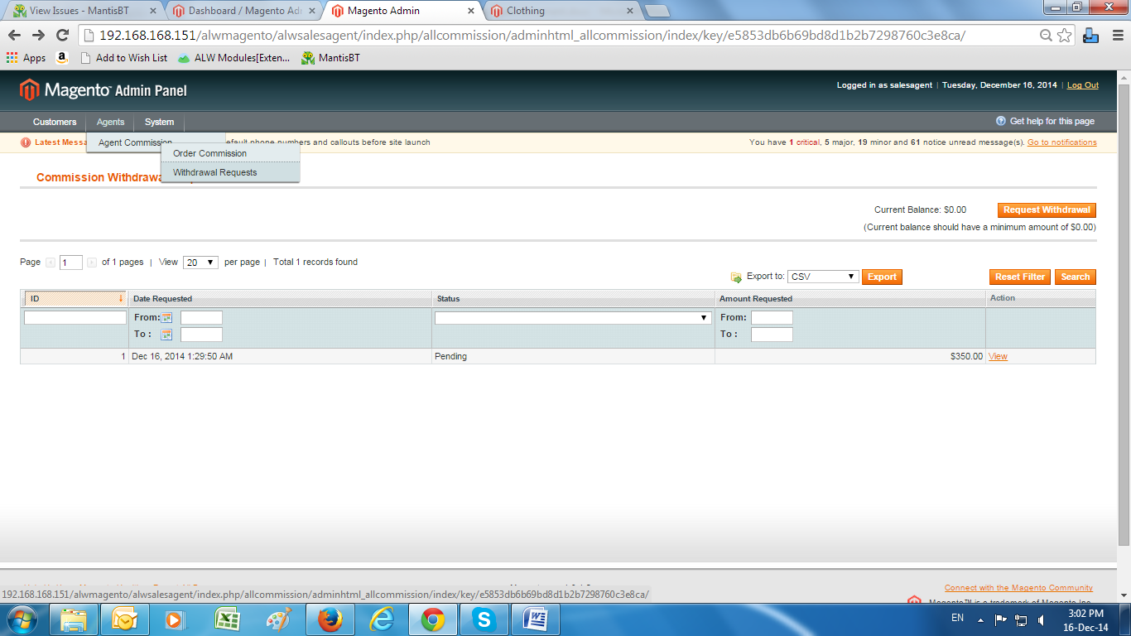

General Tabs
- Request withdraw tab: You can request commission from admin
- Current balance: This will display the commission, agent has received till now

1.6 Manage Accounts
You can access Accounts from system> my accounts
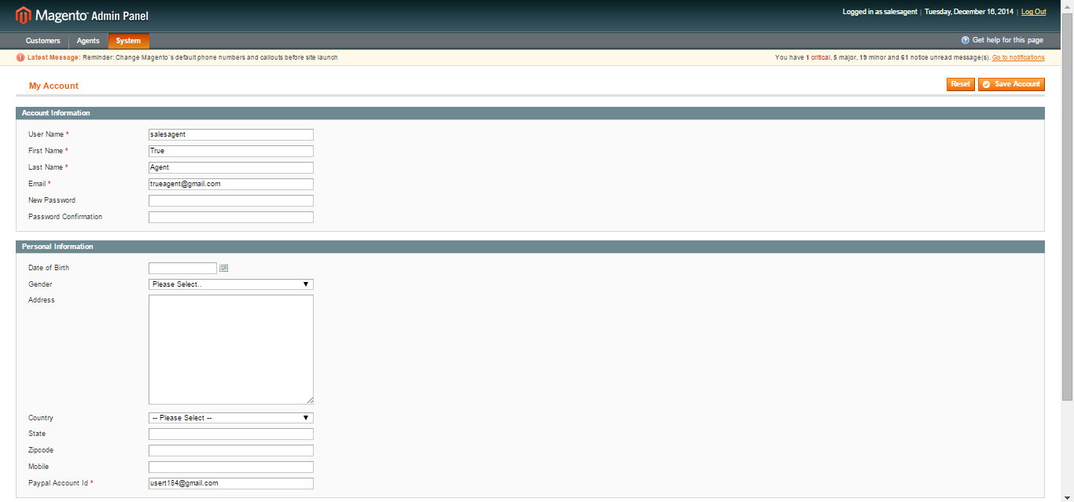
General Tabs
- Username: Update the username of Agent
- First Name: Update the first name of Agent
- Last Name: Update the last name of Agent
- Email: Update the email address of Agent
- Password: Update the password by entering new and confirm password fields
- Save: Save the updated information

