Module version: 1.9.16.1

Extension User Guide

Shop by Brands

Shop by Brands

Published: JANUARY 23, 2017

Contents
Shop by Brands 3
1. Configuration 5
2. Manage Brands section 6
3. Create new brand 7
4. Brand Configuration 8

Shop by Brands

Overview
The Shop by Brand extension helps customers to search and browse products through its Brands. When customers look out for products in the site they usually search for its brands. Considering this habit, we have designed the Shop by Brand Extension which enables your customers to search products within a particular brand and also allows you to perfectly manage brands on your site. More will be the ways for customers to navigate through products in your store, more will be the chances they find their needed product. Shop by Brand is a new method that will help your customers to connect with the products they are looking for, in an efficient way.

Features
- Allows creating different lists of Brands for each store view and/or website
- Admin can associate a brand name for products or within a Category
- Add/Edit/Delete brand (manufacturer) attributes
- Creates editable brand page with logo, brand description and all products under the brand with customizable layouts
- Attach image for each brand name
- Allows for setting the sort order for products on the brand page
- Enables optimizing brand pages for search engines by specifying custom meta-tags and SEO friendly URLs
- A new sidebar block is available with links to most popular or featured brands to be appeared in the listing page. There has to be alphabetical listing of the brands that allows customers more easily to shop. Admin can limit the number of brands to be displayed
- A new sidebar block with links to 5 recently added brands by admin. There has to be alphabetical listing of the brands that allows customers more easily to shop. Admin can limit the number of brands to be displayed
- An option to view all brands where brands will be listed in alphabetical order grouped by name with the number of products in brackets
- The sort by category pages have an option to sort products by brand
- Allows inserting a brand block or a brand logo on the product detail page and links from product pages to associated brand pages
- Allows users to filter products by brand, with a categories sidebar shown on the page as well

- Allows displaying brands only from the current category in the sidebar block
- Creates a neat list of all brands in alphabetical order to be added in layered navigation
- Places small brand logos for brands sidebar block

1. Configuration
To access the Magento backend administration environment
- Log in using the user name and password

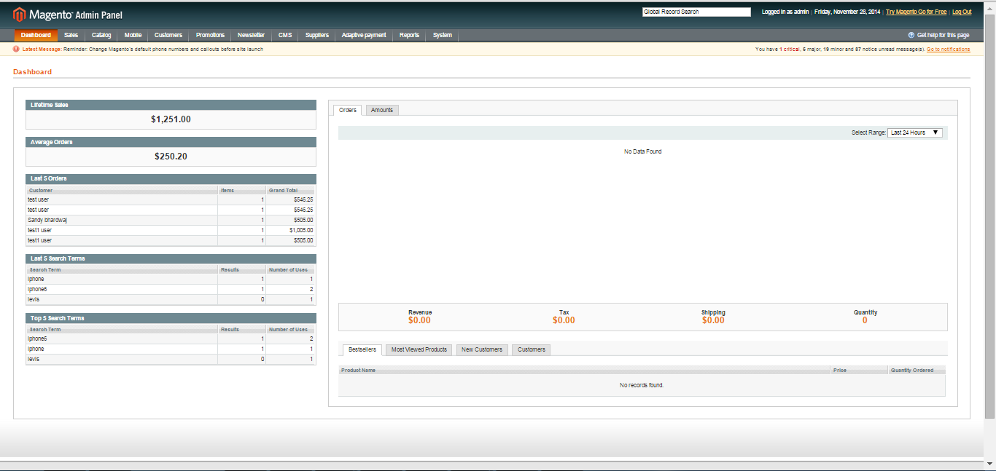

- Click the Login button to display the administration panel

2. Manage Brands section
Select Catalog > Manage Brands Names from admin panel
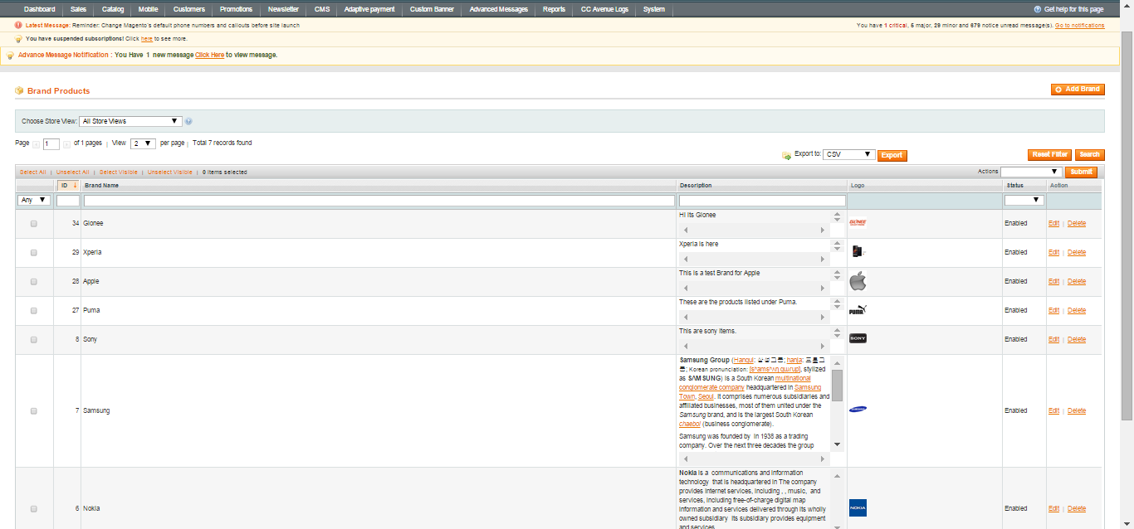

General Tabs
- Actions: To perform actions on created brand products such as remove, change status of product
- Search: One can filter the created brands on basis of Brand name, description, status
- Reset filter: To reset the applied filter on brand names
- Add brand: To add a new brand in brand section

3. Create new brand

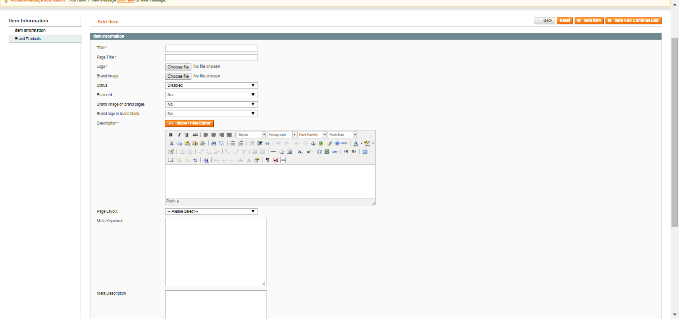

General Tabs
- Title : The title of the brand to be entered
- Page title : Defines the brand page title
- Logo : Defines the brand logo
- Brand Image : Defines the brand image to be displayed on brand page
- Status : To enable or disable the created brand
- Featured : Select yes or no from dropdown to include brand as featured or not
- Brand image on brand pages : Select yes or no from dropdown to show brand image or not
- Description: Defines the description of the brand
- Brand Products : To add related brand product under the created brand
- Save item : Save the created brand

4. Brand Configuration
Select from system > Configuration > Configuration for brands in admin panel
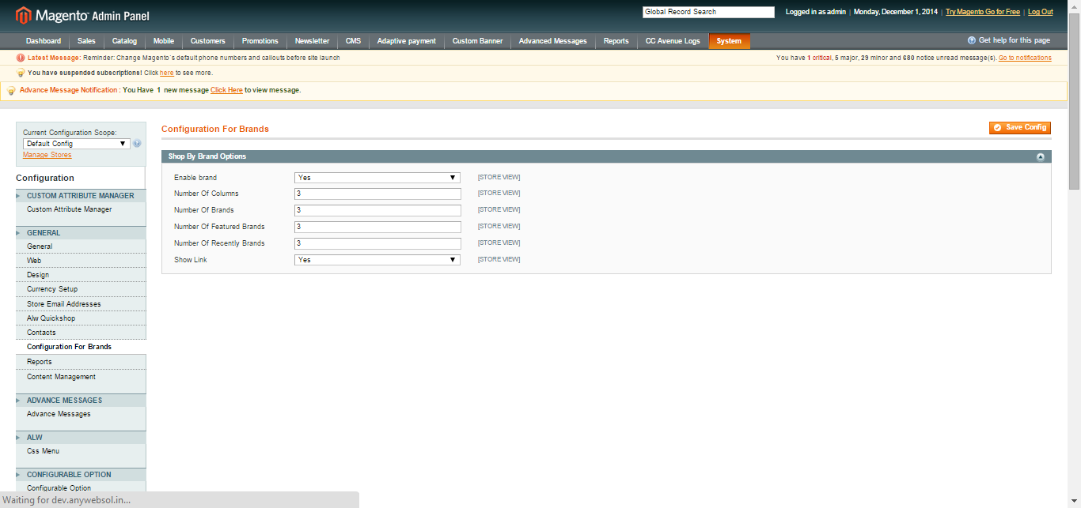
General Tabs
- Enable Brand : Shop by brand configuration can be enabled or disabled
- No. of columns: Mention the no of columns in which brand will get display on frontend
- No. of brands : No. of brands to be displayed on frontend
- No. of featured brands : No. of featured brands to be displayed on frontend
- No. of recently brands : No. of recently added brands to be displayed on frontend
- Show Link : Select from dropdown to show link or not

