Published:

Sub Category Listing
Sub Category Listing
Extension User Guide

Module version: 1.0

Contents

1. Sub Category Listing 3
1.1. Overview 3
1.2. Features 3
1.3. Sub Category listing at front end 3
1.4. Configuration 4
1.4.1. To Enable/Disable the Sub Category Listing extension 5
1.4.2. Enable the module for Sub Category Listing 5
1.4.3. Disable the module for Sub Category Listing 6
1.4.4. Clear Magento Cache to see the reflections on front end 6

1. Sub Category Listing

1.1. Overview

Sub Category listing extension provides a unique feature of displaying the sub categories list on the main category page. This extension shows a list of sub categories with the number of products present in it. The extension also allows an administrator to enable or disable the module.

1.2. Features

- Displaying the sub categories list on the main category pages.
- It shows a count of products associated in the sub category.
- It shows an image of subcategory that user has uploaded from admin.
- It will show default image if user has not uploaded any image from admin.
- From admin dashboard, user can enable or disable this module.

1.3. Sub Category listing at front end

At front end, when Sub Category listing is enabled:

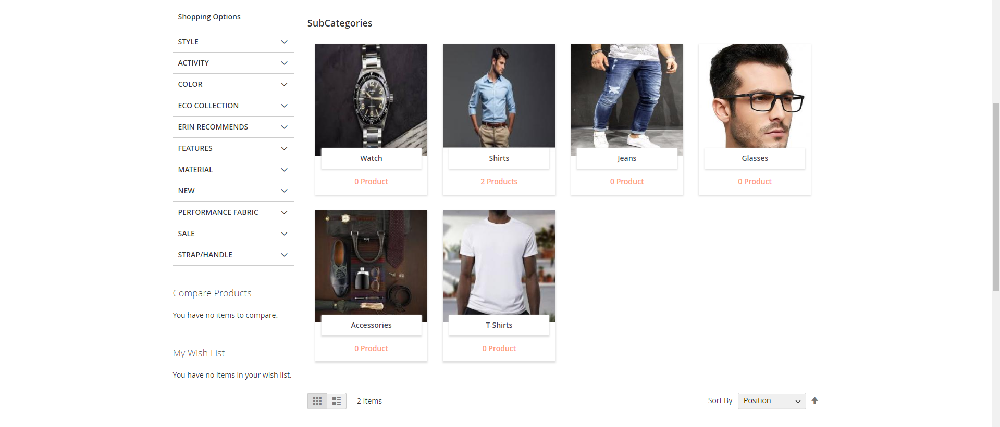

At front end, when Sub Category Listing is disabled:

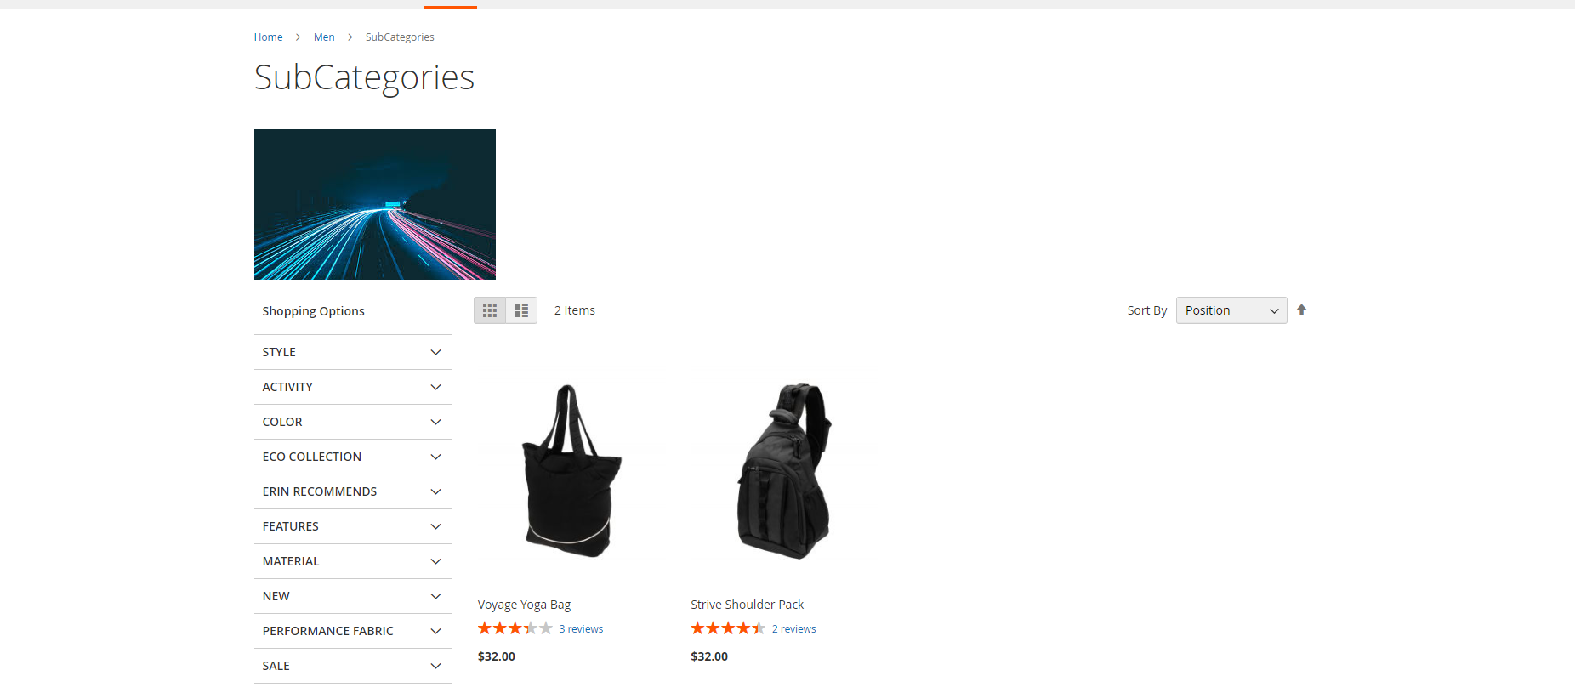

1.4. Configuration

To access the Magento backend administration environment
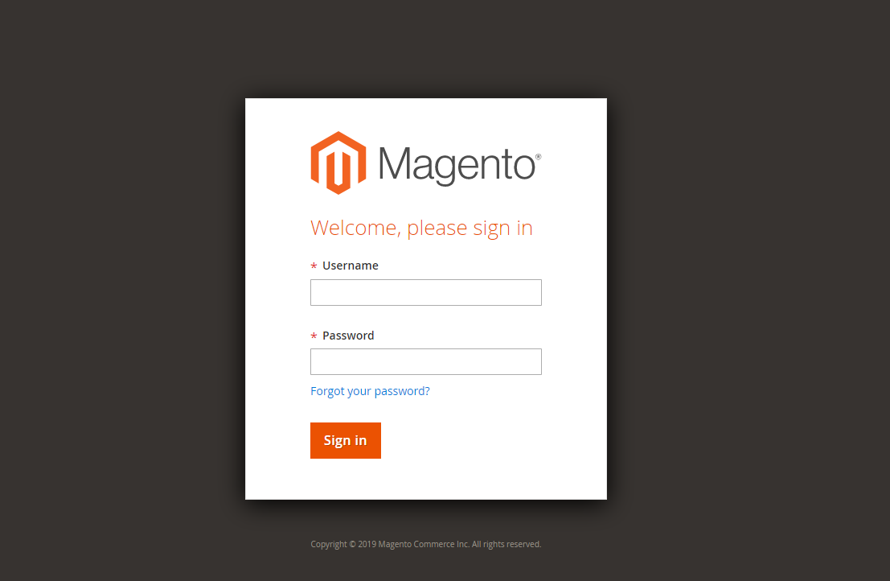

- Log in using user name and password
- Click Login button to display administration panel

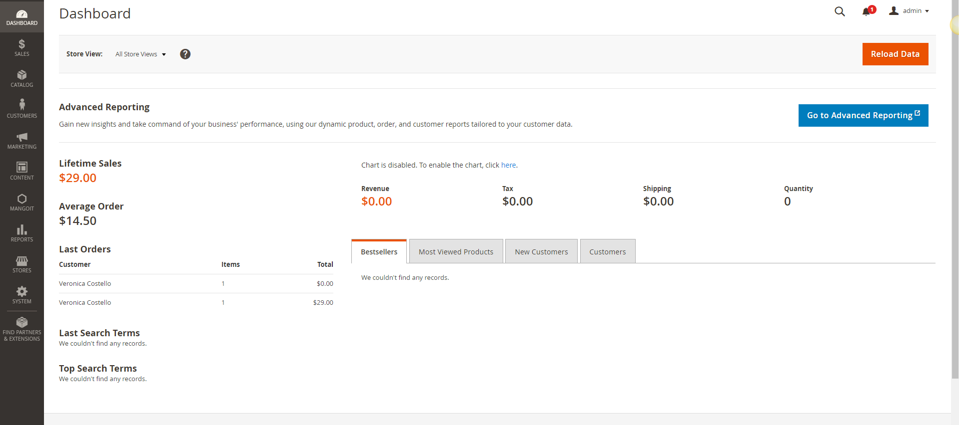

1.4.1. To Enable/Disable the Sub Category Listing extension

Select MANGOIT Sub Category Listing Configuration from admin panel
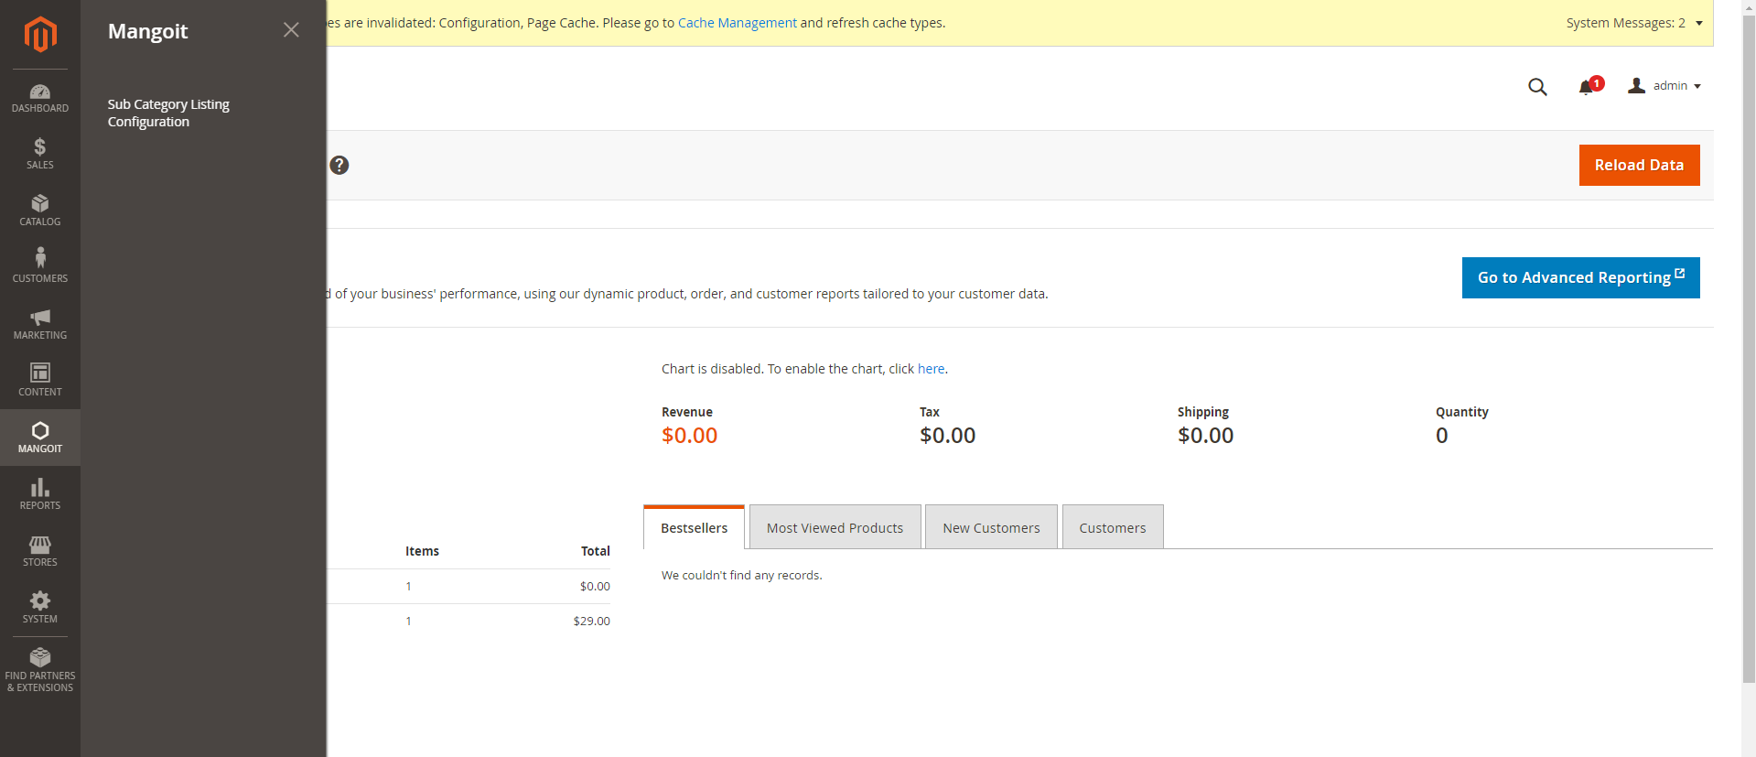

1.4.2. Enable the module for Sub Category Listing

On enabling module, the sub categories will start displaying at front end. Once user enables the module and save, after saving the configuration clear the Magento cache. And the changes will get reflect at the front end.
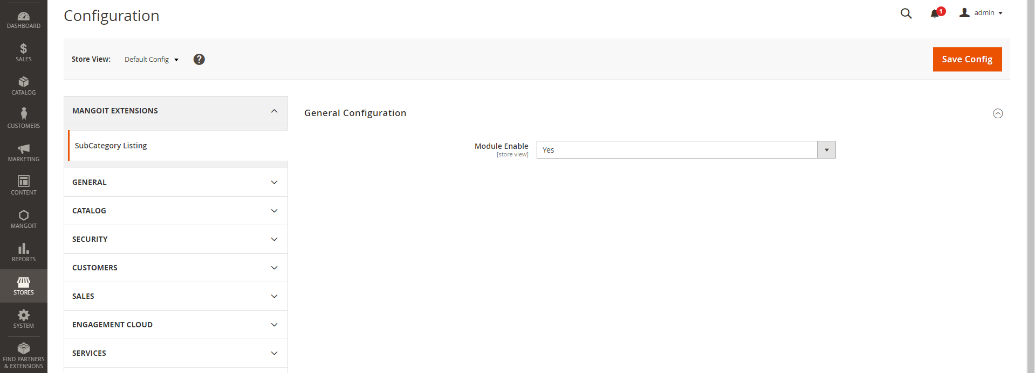

1.4.3. Disable the module for Sub Category Listing

On disabling module, the sub categories will not get display at front end. Once user disables the module and save, after saving the configuration clear the Magento cache. And the changes will get reflect at the front end.

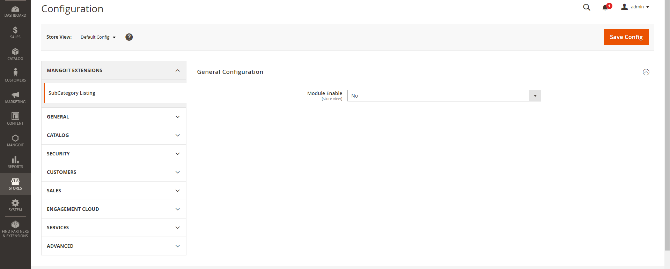

1.4.4. Clear Magento Cache to see the reflections on front end

Once user enables or disables the module and save, after saving the configuration clear the Magento cache. And the changes will get reflect at the front end.

System Cache Management Flush Magento Cache
