Module version: 1.9.18.1

Published: JANUARY 05, 2017

Suppliers Extension

Extension User Guide

Suppliers

Contents
Suppliers Extension 3
1. Configuration 5
2. Create New Supplier from admin panel 6
2.1 View the request of ‘New suppliers’ in admin panel 7
2.2 View the report of suppliers in admin panel 8
2.3 View new Category request of supplier 9
2.4 Supplier’s configuration settings 10
2.5 My Products (Suppliers Panel) 12
2.6 Admin Products (Suppliers Panel) 13
2.7 Request for New Category (Suppliers panel) 14
2.8 Report Tab 15
2.9 Supplier Details (Suppliers panel) 16
2.10 Sales Section (Suppliers panel) 16
2.11 Supplier registration (Frontend) 17

Suppliers Extension

Overview
Suppliers extension provides a unique feature of adding suppliers as third party users on Magento’s eCommerce website. The site admin will be able to allow suppliers to manage their product supply process; this will reduce the task related to product supply and also allow admin to offer other suppliers to sell their products through a well-established web store on minimum charges. Suppliers will be able to add their products and price. They will also be able to manage orders for their products. Once the user places an order it will go to the allocated supplier for shipping and invoice. Supplier will supply products directly to customer. Site admin will charge commission to supplier on every sale. Admin will be able to add percentage on sale (price margin) through configuration. Admin will also able to Manage Users, Track Payments, and View total Sales.
Features
- Admin will able to add suppliers as third party users on Magneto’s ecommerce website
- Supplier can register on the site; supplier registration link will be available on the home page
- Admin will be able to add percentage on sale (price margin) on supplier basis
- The payment received from the customer on the product’s purchase will be distributed amongst the site administrators and suppliers account. Admin margin/commission will transfer to admin account and rest of the amount will transfer to supplier account
- Admin will be able to approve or decline registration request of any supplier
- Suppliers will have to register before they can sell their products on the site
- Suppliers can log in and can edit profile, upload logo, change address, change password and configure PayPal account details
- Suppliers will be able to add/update/delete their products and their prices
- Suppliers will be able to manage orders for their products and will supply products directly to customers
- Every supplier will have his/her own page on the site. All the products of the supplier will be displayed on this product listing page of supplier
- Admin will able to filter/ sort all the reports supplier wise
- Admin will able to see product wise order status reports with main order status

1. Configuration
To access the Magento backend administration environment
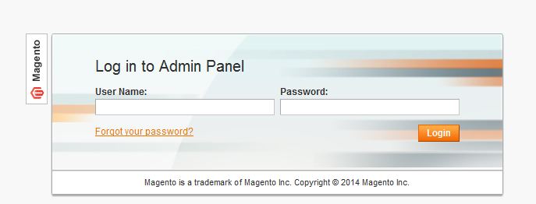

- Log in using the user name and password
- Click the Login button to display the administration panel

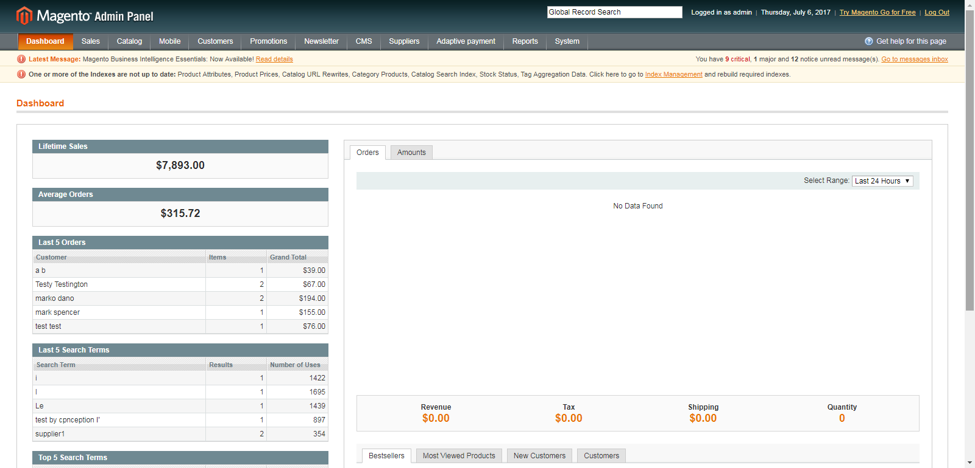

2. Create New Supplier from admin panel
You can access following the path Supplier > Manage supplier

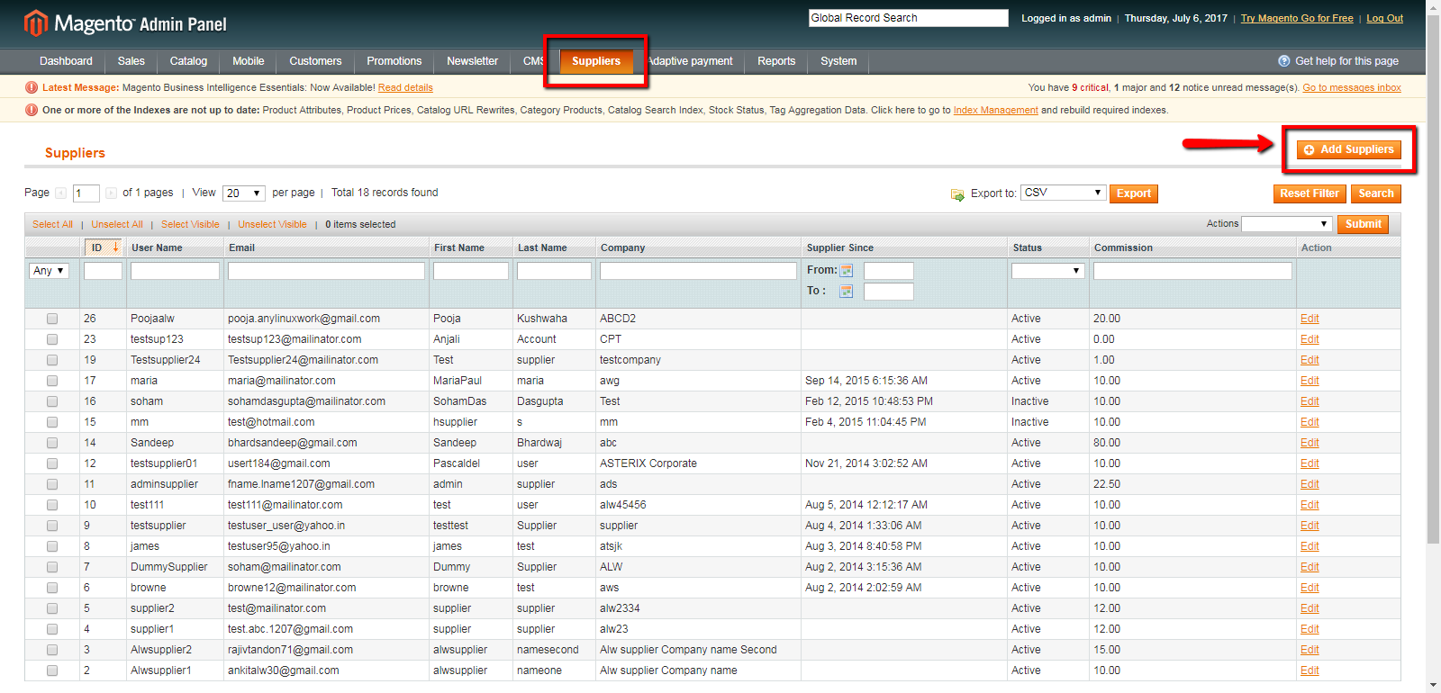

- It will display a list of already created suppliers in the section
- Click on Add Suppliers on the top right of the page to display the add supplier page

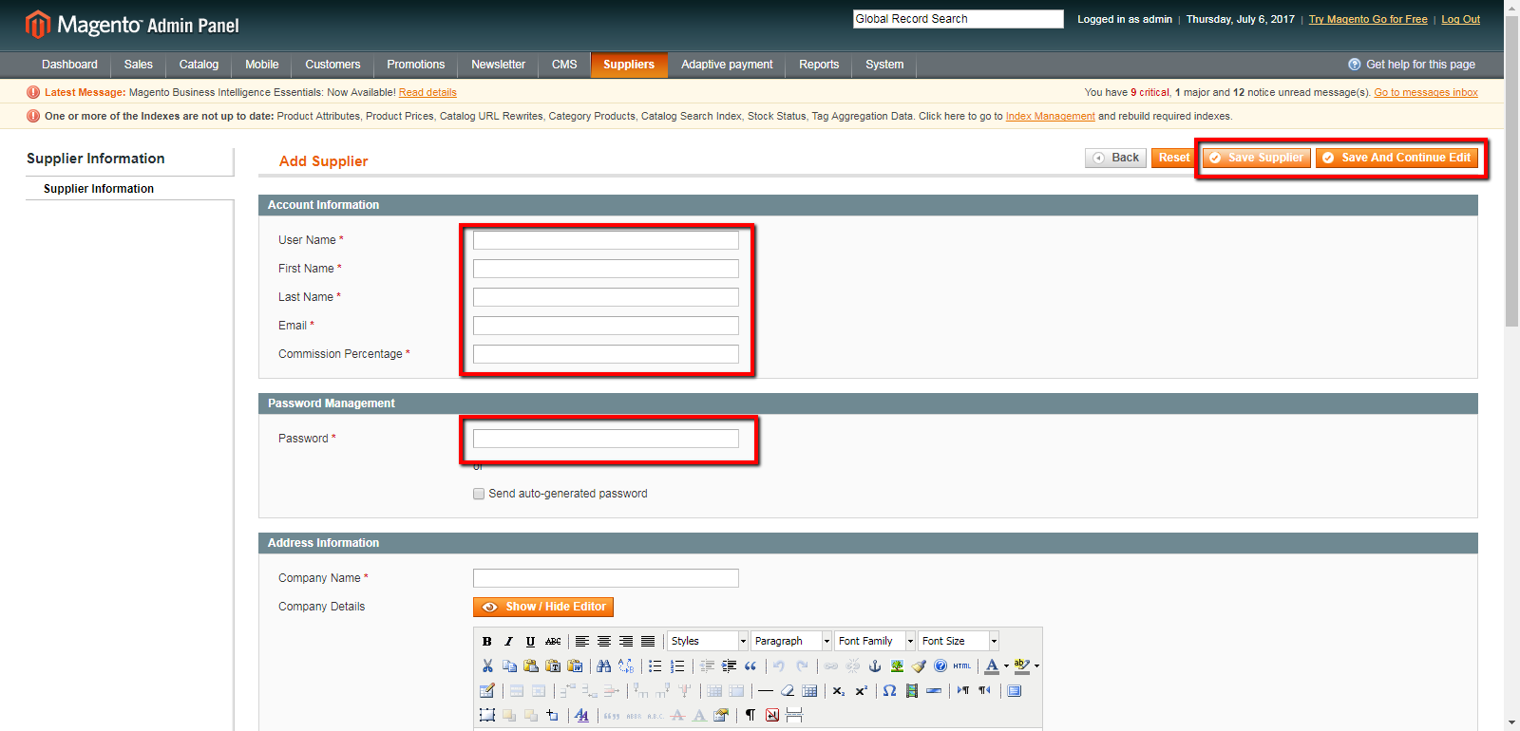

General Tabs
Fill in all the mandatory fields, which are indicated by a red asterisk (*)
- User Name: The supplier’s user name which can be used for logging in to the supplier panel
- First Name: Name of supplier
- Last Name: Last name of supplier
- Email : Supplier’s mail id where he can receive mails
- Commission Percentage: Admin can set the required commission for supplier
- Password: Password which supplier can use to login to the suppliers panel
- Company Name: Name of suppliers company
- Phone/mobile: Suppliers contact number

2.1 View the request of ‘New suppliers’ in admin panel
You can access following the path Supplier>New supplier

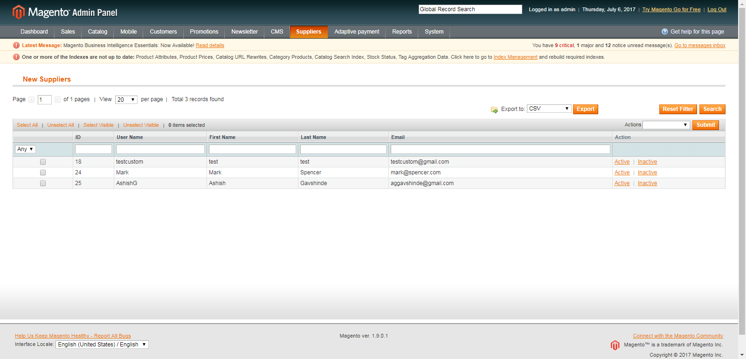

General Tabs
- Active: Admin can accept the supplier’s request
- Inactive: Admin can suspend the request

2.2 View the report of suppliers in admin panel
You can access following the path Reports > Suppliers report > Specific report

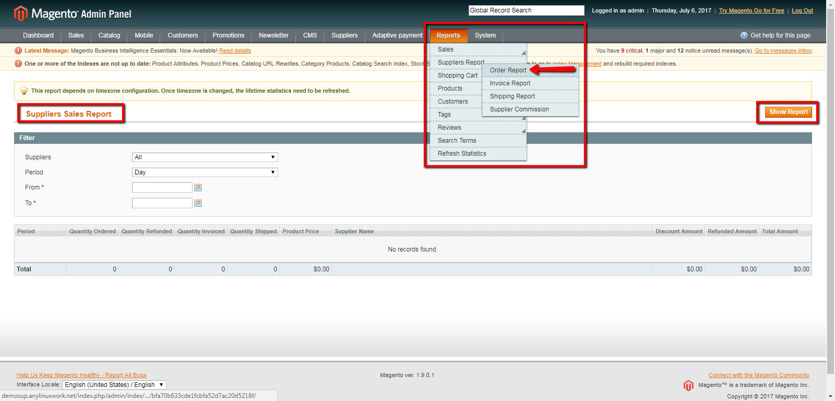

General Tabs
- Supplier : Admin can view the report of all suppliers or select specific supplier from the dropdown field
- Period : Select the period from drop down
- From to: Select from to date calendar
- To date: Select to date from calendar

2.3 View new Category request of supplier
You can access following the path Catalog>New category
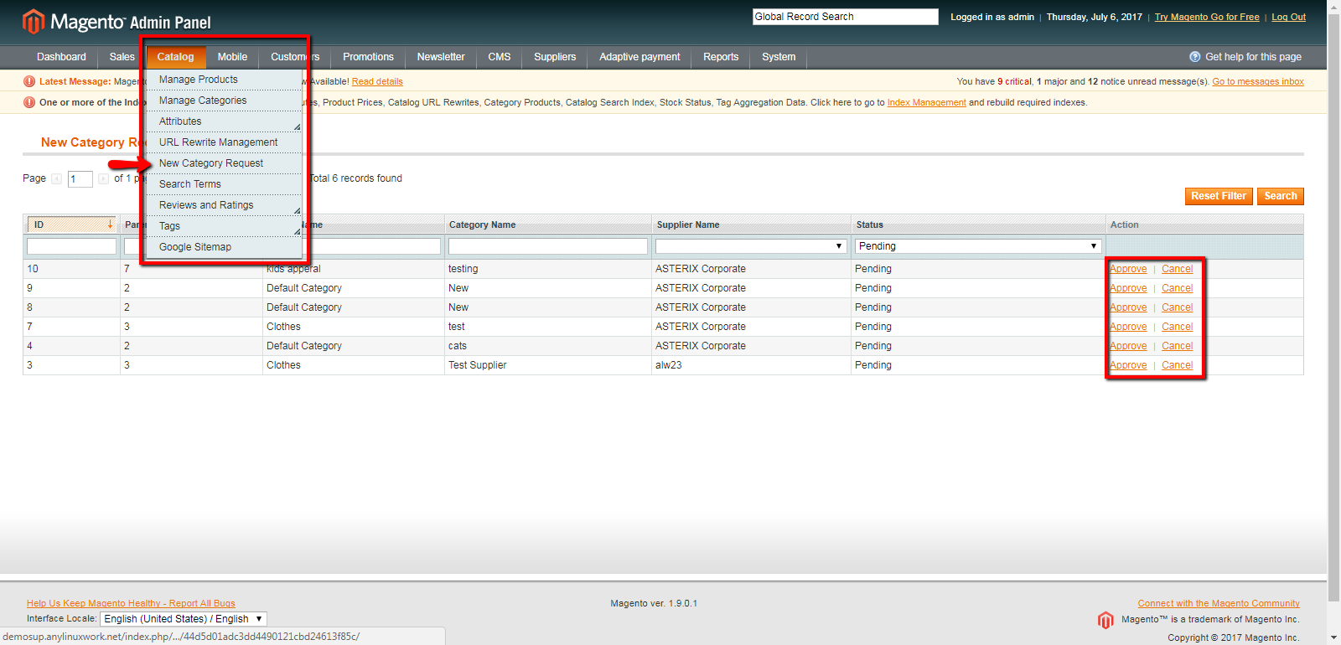
1. Approve: This will approve the request of supplier for category
2. Cancel: This will cancel the request of supplier for category
3. Search: Admin can filter the request of supplier when clicked after applying the filter

2.4 Supplier’s configuration settings
You can access following the path System>Configuration>Suppliers
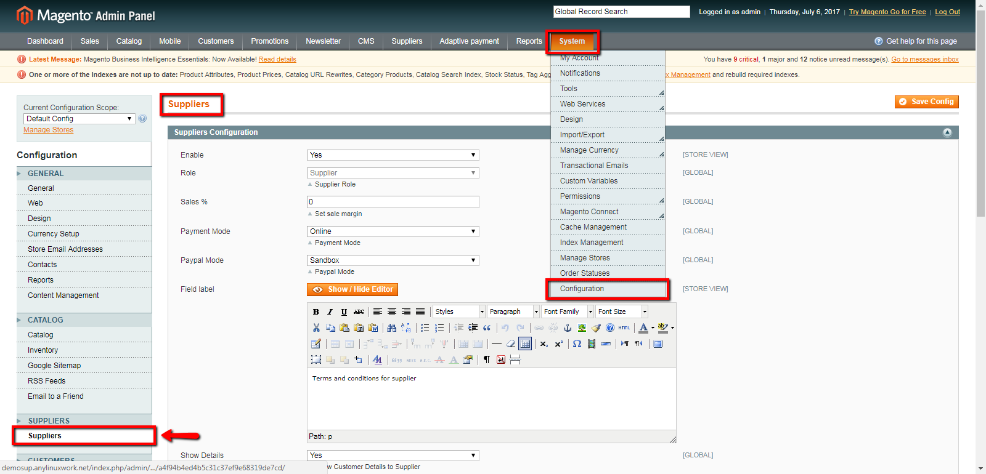

General Tabs
Admin Details
- Enable: Enable or disable the supplier extension from backend
- Sales %: Can set the sale margin
- Payment mode: Select the payment mode as online or offline
- PayPal Mode: Select the PayPal mode from dropdown
- Show customer details: Select Yes/No to hide customer details or not
- Show Email id: Select Yes/No to hide email id of customer or not
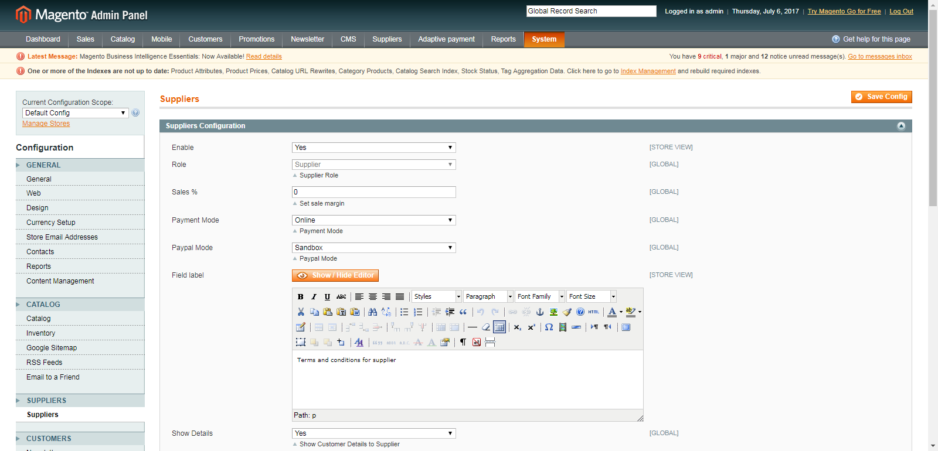
To access backend for Suppliers Section
- Log in using the user name and password for supplier
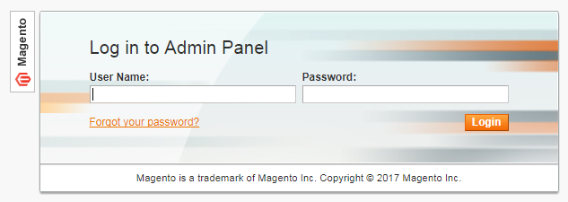

2.5 My Products (Suppliers Panel)
You can access following the path Catalog > My Products

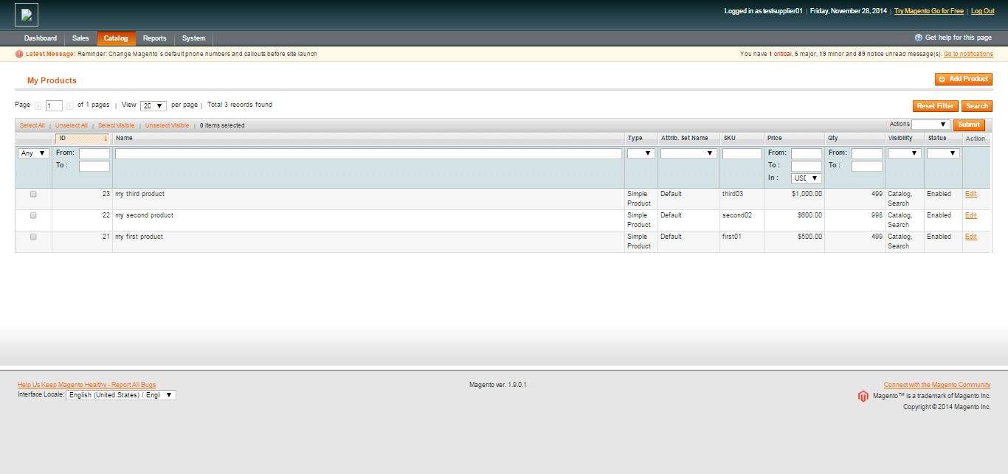

Click Add Product on the top right of the page to display the New Product page
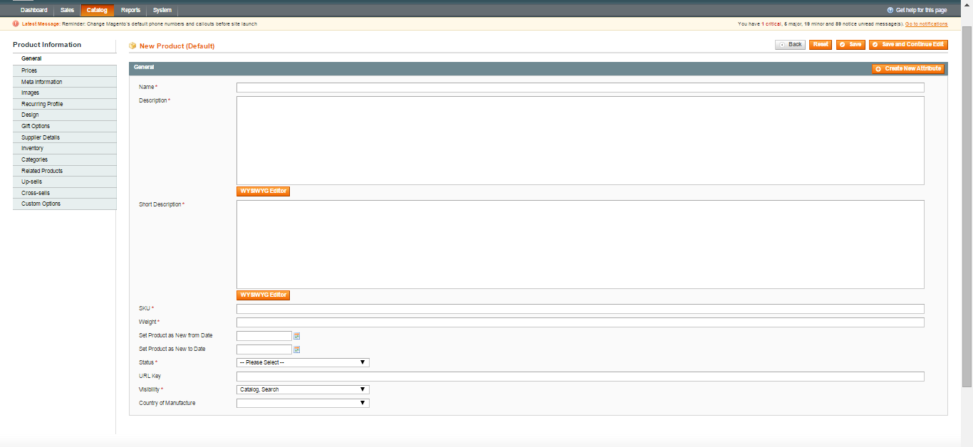

2.6 Admin Products (Suppliers Panel)
- Select catalog>admin products from supplier panel
- Supplier can view products on clicking each grid of the product
- Supplier can search products by applying the filter and clicking ‘Search’ tab
- Supplier can reset the filter by clicking ‘Reset filter’

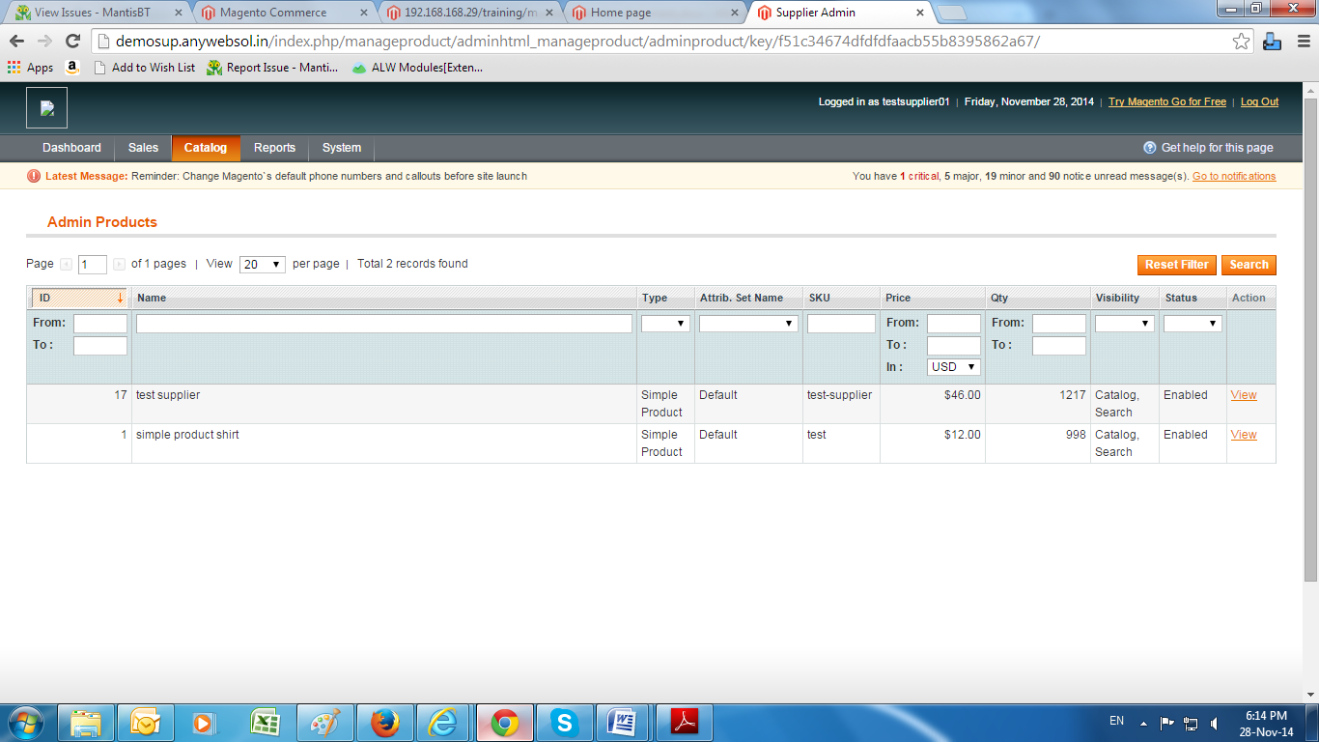

2.7 Request for New Category (Suppliers panel)
You can access following the path Catalog > Request for new category

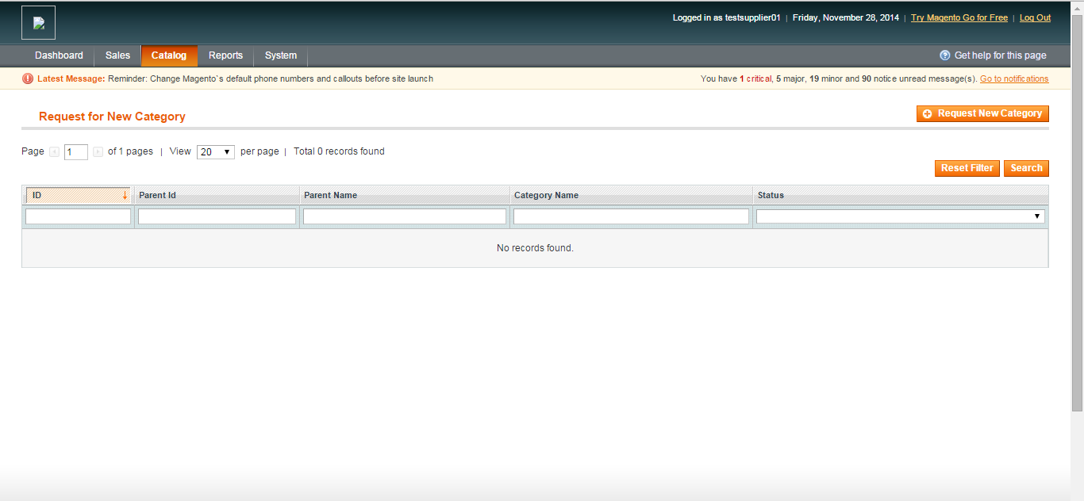

- It will display the list of category request which supplier has send to admin
- Click on ‘request for new category tab on request for new category page
- It will open up Suggest category page as shown below

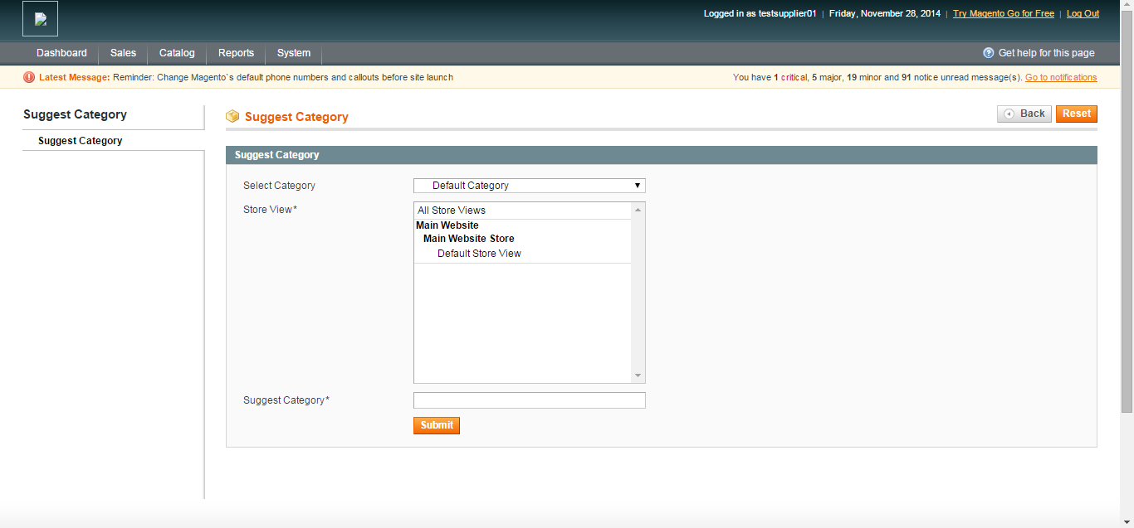

General Tabs
- Select Category: Select the category under which the suggested category can be placed
- Store View: Select store view where the category will get display
- Suggest Category: Name of the category you want to suggest
- Reset: You can reset the entered details on click
- Submit: It will send the suggested category request to admin

2.8 Report Tab
You can access following the path Reports>Supplier Report>Admin Commission
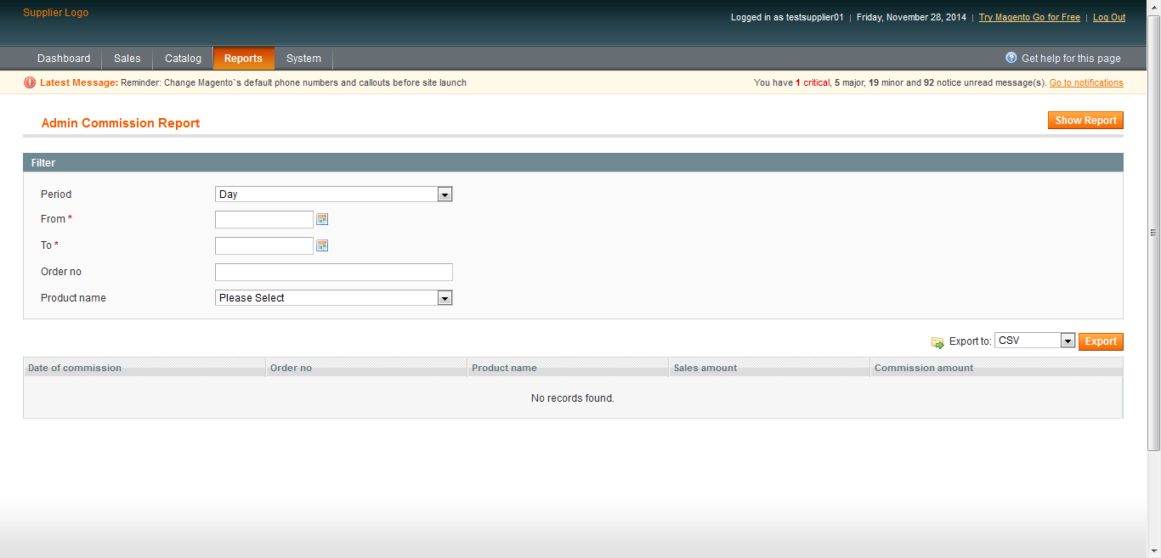

General Tabs
- Period: Supplier can select period from dropdown
- From & To: Date wise filter can be applied
- Order No.: Filter the report for any specific order number
- Product Name: Filter the report on basis of product name, selecting from dropdown

2.9 Supplier Details (Suppliers panel)
- Select System> my account from supplier panel
- Account page will be displayed
- The account page will contain all the details of supplier as entered while registering
- Supplier can update the details and save

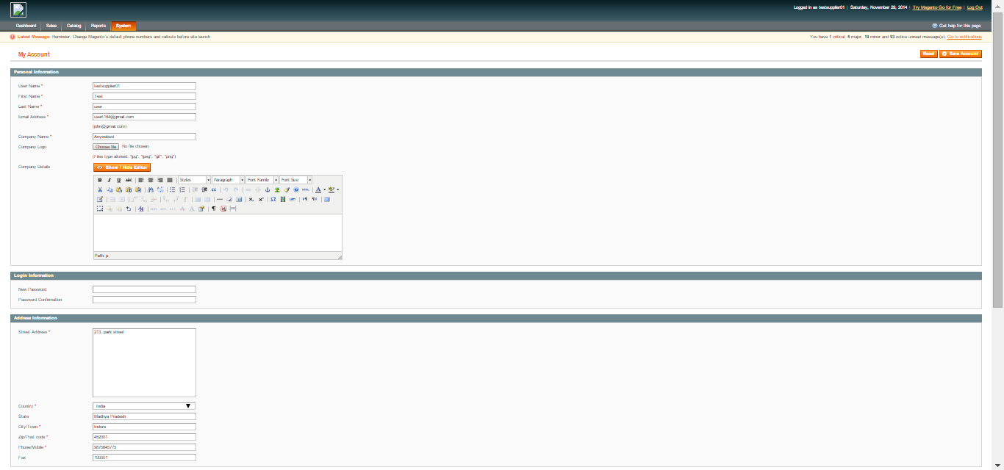

2.10 Sales Section (Suppliers panel)
- Order: It will display the list of orders
- Invoice: It will display the invoice list
- Shipment: It will display the shipment list
- Credit Memo: It will display the Credit memo list
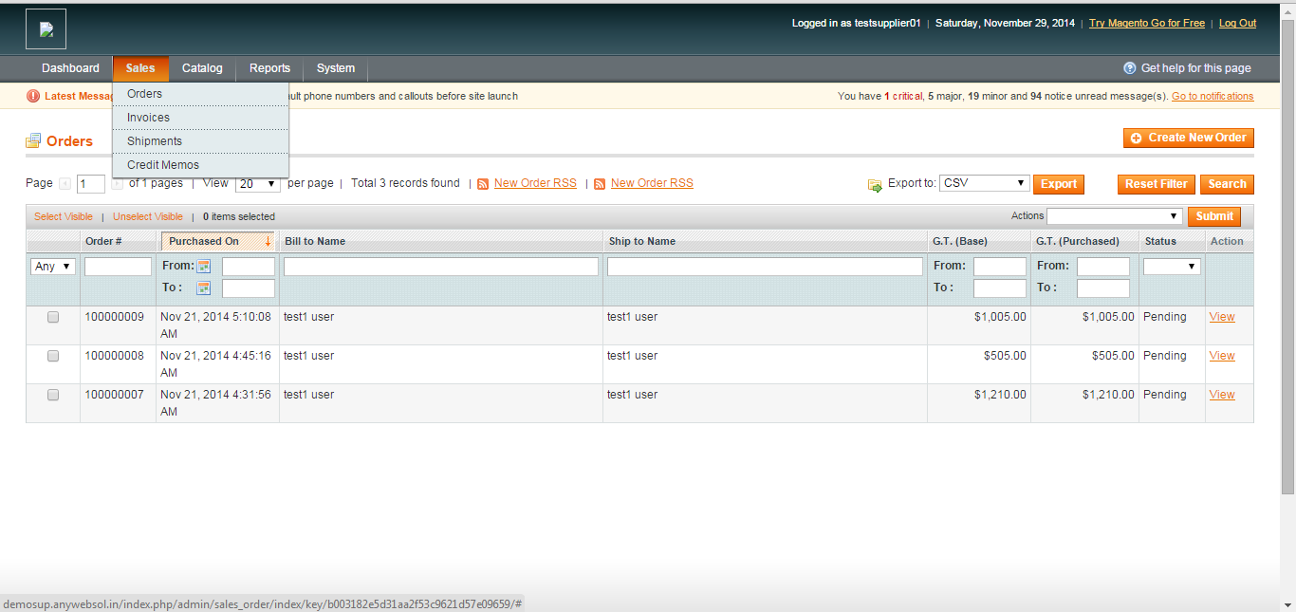

2.11 Supplier registration (Frontend)
You can access following path Home> Footer links> Supplier registration
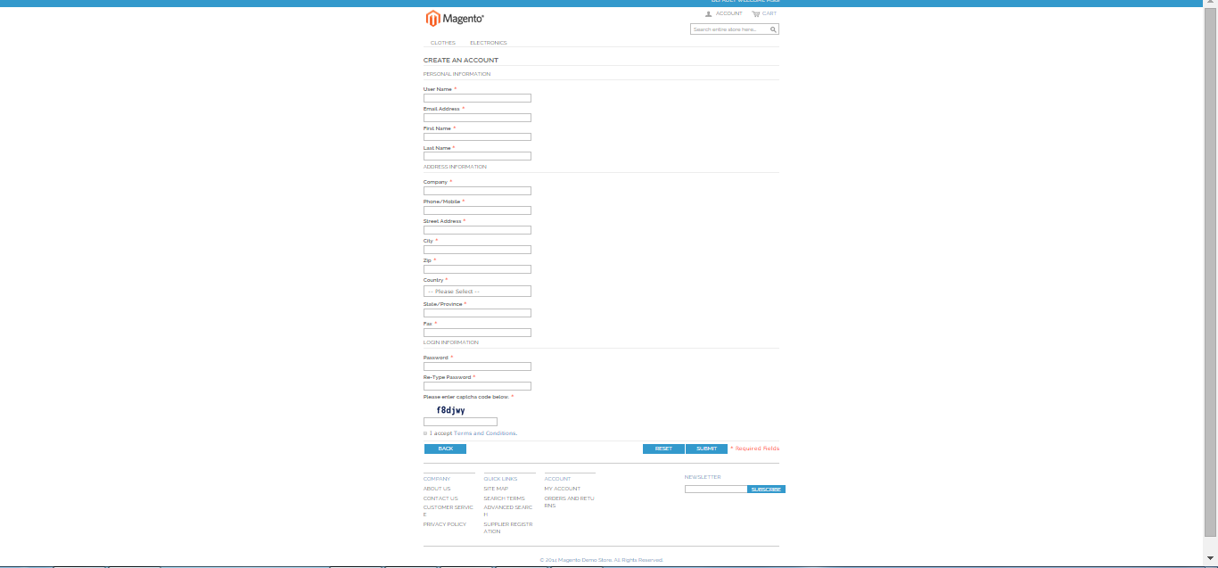

Fill all the mandatory fields, which are indicated by in red asterisk (*)
- User Name: The supplier’s user name which can be used for logging in to the supplier panel
- First Name: Name of supplier
- Last Name: Last name of supplier
- Email: Supplier’s mail id where he can receive mails
- Commission Percentage: Admin can set the required commission for supplier
- Password: Password which supplier can use to login to the suppliers panel
- Company Name: Name of suppliers company
- Phone/mobile: Suppliers contact number
- Captcha Code: Enter the Captcha in the field as shown

